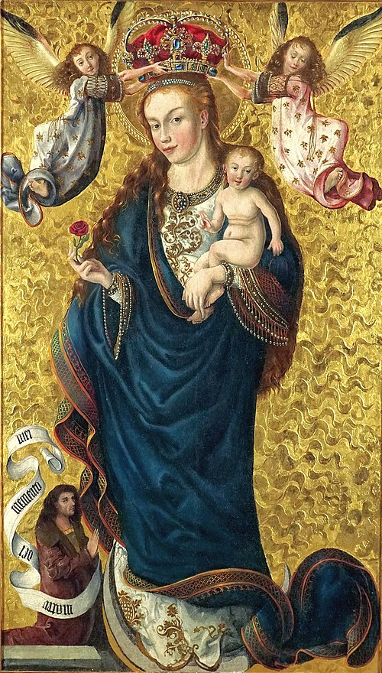

Ascend – The Monthly Publication of Mary’s Ward – January 2026 – Vol.2 No.1

From the Editor

Happy New Year! Good cheer is defiance. A smile, a kind word, an act of selfless giving – these are acts of resistance in 2026 America. When we are able to show love, we are absorbing the trauma, refusing to pass on the abuse, ending the cycle of violence. Being calm and caring are radical actions when our environment is permeated with unspeakable horrors. “Be still and know that I am God” (Psalm 46:10). In the same vein as tactical frivolity, what would otherwise be considered normal human decency has now been elevated to acts of heroic resistance to tyranny. Shine on, fellow nonviolent resisters!

January also brings the Roman Catholic Solemnity of Mary Mother of God on the first and The Epiphany on the sixth. Both provide needed light and hope during a dark time, both seasonally and politically. But speaking of hope, the winter solstice has passed and the “season of the sun’s rebirth” (a phrase from Nancy Cardozo’s poem recited at the candle lighting ceremony at the Dalton School), the return of increasing hours of daylight, is here. Winter provides a time of reflection and rest in anticipation of spring.

Matthew 13 is our Not in So Many Words chapter in synopsis and bindu-point format. The Homily for the Second Sunday after Epiphany explores the Body of Christ as community. Veda in Christianity explores how more imagery from the Veda is expressed in the Bible.

Messages and titles of Our Lady from a selection of international apparitions and devotions are compared with the messages of The Mother in Blueprint for Marian Maternal Life. We revisit the necessity of clean air and ways to obtain it without money in Not Serving Two Masters. Recent developments towards realizing Mary’s Ward goals are reported in Progress.

A Jazzy Jingle about a Junior Goat is Chapter 13 of our serialized kid-friendly Learning to Read with Goats this month. Homemade holy images and symbols of resistance is our kid-friendly Justice in Action DIY Free Project for Independence at All Ages. Free public library/classrooms everywhere is the topic for the Mary’s Ward Global Classroom update.

A deeper look at the significance of positive qualities, emotions, thoughts, and actions as acts of resistance is examined in How You Can Help.

Meeting a New Year with renewed determination!

Selby Beebe-Lawson, Editor
January 1, 2026

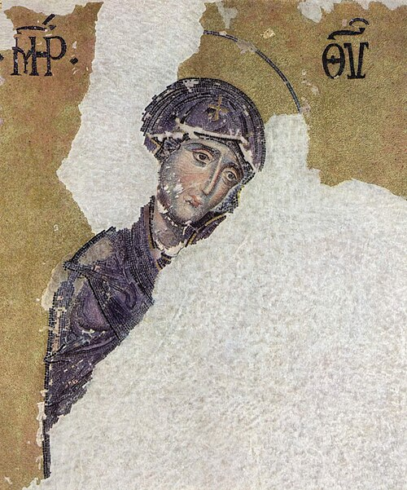
anonymous mosaic in Hagia Sophia, Mother of God, 12th century

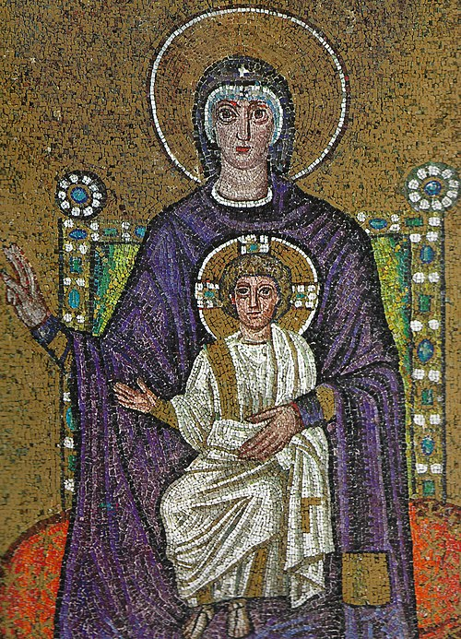

Byzantine mosaic artist, Theotokos, c. 560

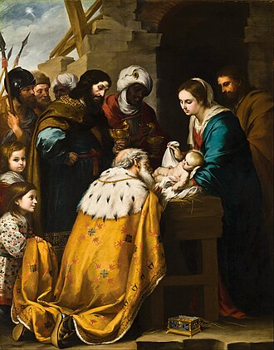

Bartolomé Esteban Murillo, Adoration of the Magi, 1655-1660

Table of Contents

Light

Not in So Many Words 1

Homily 3

Veda in Christianity 6

Love

Blueprint for Marian Maternal Life 10

Not Serving Two Masters 18

Progress 20

Life

LTR with Goats 21

Justice in Action 25

MW Global Classroom Update 27

How You Can Help 28

Anonymous, Matka Boża Pięknej Miłości w Bydgoszczy, 1467-1475
January birth flowers are carnation and snowdrop. Both are related to Mary’s tears in Christian lore.
Mother named carnations Collaboration and snowdrops Promise of Renewal.

Not in So Many Words
Matthew 13
At the sea Jesus preached from a boat as large crowds listened from the shore. The parable of the sower communicated the different abilities of listeners to absorb God’s message in terms of seed sown in different aggregates, only some fertile to plant growth. The condition of the soil determines the fruitfulness of the seed sown. Asked why he spoke in parables, Jesus answered that only some are prepared to hear about God’s kingdom and to act on that message come what may. To those with some spiritual knowledge, more will be given, but to those unable to receive it, it will not take root. Many have desired this knowledge, but a certain level of preparation is required, as with soil. Another parable, the wheat and the weeds: a gardener sowed wheat, but his enemy sowed weeds. Asked whether the weeds should be removed, the gardener was instructed to leave them. At harvest time the weeds could be gathered for burning and the wheat stored in the barn. Two more parables about the kingdom of heaven: the mustard seed and the leaven. The tiny mustard seed sown becomes a giant plant in which birds gather and perch. A little leaven added to meal leavens the whole batch. Three more: the parable of the treasure hidden a field, the pearl of great price, and the casting of a net in the sea. All speak of abandoning what is not good and giving up everything to attain the kingdom of heaven. Speaking of the end of the world, Jesus says, “The Son of man shall send his angels, and they shall gather out of his kingdom all scandals, and them that work iniquity. And shall cast them into the furnace of fire: there shall be weeping and gnashing of teeth. Then shall the just shine as the sun, in the kingdom of their Father. He that hath ears to hear, let him hear.” a passage, clearly in symbolic language, which needs much unpacking, referring according to some to a final judgment. (See commentary). A final parable, the scribe instructed in the kingdom of heaven like a householder bringing forth “old and new things”. Because the listeners knew his mother and siblings, they discounted Jesus’ message. He performed few miracles for them as “a prophet is not without honour, save in his own country, and in his own house.”

Commentary
- Jesus’ message is always about the kingdom of heaven
- identification of that kingdom as after-life, distinct from earthly here and now, is not Jesus’ message
- spiritual advancement follows spiritual preparation and evolution
- fire as image of burning weeds, sin, falsehood = fire of concentrated spiritual effort (tapasya) = Vedic concept of sacrifice as concentrated spiritual transformation, neither damnation nor eternal hellfire, but the burning of spiritual impurities in the fire of the Spirit, a process that is unpleasant only when we cling to ego-satisfying distortions of Truth

1
- parables emphasize the precious value of spiritual knowledge of the kingdom of heaven
- parables speak of growth of the kingdom resulting from that knowledge
- purpose of knowledge of the kingdom of heaven is not individual salvation, but of extension of that kingdom everywhere (not in a sense of promoting one religion, but of living kingdom values of justice, mercy, humility (cf. Micah 6:8).

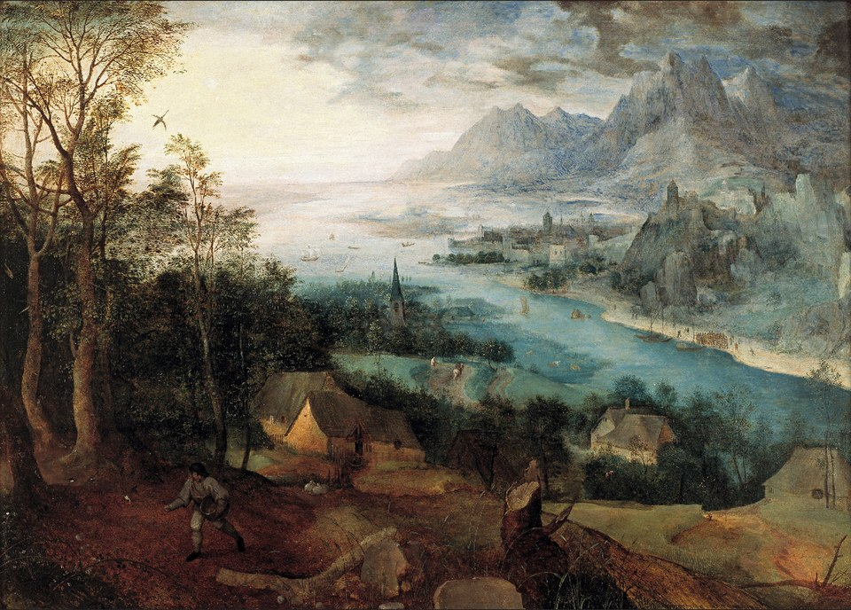
Pieter Bruegel the Elder, Parable of the Sower, 1557

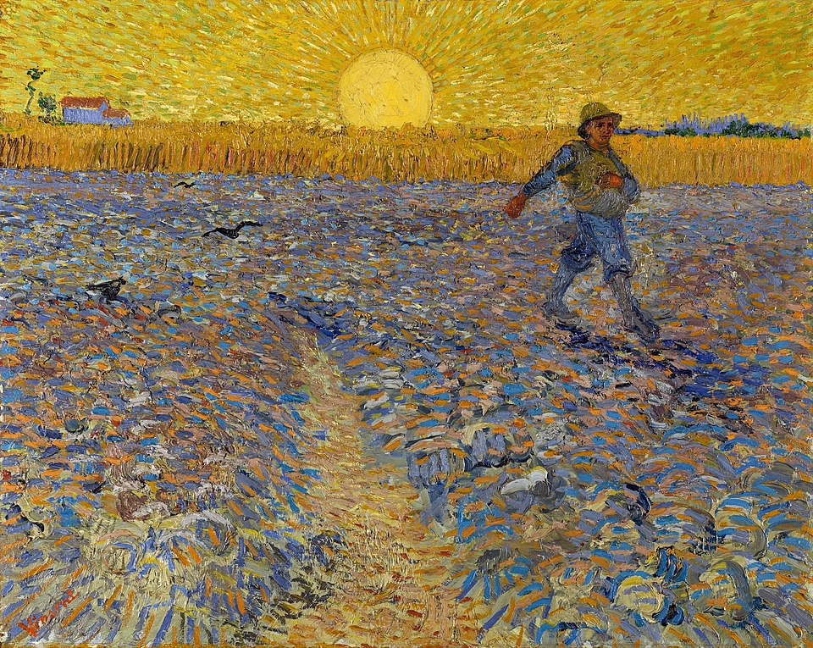
Vincent Van Gogh, The Sower, 1888

2
Homily
The Second Sunday after the Epiphany
Intent: Fellowship [Kinship]

The Collect

O LORD Christ, we thank Thee that it hath pleased Thee to draw us into wondrous fellowship [kinship] with Thee through Thy mystical body the Church, and we pray that all who profess and call themselves Christians may grow into the fullness of Thy love, and hold the faith in unity of spirit, in the bond of peace, and in righteousness of life, O Thou great King of Love, to whom be praise and adoration from men [humans] and from the Angel host. R/: Amen.

The First Lesson

The First Lesson is taken from the first chapter of the Epistle of St. Paul the Apostle to the Colossians, beginning at the ninth verse.

WE do not cease to pray for you, and to desire that ye might be filled with the knowledge of His will in all wisdom and spiritual understanding; that ye might walk worthy of the Lord unto all pleasing, being fruitful in every good work, and increasing in the knowledge of God; strengthened with all might, according to His glorious power, unto all patience and long-suffering with joyfulness; giving thanks unto the Father, who hath made us meet to be partakers of the inheritance of the saints in light, who hath delivered us from the power of darkness, and hath translated us into the kingdom of His dear Son, who is the image of the invisible God, the first-born of every creature. For by Him were all things created, that are in heaven and that are in earth, visible and invisible, whether they be thrones or dominions or principalities or powers: all things were created by Him, and for Him; and He is before all things, and by Him all things consist. And He is the head of the body, the Church, who is the beginning, the first-born from the dead; that in all things He might have the pre-eminence.

Here endeth the Lesson.

The Second Lesson

The Second Lesson is taken from the seventh chapter of the Gospel according to St. Luke, beginning at the second verse.

NOW a certain centurion’s servant, who was very dear unto him [them], was sick and ready to die. And when he heard of Jesus, he sent unto Him the elders of the Jews, beseeching Him that He would come and heal his [their] servant. And when they came to Jesus, they besought Him instantly, saying that he was [they were] worthy for whom He should do this: for he [they] loveth our nation, and he [they] hath built us a synagogue. Then Jesus went with them. And when He was now not far from the house, the centurion sent friends to Him, saying unto him: Lord, trouble not Thyself; for I am not worthy that Thou shouldest enter under my roof (wherefore neither thought I myself worthy to come unto Thee); but say in a word, and my servant shall be

3
healed. For I also am a man [person] set under authority, having under me soldiers, and I say unto one: Go, and he [they] goeth; and to another, Come, and he [they] cometh; and to my servant, Do this and he [they] doeth it. When Jesus heard these things, He marvelled at him [them], and turned Him about, and said unto the people that followed Him: I say unto you, I have not found so great faith; no, not in Israel. And they that were sent, returning to the house, found the servant whole that had been sick.

Here endeth the Lesson.

In the name of the Father, and of the Son, and of the Holy Ghost. Amen.

Today is the Second Sunday after the Epiphany, whose intent is Fellowship, although I prefer the more gender-neutral term Kinship. And before I get into the subject, let me confess that I struggled with whether or not to render the character of the centurion in the Gospel as a gender-neutral character. At first I left it alone, and then I changed it, and then I changed it back, and finally I changed it again. Is this a story about a particular male person, because of course all soldiers, indeed almost all characters then thought worthy to talk or write about, were male? But that is not how I see Jesus, nor how I understand his parables. They are for all time. Today, though not fully-realized, authority within the government and all its departments is theoretically open to all. Therefore, I changed it from a story about a man, to one about anyone in his position. Having written the struggle out, I am firmly convinced in the rightness of gender-neutral language. My apologies for wavering.

Kinship is a concept much overlooked by those who loudly proclaim that the United States is a Christian nation. And it’s not just Evangelical MAGA types. I had to add a vendor to my boycott list who supplies Catholic churches and lay people. I was searching for holy cards in Spanish and other languages to bring to the vigil at the Cumberland County Jail. Already disgusted that all the images of black and brown saints were drawn with European features and then colored brown, I chanced upon a holy card depicting Jesus embracing Charlie Kirk. Now, I have no doubt whatsoever that Jesus embraces everybody. But this informal canonization of someone who spouted hate, the creation of a right-wing martyr by folks who don’t even think the Catholic Church and Her canonization of saints is legit, well, that was too much for me to stomach.

So my work is to find kinship with MAGA, with Charlie Kirk, with Donald Trump and many others. I know that Jesus loves them. But I also need to speak truth to power with prophetic clarity. No one who cheers for the ethnic cleansing and cruelty that is being perpetrated by ICE is following Jesus. Period. The only nation that is Christian is the kingdom of God, and while that kingdom is present here and now, it is in no way conterminous with the United States, especially at this time. The kingdom of God has no borders, no law but love, no immigration process. Want in? You’re in! As soon as you realize that it exists, you are eligible to be a member, to be ‘kin’. You are then given authority to spread the kingdom far and wide, not by colonizing, not by proselytizing, certainly not by hate, war, bigotry, violence, or bullying, but only by love, by seeing everyone, everyone, everyone as kin.

And just as many of us have an Uncle Donald, a Cousin Charlie, a Half-brother J.D., a Brother-in-Law Robert, a Father-in-Law Stephen, a Son-in-Law Russell, or a Great Aunt Kristi Lynn, so we as followers of Jesus have these kin who we are commanded to love, but whose terrible actions we need to oppose and mitigate.

4
Today’s Collect really says it all.

O LORD Christ, we thank Thee that it hath pleased Thee to draw us into wondrous fellowship [kinship] with Thee through Thy mystical body the Church, and we pray that all who profess and call themselves Christians may grow into the fullness of Thy love, and hold the faith in unity of spirit, in the bond of peace, and in righteousness of life, O Thou great King of Love, to whom be praise and adoration from men [humans] and from the Angel host. R/: Amen.

Fullness of love … unity of spirit … bond of peace … righteousness of life … King of Love! These very holy words, especially righteousness of life, have undergone such distortion and misuse by those who advertise themselves as Christian and act in ways anathema to Jesus. May we take these words seriously in all sincerity and humility. May we love without exception. May we follow Jesus, who was born without adequate shelter, a Palestinian Jew, whose first companions were his parents and various animals, who was greeted by the outcast of society, the poor shepherds who watched their sheep literally on the margins – outside the city, who had been terrified by a sky full of heavenly hosts telling them to seek Jesus. Yes, this Jesus who was sought also by foreigners, who undertook a journey following a star, and because of whose visit, Jesus and his parents sought asylum in Egypt. Jesus was hated by most of the religious establishment of his time who felt threatened by his teachings. Today he is disregarded by those who use his name for status, power, and greed. In Matthew 25 Jesus plainly said that whatever we do to the least among us, we do to him. I am a great supporter of all those brave congregations and clergy, across denominations, who used their Nativity displays this Christmas to demonstrate this truth.

In the end, love wins. We are kin with the King of Love. We are able to create the kingdom of God in our midst. Every act of love and kindness is true power and true wealth.

“We shall overcome. We shall overcome. We shall overcome some day. Oh, deep in my heart, I do believe, we shall overcome some day!”

In the name of the Father, and of the Son, and of the Holy Ghost. Amen.

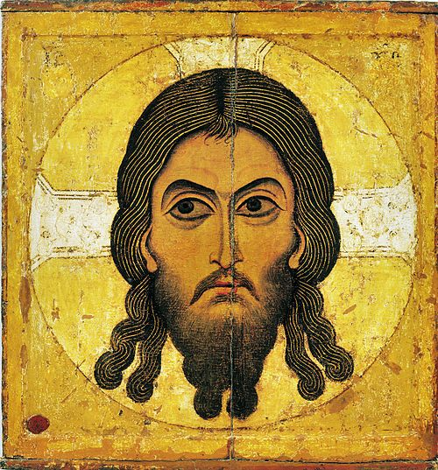
Anonymous, The Savior Not Made by Hands, c. 1100

5
Veda in Christianity
“Thus in images of physical Nature the Vedic poets sing the hymn of our spiritual ascension.” Sri Aurobindo, Hymns to the Mystic Fire, (Pondicherry: Sri Aurobindo Ashram, 2013) 29

सुस॑मिद्धो न॒ आ व॑ह दे॒वाँ अ॑ग्ने ह॒विष्म॑ते । होतः॑ पावक॒ यक्षि॑ च ॥ RV 01.013.01
súsamiddho na ā́ vaha devā́m̐ agne havíṣmate ǀ hótaḥ pāvaka yákṣi ca ǁ RV 01.013.01
When thou hast been increased to thy height, bring for us the gods, O Agni, to me who hold ready the offering, O priest of the sacrifice, O purifier and apply thyself to thy work. RV 01.013.01 (Sri Aurobindo’s interpretation)

मधु॑मंतं तनूनपाद्य॒ज्ञं दे॒वेषु॑ नः कवे ।अ॒द्या कृ॑णुहि वी॒तये॑ ॥ RV 01.013.02
mádhumantam tanūnapādyajñám devéṣu naḥ kave ǀ adyā́ kṛṇuhi vītáye ǁ RV 01.013.02
O son of force, honey-sweet do thou make the yajna to the gods for us today, O seer, that manifestation may be. RV 01.013.02 (Sri Aurobindo’s interpretation)
नरा॒शंस॑मि॒ह प्रि॒यम॒स्मिन्य॒ज्ञ उप॑ ह्वये ।मधु॑जिह्वं हवि॒ष्कृतं॑ ॥ RV 01.013.03
nárāśáṃsamihá priyámasmínyajñá úpa hvaye ǀmádhujihvam haviṣkṛ́tam ǁ RV 01.013.03
I call here in this yajna on the beloved, the strong expresser of things, the honey-tongued maker of the oblation. RV 01.013.03 (Sri Aurobindo’s interpretation)
अग्ने॑ सु॒खत॑मे॒ रथे॑ दे॒वाँ ई॑ळि॒त आ व॑ह ।असि॒ होता॒ मनु॑र्हितः ॥ RV 01.013.04
ágne sukhátame ráthe devā́m̐ īḷitá ā́ vaha ǀ ási hótā mánurhitaḥ ǁ RV 01.013.04
O Agni, bring, adored, the gods in a car of utter ease; thou art the thinker, the beneficent, the priest of the oblation. RV 01.013.04 (Sri Aurobindo’s interpretation)
स्तृ॒णी॒त ब॒र्हिरा॑नु॒षग्घृ॒तपृ॑ष्ठं मनीषिणः ।यत्रा॒मृत॑स्य॒ चक्ष॑णं ॥ RV 01.013.05
stṛṇītá barhírānuṣágghṛtápṛṣṭham manīṣiṇaḥ ǀ yátrāmṛ́tasya cákṣaṇam ǁ RV 01.013.05
Strew the flame without a break, O ye wise of heart, the flame with shining back, where the vision of immortality has been seen. RV 01.013.05 (Sri Aurobindo’s interpretation)
वि श्र॑यंतामृता॒वृधो॒ द्वारो॑ दे॒वीर॑स॒श्चतः॑ ।अ॒द्या नू॒नं च॒ यष्ट॑वे ॥ RV 01.013.06
ví śrayantāmṛtāvṛ́dho dvā́ro devī́rasaścátaḥ ǀ adyā́ nūnám ca yáṣṭave ǁ RV 01.013.06
Let the doors swing apart, the goddesses that conceal the force that grows by Truth, today at least and for the sacrificial act. RV 01.013.06 (Sri Aurobindo’s interpretation)
नक्तो॒षासा॑ सु॒पेश॑सा॒स्मिन्य॒ज्ञ उप॑ ह्वये । इ॒दं नो॑ ब॒र्हिरा॒सदे॑ ॥ RV 01.013.07
náktoṣā́sā supéśasāsmínyajñá úpa hvaye ǀ idám no barhírāsáde ǁ RV 01.013.07
To night and dawn in this yajna I call, the clear of eye, I sit beside this our flame. RV 01.013.07 (Sri Aurobindo’s interpretation)
ता सु॑जि॒ह्वा उप॑ ह्वये॒ होता॑रा॒ दैव्या॑ क॒वी ।य॒ज्ञं नो॑ यक्षतामि॒मं ॥ RV 01.013.08
tā́ sujihvā́ úpa hvaye hótārā dáivyā kavī́ ǀ yajñám no yakṣatāmimám ǁ RV 01.013.08
On them, the bright of tongue I call, the priestesses, goddesses, seers; may they conduct this yajna of ours. RV 01.013.08 (Sri Aurobindo’s interpretation)

6
इळा॒ सर॑स्वती म॒ही ति॒स्रो दे॒वीर्म॑यो॒भुवः॑ । ब॒र्हिः सी॑दंत्व॒स्रिधः॑ ॥ RV 01.013.09
íḷā sárasvatī mahī́ tisró devī́rmayobhúvaḥ ǀ barhíḥ sīdantvasrídhaḥ ǁ RV 01.013.09
May Ila, Saraswati and Mahi, the three goddesses born of the sphere of delight sit unfailingly beside our flame. RV 01.013.09 (Sri Aurobindo’s interpretation)
इ॒ह त्वष्टा॑रमग्रि॒यं वि॒श्वरू॑प॒मुप॑ ह्वये । अ॒स्माक॑मस्तु॒ केव॑लः ॥ RV 01.013.10
ihá tváṣṭāramagriyám viśvárūpamúpa hvaye ǀ asmā́kamastu kévalaḥ ǁ RV 01.013.10
Call here Twastha supreme whose shape is the world; may he be to us absolute and pure. RV 01.013.10 (Sri Aurobindo’s interpretation)
अव॑ सृजा वनस्पते॒ देव॑ दे॒वेभ्यो॑ ह॒विः । प्र दा॒तुर॑स्तु॒ चेत॑नं ॥ RV 01.013.11
áva sṛjā vanaspate déva devébhyo havíḥ ǀ prá dātúrastu cétanam ǁ RV 01.013.11
Let down, O god master of the forest, the oblation for the gods; let the giver get his awakening of soul. RV 01.013.11 (Sri Aurobindo’s interpretation)
स्वाहा॑ य॒ज्ञं कृ॑णोत॒नेंद्रा॑य॒ यज्व॑नो गृ॒हे । तत्र॑ दे॒वाँ उप॑ ह्वये ॥ RV 01.013.12
svā́hā yajñám kṛṇotanéndrāya yájvano gṛhé ǀ tátra devā́m̐ úpa hvaye ǁ RV 01.013.12
Swaha (O Shakti), perform the yajna to Indra in the house of the master of the yajna. Thither I call the gods. RV 01.013.12 (Sri Aurobindo’s interpretation)
I have specifically chosen a hymn from the Ṛgveda for this month’s article which is not immediately obvious in its relation to Christianity and the Bible. I have done this is in order to demonstrate that all of the Veda is present in one form or another, barely or greatly hidden, within the imagery of Christianity. My intent is not an exhaustive analysis of this hymn, but rather twofold: firstly, a broad statement of the shared vision of Veda and Christianity and secondly, some examples from the Bible of similar imagery, which at first glance we might assume are unique to Hinduism, are presented.
The broad vision of the Veda, as indicated in Sri Aurobindo’s quote from Hymns to the Mystic Fire, is “spiritual ascension.” Christ’s life culminates in his own ascension to the Father, a journey into which faith in him invites all of us as well. Hence although both East and West have reinterpreted the Vedic sacrifice in very specific and different ritualistic ways, both have missed the overarching concept of sacrifice as spiritual transformation. Using Sri Aurobindo’s keys to the psychological meanings of the Vedic imagery, we can begin to unlock the Veda’s true intent. The same can be said of Biblical imagery, many of which are the same images represented in a Judaeo-Christian context.
In this article, the images in RV 01.013 will be sought in the Bible. Rigorous analysis of their meaning can follow in a future article.
When thou [fire, cf. burning bush] hast been increased to thy height [cf. pillar of fire], bring for us the gods [“The Gods, the powers of Light and Truth are powers and names of the One, each God is himself all the Gods or carries them in him: there is the one Truth, tat satyam, and one bliss to which we must rise. But in the Veda this looks out still mostly from behind the veil. There is much else but this is the kernel of the doctrine.” Sri Aurobindo, Hymns to the Mystic Fire, 18, cf. God and Jesus’ “I am …” statements], O Agni [ cf. Agnus Dei, the Lamb of God], to me who hold ready the offering [cf. Abraham preparing to offer Isaac], O priest of the sacrifice [cf. Zacharias, many High Priests,

7
Jesus in Book of Hebrews], O purifier [cf. The Lord as purifier in Malachi 1] and apply thyself to thy work.

O son of force [cf. Son of God], honey-sweet [cf. honey from the rock in Deuteronomy 32:13, Psalm 81:16, and the scroll that tasted like honey then turned bitter in Rev. 10:9-10] do thou make the yajna to the gods [cf. God desires mercy not sacrifice Hosea 6:6. Matthew 9:13, the sacrifice of praise Hebrews 13:15, make your body a living sacrifice Romans 12:1] for us today, O seer, that manifestation may be [cf. God’s creation in Genesis 1:1, Jesus as agent of creation John 1:3].
I call [cf. call to me and I will answer you and show great hidden things, Jeremiah 33:3] here in this yajna on the beloved [cf. Song of Songs/Solomon], the strong expresser of things [winepress of the Lord (which needs deconstruction) Isaiah 63, Revelation 14], the honey-tongued maker of the oblation.
O Agni, bring, adored, the gods in a car of utter ease [cf. chariots of fire as heavenly conveyances in 2 Kings 2:11, 2 Kings 6:17]; thou art the thinker [cf. Jesus as the head of the body, the church Colossians 1:18], the beneficent [cf. Jesus the Good Shepherd John 10:11], the priest of the oblation [Jesus as the new High Priest Hebrews 4:14].
Strew the flame without a break [cf. Prepare ye the way of the Lord Isaiah 40:3, Mark 1:3], O ye wise of heart [cf. wise of heart Proverbs 10:8, 16:21, 1 Kings 3:12], the flame with shining back [cf. Transfiguration and John’s vision of Jesus and lamps in Revelation 1], where the vision of immortality has been seen [cf. I saw a new heaven and a new earth Revelation 21].
Let the doors swing apart [cf. And the gates thereof shall not be shut by day: for there shall be no night there. Revelation 21:25], the goddesses that conceal the force that grows by Truth [cf. The seven spirits of God Revelation 1:4, 4:5, 5:6], today at least and for the sacrificial act [cf. After these things I looked, and behold, a door opened in heaven. Revelation 4:1].
To night and dawn in this yajna I call [cf. day to day utters speech, and night to night shows knowledge Psalm 18/19:3], the clear of eye [cf. the light of the body is the eye Matthew 6:22, Luke 11:34], I sit beside this our flame.
On them, the bright of tongue [cf. tongues of fire at Pentecost] I call, the priestesses, goddesses, seers [cf. angels and heavenly hosts heralded Jesus’ birth Luke 2:13; angels ministered to him in the wilderness Matthew 4:11, Mark 1:13 and in the Garden of Gethsemane Luke 22:43]; may they conduct this yajna of ours.
May Ila, Saraswati and Mahi [cf. Wisdom in Book of Wisdom, Valiant woman = Mary in Proverbs 31:10-31, and the Spirit, a faminine noun in Hebrew], the three goddesses born of the sphere of delight sit unfailingly beside our flame.
Call here Twastha supreme whose shape is the world [cf. Solomon’s call for Wisdom who was present at creation to come assist him Wisdom 9:9-11]; may he be to us absolute and pure.
Let down, O god master of the forest, the oblation for the gods [cf. Giv us this day our daily bread
8
Matthew 6:11 and Luke 11:3; I am the bread of life John 6]; let the giver get his awakening of soul [idem].
Swaha (O Shakti) [cf. the woman clothed with the sun Revelation 12], perform the yajna to Indra [cf. God’s throne with lightnings and thunders Revelation 4:5] in the house of the master of the yajna [cf. Jesus referred to Temple as his and his Father’s house Luke 2:49, Matthew 21:13, Mark 11:17, Luke 19:46, and John 2:16]. Thither I call the gods [cf. The body as the temple of the Holy Spirit 1 Corinthians 6:19].
Well, that was an exhausting, if not exhaustive, exercise. As can be seen, there is a lot of overlap in imagery, and I would argue of concepts as well, between Veda and Bible. Once the overall sense of the Veda is grasped with the indispensable help of Sri Aurobindo’s work, the same spirituality can be discerned in the Bible and thus in Christianity. It’s a huge work to try to point it out, but every piece of the puzzle helps to present an overall picture of congruence.

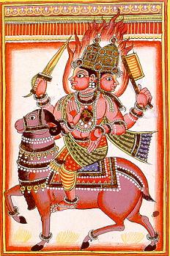
Agni rides a ram or a goat.

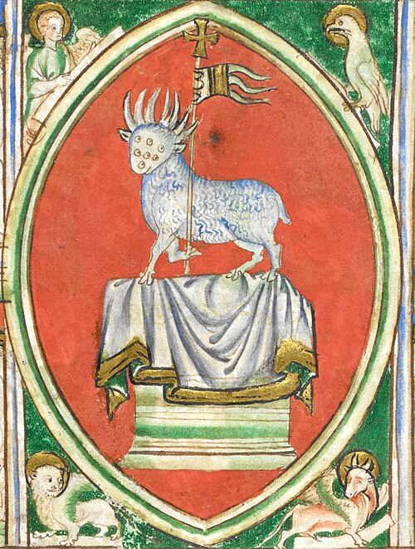
13th century seven-eyed Lamb of God from Revelation.

9
Blueprint for Marian Maternal Life
“Am I not your mother?” Our Lady of Guadalupe to Juan Diego in 1531
The Blessed Virgin Mary emphasized her maternal closeness to Juan Diego when she appeared to him on Tepeyac Hill in Mexico City in 1531. Her message was to ask that a church be built for her there. Her tone was consoling and nurturing. In order to prove her reality, she produced Castilian roses out of season for him to carry to the unbelieving bishop, which fell from his arms revealing a miraculous image of Our Lady on Juan Diego’s cactus fiber tilma (poncho), which can be seen today in the Basilica erected there. “Am I not your mother?” were her most famous and enduring words.
Sri Aurobindo changed Mirra Alfassa’s name to The Mother and to this day, those who revere her refer to themselves as “children of The Mother.”
Jumping ahead several centuries, Our Lady appeared to a poor teenager out collecting firewood at Massabielle (big rock), a dark place used as a pig shelter. Since Our Lady appeared there eighteen times in 1858, revealing a spring with healing waters and calling herself the Immaculate Conception, the site in Lourdes, France has become a place of pilgrimage, especially for the sick seeking healing. Bernadette Soubirous, then just fourteen, was put through many physical and psychological tests by local authorities. Our Lady’s message was to ask Bernadette to return over and over again, to drink from the spring which had not yet appeared, for prayer, especially the rosary, pilgrimage, and turning towards God. Bernadette responded with faith, courage, and perseverance.
The three main aspects of the Integral Yoga of Sri Aurobindo and The Mother are represented in this story: aspiration in Our Lady’s request for prayer, rejection in Bernadette’s persistent presence at the Grotto despite public humiliation, and surrender in Bernadette’s attempt to drink from a spring not yet in evidence, resulting in her face being covered in mud and many onlookers thinking she was mad. Our Lady’s self-naming as the Immaculate Conception also aligns with Sri Aurobindo and The Mother’s contention that the only sin is separation from the Divine expressed in something misaligned or out of place. The Mother embodied, embraced, and expressed birth without the stain of original sin. In fact, as she had another interpretation of the Fall of Man story, she felt that the concept of original sin was barbaric.
In the turbulent year of 1917, Our Lady appeared to three shepherding children in Fatima, Portugal. She appeared on the thirteenth of every month, culminating in the Miracle of the Sun, viewed by thousands of believers and skeptics alike, on October 13, 1917. These children, like Bernadette Soubirous, faced scrutiny, humiliation and severe intimidation and bullying by local authorities. Yet, they never wavered in their faith in their experience of the apparitions. They were just seven, nine and ten years old at the start. Our Lady asked for prayer, chiefly the rosary, and sacrifices. She showed them prophetic visions, including of hell, and gave them secrets. The Miracle of the Sun, the unusual event of the sun seeming to dance in the sky, plunging to earth at one point, and many colors, was seen by many and even reported in newspapers by the secular and unbelieving press.

10
The sun is a Vedic image of the Divine, just as hell, rather than a place of torment, in Vedic imagery represents the fire of sacrifice (ie. transformation) through self-offering to Agni (=Christ). The seers’ vision, therefore, also corresponds to the need for aspiration (prayer), rejection (sacrifice), and surrender (self-offering to the Divine and the process of purification and transformation.)
In November 1981 and continuing through 1982, several school girls in Kibeho, Rwanda saw Our Lady and likewise received prophetic visions of hell, purgatory, and heaven, which they described as spiritual journeys. They also received visions of violence in their land, prophetic warnings perhaps of the impending Rwandan Genocide of 1984. Our Lady emphasized prayer and conversion, but also her great sorrow, introducing and asking the girls to promote the Rosary of the Seven Sorrows. She asked for unceasing prayer with a sincere heart.
The plea for sincerity is not well known to followers of the Integral Yoga of Sri Aurobindo and The Mother. Sincerity is one of the Twelve Qualities, or Powers, of The Mother manifested for her work, and represented as one of the outer petals of her symbol. Sincerity is the first attribute needed, the one from which all other eleven ultimately flow in succession. Interestingly, the Madonna of Sorrows is feeatured in the epic poem of Sri Aurobindo Savitri, as one aspect of the Universal Mother. In Catholic iconography, she is depicted with seven swords piercing her heart. The seven sorrows are Simeon's Prophecy, the Flight into Egypt, the Loss of Jesus in the Temple, meeting Jesus on the Way to Calvary, the Crucifixion, Jesus being Taken Down from the Cross, and Jesus' Burial. We live in a time when great sorrows are being borne by many people, especially people of color and other marginalized groups. An ethnic cleansing, such as the one that incited the Rwandan Genocide, is being carried out today as white supremacy and Christian Nationalism in this country and abroad. There is no doubt that the Mother of God is sad. As always, she calls for aspiration (prayer), rejection (sacrifice, penance) and surrender (conversion of heart, turning towards God).
Staring only a few months before its African counterpart, but continuing even today, Our Lady of Medjugorje appeared to children of the war-torn country of Bosnia-Herzegovina. The work of Martin Sobieroj in comparing the Gospa (Our Lady of Medjugorje), with The Mother appeared in the AuGust 2025 issue of Ascend. To recap briefly, the Gospa insisted on five pillars: prayer, fasting, study of Scripture, regular confession, and regular reception of the Eucharist at Mass. Prayer is aspiration, fasting and confession are rejection, and study of Scripture and participation at Mass are surrender (and means of receiving grace). Since August, I became aware that Martin Sobieroj, now deceased, and I have a mutual friend, a Sanskrit classmate of mine. They discussed Martin’s writings many times. My friend Milan narrated to me an anecdote: Martin brought a photograph of The Mother to Medjugorje and asked one of the seers to ask Our Lady if it was her. Milan reported that Martin said, “No answer was given, neither yes nor no, but Our Lady, according to the seer, looked very serious.” Martin amassed a huge number of references from The Agenda, a series of interviews with The Mother by her devotee and fellow francophone Satprem, published in thirteen volumes. Checking his references which he claimed substantiated The Mother’s interest in rebooting Christianity as a true path of spirituality is definitely on my agenda for 2026.

11
Is Mirra Alfassa, The Mother, who Sri Aurobindo says she is and who she hints that she is? How is she related to Our Lady? These are questions for individual contemplation in the deep recesses of the hearts of her children.
Hail Mary! Jai Maa!

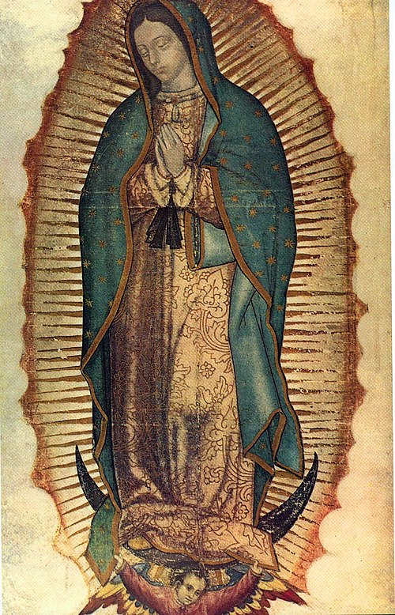
Our Lady of Guadalupe on Juan Diego’s cactus fiber tilma, 1531

12
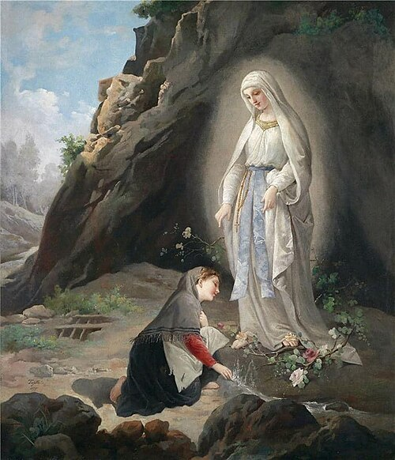
Painting of apparition at Lourdes Grotto at Massabielle in 1858

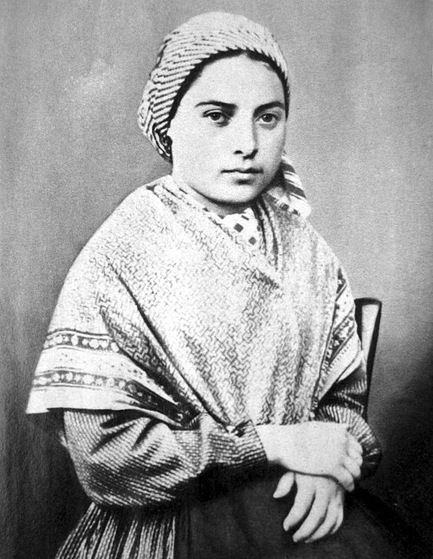
Bernadette Soubirous, 1858

13
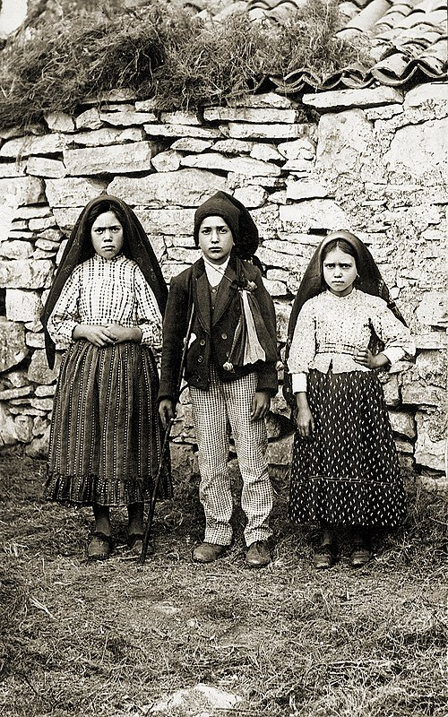
Lucia dos Santos (L) with Francisco and Jacinta Marto, 1917, Fatima seers.

14
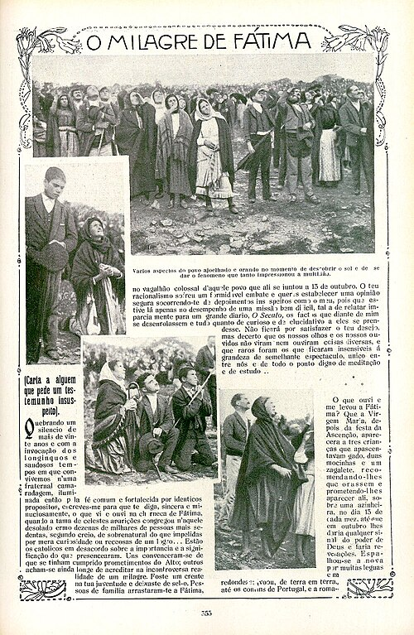
Page from Ilustração Portuguesa, 29 October 1917 , during the Miracle of the Sun on October 13, 1917.

15
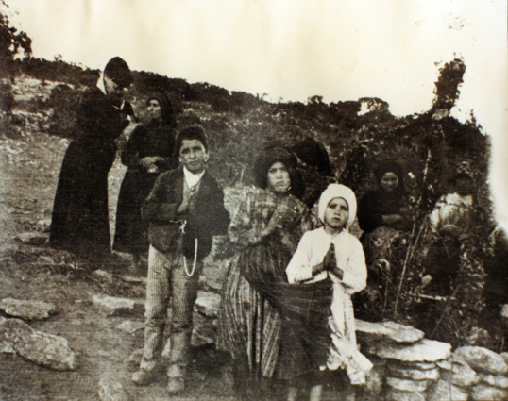
Fatima seers in 1917

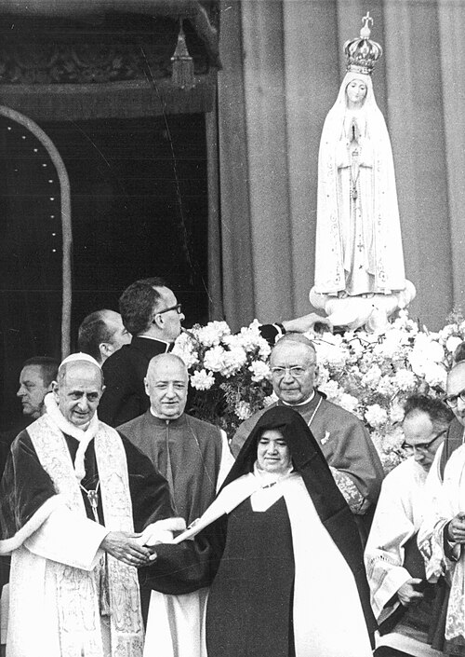
Pope Paul VI with seer Lucia dos Santos, May 13, 1967

16
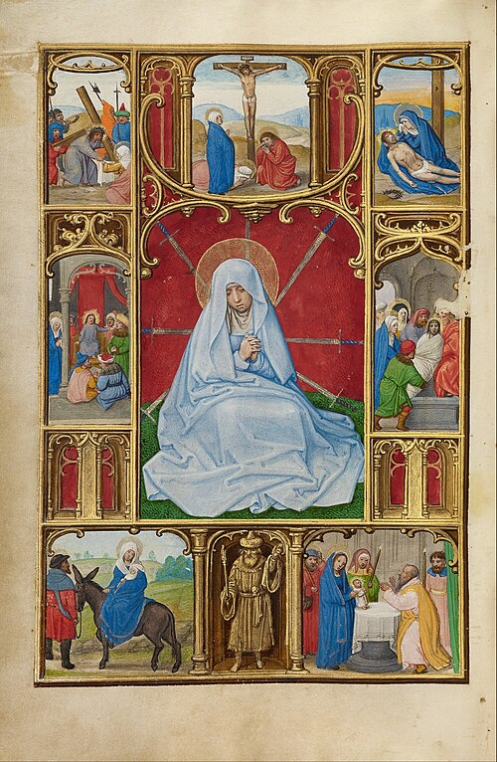
Simon Bening, The Seven Sorrows of the Virgin, c. 1500

Public domain images of Our Lady of Kibeho could not be found. Here is a link where some can be viewed: https://en.wikipedia.org/wiki/Our_Lady_of_Kibeho
Public domain images of Our Lady of Medjugorje are also not available. View here: https://en.wikipedia.org/wiki/Our_Lady_of_Medjugorje
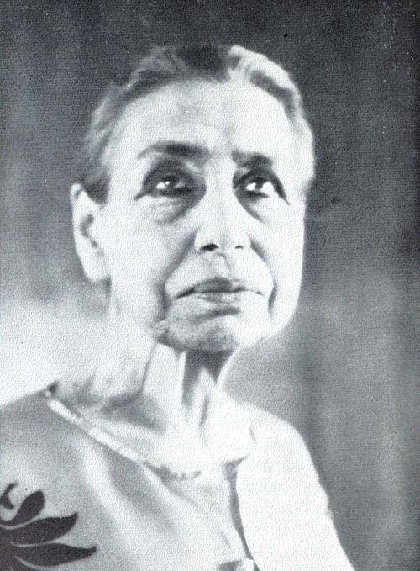
Henri Cartier-Bresson's photo of Mirra Alfassa, The Mother, in Pondicherry, India, April 24, 1950

17
Not Serving Two Masters
Stepping Out of the Money Paradigm by Choice

We’re back at the beginning of our list of twelve human necessities again, starting with fresh, clean air. Due to the current governing regime’s attitude toward the environment, our prospects for clean air are markedly diminished since last year at this time. Therefore, the actions required to access clean air for free are political. Community organizing, supporting local candidates who prioritize the environment, volunteering for grassroots organizations, these are the work that we all need to do in order to make fresher cleaner air available to all everywhere. On a micro level, trying to generate less personal trash, making sure trash makes it into appropriate receptacles, trying to lighten our own load of plastic and synthetic materials and fibers, working to retrain ourselves toward a less disposable approach. Toward that latter end, there are skills our grandparents possessed which can serve us well today. Learning to mend clothing, repair furnishings, darn socks, or even cut worn textiles into strips to be woven, crocheted, or knit into more useful items. These skills keep extra material out of the waste stream, which, since much of our trash is burned, positively affects our air quality. They also give us a sense of agency over other needs. Being able to transform trash into artistic creations that better meet our needs is a very empowering activity.

Maintaining personal hygiene to the best of our ability within our particular circumstances is another way to be mindful of the air we all share. Everyone perspires and everyone’s body smells when unwashed. Not only is it honoring to ourselves and the divinity that dwells within us to maintain good hygiene, it freshens everyone’s air. Personal care products can usually be obtained in local nonfood pantries. If a group of people have such a need, local organizations, faith-based or political, will surely be happy to help provide them. Some local groups give out hygiene bags along with snack bags to those without shelter.

It is important not to give up on caring for your body. If you are mentally able to remember its importance, there will certainly be community helpers willing to assist you in finding everything you need.

If you are sheltered, even in a group shelter, remember that even a tiny plant hanging out of your backpack can improve your immediate air quality. Plants utilize the carbon dioxide which we exhale and produce frsh oxygen for us to inhale. Being in a green environment is more than just aesthetically pleasing. Unless you live under a tree, find some trees to breathe among as often as possible. And sprout some seeds in a damp paper towel in a plastic bag in the pocket of your backpack. Carrying a tiny living plant with you will remind you of your need for self-care and also give you the opportunity to care for anpther living being. This action alone can improve your outlook on life!

Whenever you do venture into a lush green area, take some deep breaths. This will both lower your level of stress and revitalize you with more oxygen. When life gets emotionally difficult, paying attention to your breathing, trying to slow it down and deepen it, can help you navigate stressful situations. Breathing is a beautiful tool as well as a necessity. Accompanying your inhalation with a thought of what you want to become, and sending out with exhalation all that you wish to discard is a time-honored practice with surprisingly positive results.

18
We require air, but we often breathe without even thinking. We can lobby for a good quality of air and we can take many steps to improve our situation by becoming aware of the gift of our breath.

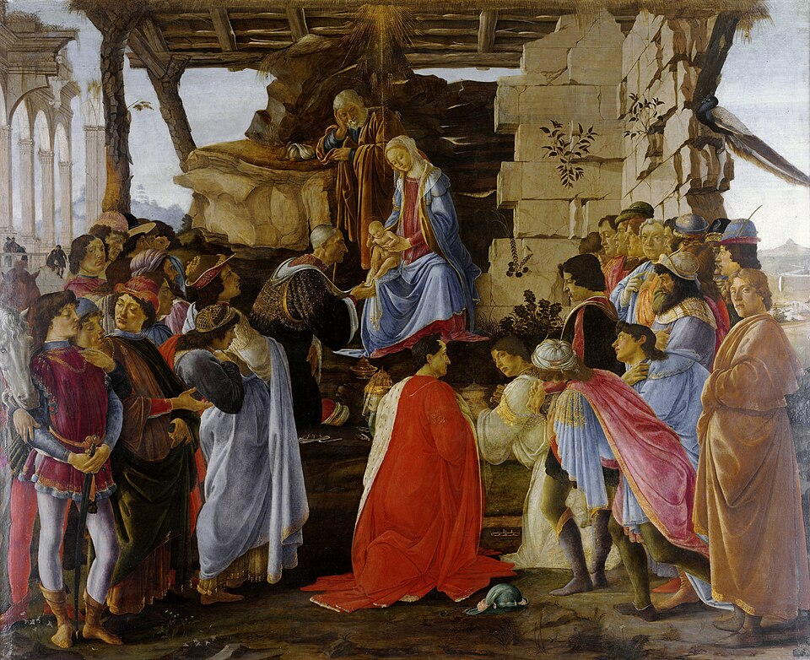
Sandro Botticelli, Adoration of the Magi, 1475
Note the plants breaking through the crumbling walls.

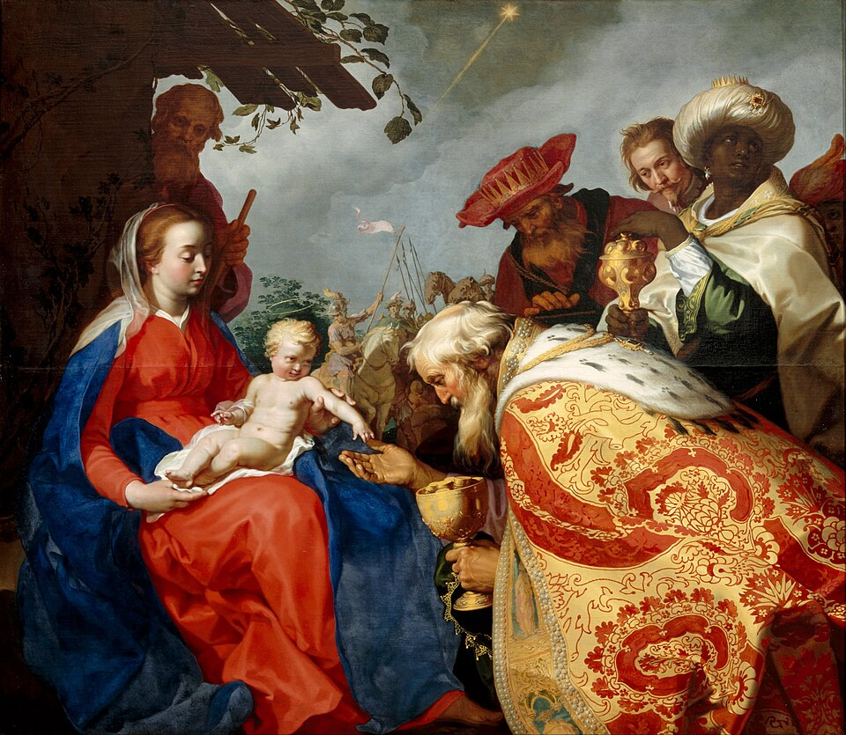
Abraham Bloemaert, Adoration of the Magi, 1624

Note plants along the roof of the shelter and the tree framing Jesus’ head.

19
Progress
“The way in which most people surrender:
Let God manifest his will but let it be the same as mine.”
The Mother, Words of the Mother – II, 15 April 1931
- Seminary work continues for LCCI/Mary’s Ward seminarian
- A second visit to Springfield to begin assembling personal property, assessing damage, and making future plans is scheduled
- God’s will concerning the house in Springfield is being earnestly sought with intense prayer and meditation by sādhaks (spiritual aspirants) in Boston and Gorham. The fact that multiple people are praying is itself a great blessing!
- educational applications using Sri Aurobindo’s Integral Paradigm of Knowledge are being discussed and pursued
- possibilities for collaboration with a local arts center in the rebooting of SPANDA Dance Company have been proposed
- first set of bookcases from reinforced corrugated cardboard in process
- Auromobiles in conception stage still
- work continues to make chapel/studio/classroom/hub in Gorham functional and welcoming
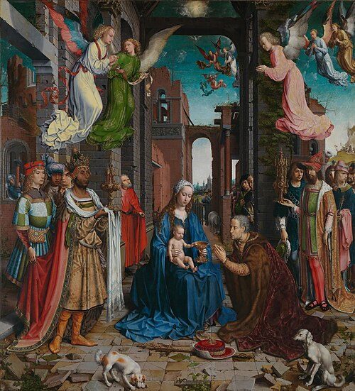

Jan Gossaert, Adoration, 1310-1515

20
kid-friendly!
Learning to Read with Goats
Chapter 13 A Jazzy Jingle about a Junior Goat

“A jonquil in a jar, Grandma?” Linh jostled the jar to try to jiggle the jonquil bulb and pebbles.

“The jonquil is joined to the pebbles by the jumble of roots that jut out from the bulb,” injected Farmer Lane.

“Looks like a jigsaw puzzle held together by the roots,” judged Linh.

“It bloomed back in January, when we put it in the jar with pebbles and watered it, here in the warmth of the house. Remember Linh?” joined in Hong. “Grandma, can we plant the bulb and leaves in the garden?”

“Yes, we can. I will gently untangle the jigsaw puzzle of pebbles and roots. Another option is to wait till the leaves die, then dry out the bulb and plant it in the fall.”

“Whatever you think is best, Grandma,” Linh adjured.

“Jonquils! Jonquils!” Uyen jogged in dragging a jump rope.

“In just a few days, we will start more garden seedlings indoors, including Job’s Tears, the plants that have seeds that are beads. We have made rosaries and jewelry with Job’s Tears before, girls.”

“Let’s have a jungle of Job’s Tears,” Linh projected.

“And Johnny Jump Ups,” added Hong in a jiffy.

“Jump Up! Jump Up!” Uyen started doing jumping jacks as Linh and Hong did a jig in celebration of their gardening objectives.

“This jolly jumping jamboree reminds me of a situation with the first little buckling I ever cared for,” Farmer Lane joined in.

“Which junior goat was that, Grandma?” said Linh, adjusting jig mode to inquiry.

“His name was Ireneusz. I was new to goat farming, and I thought I had to separate the buck from the does,” reflected Farmer Lane, without judging her own change in perspective.

“You don’t do that anymore, Grandma,” Hong observed quietly.

“Goats hate to be alone. They are herd animals. Being alone was like jail for him. I realize now that I jeopardized his development by isolating him. It was my mistake, but he grew up to be a jolly buck nonetheless.”

21
“Tell us about the jumping,” Uyen prodded, jump rope in hand.

“”Ireneusz was on a porch off the kitchen, so I could bottle feed him. Girls, there are so many things I would do differently now.”

“The jumping, Grandma,” Uyen insisted.

“The kitchen door had a window in it. When we were in the kitchen, Ireneusz would jump up to look in the window. I had to keep that door locked, otherwise his jumping would sometimes turn the doorknob, which would open the door, and in he’d come. As he grew stronger and taller, he would just stand on his hind legs and watch us through the window.”

“Grandma, may we jog down to the barn with you and see if any goats are jumping today?” Linh was still jolly from all the rejoicing over flower gardening.

“Jerseys, junky pants, and jackets, girls,” Farmer Lane enjoined.

Hong stayed behind and hugged Farmer Lane, sensing her grandmother’s jumble of emotions about lessons learned in her journey of discovery through goat farming.

“You let the goats teach you, Grandma. That’s just really special.”

Hong joined the others, all three soon joking and jesting as they jabbed each other with jerseys, junky pants, and jackets, till the job of getting dressed for the barn was complete. Then the jostling shifted to jockeying for position to hold Farmer Lane’s hand on the jaunt to the barn.

“Three jewels, two hands. Let’s all journey together, with joy, not jingle jangle jitters of jealousy.”

And off they went, jumping joyfully to join their jovial goat friends.

Goats greeted them by jumping up with front hooves on the top rail of the corral fence. The girls enjoyed their puppet-like comings and goings.

“All joking aside, girls, there have been times when I have utilized this jumping joy of the goats to inject medicine in their mouths or to trim front hooves.”

Farmer Lane joined the girls along the fence rail, scratching the goats on their cheeks and under their jaws, jiggling their beards in the process.

“Philemon was a big buck with very large horns. He hated to have his hooves clipped. Hooves are like finger nails; it doesn’t hurt to cut them, but there is skin nearby, and if you’re not careful, you can jab the skin and cause pain.”

“Fingernails and toenails are the same, Grandma,” Linh injected.

“I could easily trim Philemon’s back hooves by standing with my back to him and bending his knee

22
between my legs. But I was a bit jittery about working on his front hooves with my head so close to his big horns. If he got jangled nerves about it, one jerk of his head and I would be in trouble.”

“Did he like to jump, Grandma?” Hong anticipated the point of the story.

“He was the best jumper ever. So when he stood with front hooves on or over the top rail, I would distract him with some juicy plants or brush and clip away!”

“What about the medicine, Grandma?” Uyen never missed a detail.

“Another buck named James had a swollen jaw. He needed my garlic-fennel-oregano medicine. But every time I entered the barn with some, I was jammed with many goats wanting some. I do give it to all the goats, because it protects them from many problems, but James had an urgent need of a dose.”

“Did you give it to him on the fence rail, Grandma?” Hong anticipated again.

“I jolly well did! And it was very successful,” Farmer Lane answered jocularly.

“Johnny Jump Ups are flowers, but Jolly Jump Ups are goats!” joked Linh.

“I think I have a jazzy jingle about our juvenile jumper Ireneusz,” Hong jumped in.

“That makes you Johnny on the spot, Hong,” Linh was on a jovial roll.

“No more jibber jabber; let’s hear it, Hong,” Uyen insisted.

“Okay, here goes. /j/, /j/, /j/, /j/, jack-in-the-box, goat in the window of a door that locks.”

“Jazzy, indeed,” judged Farmer Lane.

“Jolly,” joined in Linh.

“Joyful and jovial,” agreed Hong.

“Juicy,” enjoyed Uyen, jiggling with laughter.

“Like Jack and Jill, lets go up the hill, girls,” Farmer Lane proposed.

“But no falling down,” worried Linh.

“And no broken crowns,” assured Hong.

“And definitely no tumbling after,” joked Uyen.

Instead, Farmer Lane and the girls journeyed safely up the hill, jumping and joking and reciting their jazzy jingle about a junior goat.

23
“/j/, /j/, /j/, /j/, jack-in-the-box, goat in the window of a door that locks.”

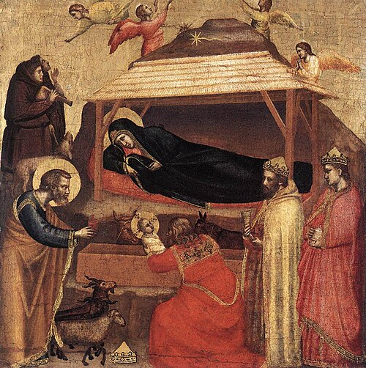
Giotto di Bondone, Adoration of the Magi, 1320-1325

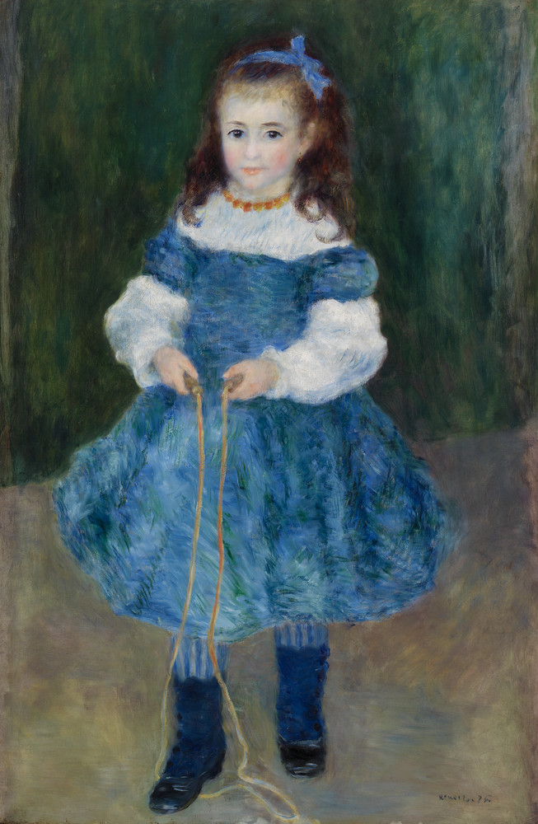
Pierre-Auguste Renoir, Girl with a Jump Rope (Portrait of Delphine Legrand), 1876

24
kid-friendly!
Justice in Action
DIY Free Projects for Independence at All Ages

Let’s make holy images and resistance symbols that are unique, original, creative, and free! We will need some materials, but they can usually be obtained from what we have or what someone wants to give away. Let’s pull together some paper scraps, a pen, flour and water paste, cardboard, fabric scraps, and needle and thread if you can manage it.

Now it’s time to dream up what images and symbols are meaningful for you. This is a very personal exercise. Different symbols and images mean different things at different ages and at different times in history. Whatever is meaningful for you, think about how you can create that design with the materials you have, either as a flat artwork on the stiff cardboard, or as a patch that can be sewn onto clothing.

A heart shape is a simple symbol to make. If you desire to cut a heart out of fabric, first make a paper pattern by taking a scrap of paper, folding it in half, and drawing half a heart along the fold. Cut (or tear, if you have no scissors) your heart with the paper still folded, the unfolded heart will be symmetric (both sides the same). You can trace the paper heart onto the cloth. If you have not scissors, simply fold the heart back until it is heart-shaped, using the traced heart as a guide. If you have needle and thread, you can sew the heart onto a piece of clothing. Or cut it out and then sew it on. Or, if you are making a cardboard-backed flat image, paste or sew the heart to the cardboard.

This is only a very simple example. Once you start thinking this way, you will be able to create many interesting patches or collages. Simple or complex, it will feel rewarding to create an image or symbolyou enjoy having as an expression of yourself. You will then find many ways to increase the complexity and beauty of new projects.

Some examples from my life will illustrate this point. It is important to me to wear something yellow as a sign of resistance to fascism. I wanted a yellow bracelet, but couldn’t find one I liked or could afford. Eventually AI was able to obtain some yellow beads and string them together. But before that happened, I fashioned a bracelet from scrap yellow felt rolled into a tube and joined at the ends. Before joining the ends, I embroidered the words “nonviolent resister” onto the felt by hand with plain thread. It was primitive, but meaningful for me.

Similarly, while the room that houses Solace of Migrants Mission, SPANDA Dance Company, Mary’s Ward Global Classroom, and Mother of Strength Sri Aurobindo Hub lacks large images of Jesus, Mary, Sri Aurobindo and The Mother, I have started four large sewing projects, taking images enlarged on the computer screen, tracing them as sketches, drawing a grid over them, then sewing 2” x 2” squares of off-white cloth to backing cloths, and sewing black felt lines to each square, following the grid sketches. Hopefully I will end up with four large cloth-mosaic portraits. It’s a slow process, but very meditative!

Brighten up your jeans, create a picture for your prayer time, or just play with materials and let art happen!

25
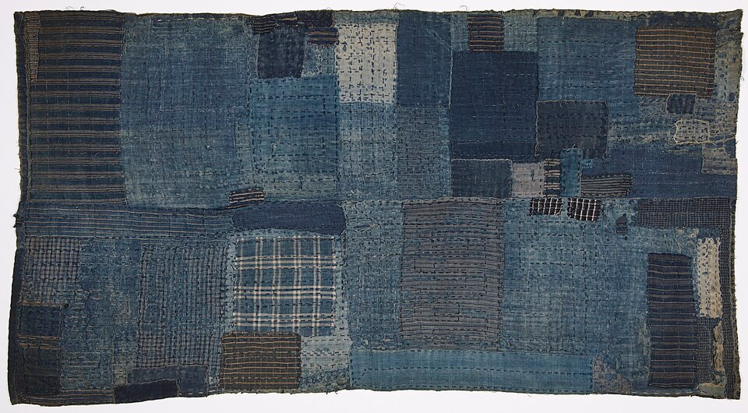
Child’s futon sleeping mat, 1800’s Japan
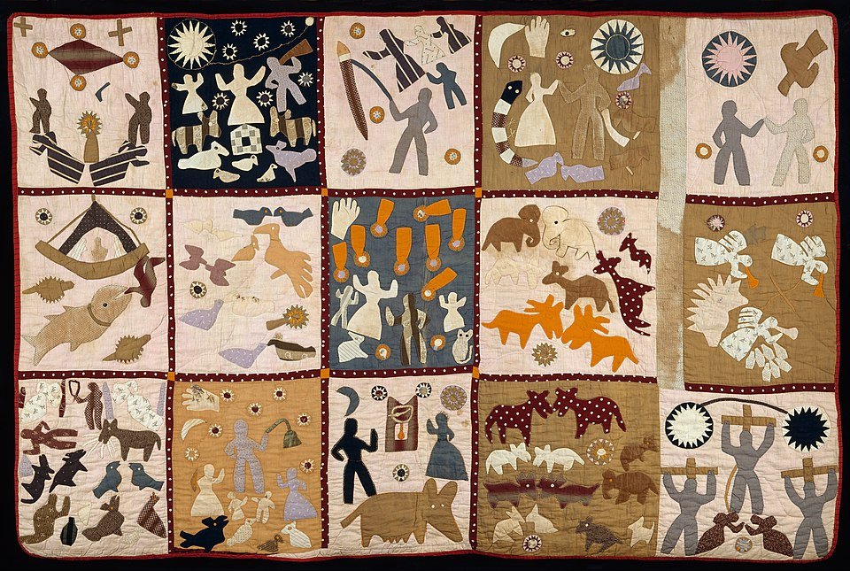
Pictorial quilt by Harriet Powers, c. 1895-1898

26
Mary’s Ward Global Classroom

- Sri Aurobindo’s Integral Paradigm of Knowledge is based on the development of the three pairs of faculties of consciousness, working in each pair from the subjective to the objective. Thus the first order of business in education is to develop thinking and seeing, speaking and hearing, feeling, and touch. These faculties eventually develop into the areas of study of psychology, philosophy, linguistics, history/sociology, art/culture/, and science. There is, of course, a lot more to it, but this is the basic framework. The implications are tremendous and there will be more development of this paradigm into practical application in the near future. Stay tuned!
- How to encourage learners to find their own svabhāva, soul nature? Everyone has inclinations towards certain pursuits. As is the case in unschooling, learners need to initiate learning by identifying their areas of interest, attraction, aptitude, and natural affiliation. These passions can unlock boundless curiosity which propels learning without need of prompting from others. Teachers become guides and facilitators. Learning becomes self-directed. Are mobile library, classrooms conducive to this kind of learning?
- Small, rural libraries in Maine have been in the news lately. State library authorities in Maine are grappling with how to administer many of the services libraries require when the libraries in need of services are volunteer-staffed with limited hours. This and the exciting concepts of Integral Paradigm of Knowledge as a new educational approach (not unlike, but more spiritually-based than others which have come before) has prompted thoughts of adding Auromobiles (micro, possibly human-powered, carts/cycles/wagons) stocked with very condensed materials to function as more “beads on a necklace” to serve multiple functions: Solace of Migrants Mission (sacraments, prayer, counseling, mutual aid), Mary’s Ward Global Classroom (micro libraries with sampling of materials to stimulate development of faculties of thinking, seeing, speaking, hearing, feeling, and touch in areas of psychology, philosophy, linguistics, history/sociology, art, and science – for all ages), Mother of Strength Sri Aurobindo Hub (sampling of writings of Sri Aurobindo and The Mother for reading circles, meditation, yoga, talks, art), SPANDA Dance Company (classes, workshops, performances) and more.
- Auromobiles can supplement, rather than replace, these activities at permanent locations. The goal is to have actual micro locations as “beads on a necklace”, but in the mean time, and forever as extensions of these micro locations, Auromobiles can bring the services to local communities.

- Imagine the human-drawn wagon/rickshaws colorfully decorated as they are in India and Bangladesh. This type of cheerful conveyance would attract much more smiling attention than the ice cream trucks in summer. Spread hope, peace, joy, and love, not just during Advent, but all year long! We need the color, the energy, the culture, the vibrancy, the optimism, the solidarity!

Nature Scene in Rangoli during a Vijayadashami festival, in Maharashtra, India

27
How You Can Help
- In the face of trauma, outrage, and sorrow, radiate kindness, cheerfulness, optimism. It’s not easy. But it is resistance to fascism. Authoritarians use fear and intimidation to overwhelm and produce submission. By not being overwhelmed, we resist.
- This does not mean pretending terrible atrocities are not being committed. It does not mean stopping resistance in other ways such as protest, boycott, noncooperation, disruption, and mutual aid and solidarity for those most targeted and marginalized.
- But joy is an act of defiance against oppression.
- We express joy in diverse ways, unique to our personalities. Bright colors, lightheartedness, smiling, humor, generosity, art, culture, celebrating perpetual spring in the middle of winter, music, dance, drama, good food, encouragement, gratitude, playfulness, supply your own flavor!
- Our situation in the United States is serious, scary, grim, and triggering. We respond with “tactical frivolity”. It’s a strategy, but also a survival skill.
- “Blessed are ye when they shall revile you, and persecute you, and speak all that is evil against you, untruly, for my sake: Be glad and rejoice, for your reward is very great in heaven. For so they persecuted the prophets that were before you.” Matthew 5:11-12. Maybe the rejoicing is not merely to be associated with former prophets, but maybe the rejoicing is the prophetic tactic itself.

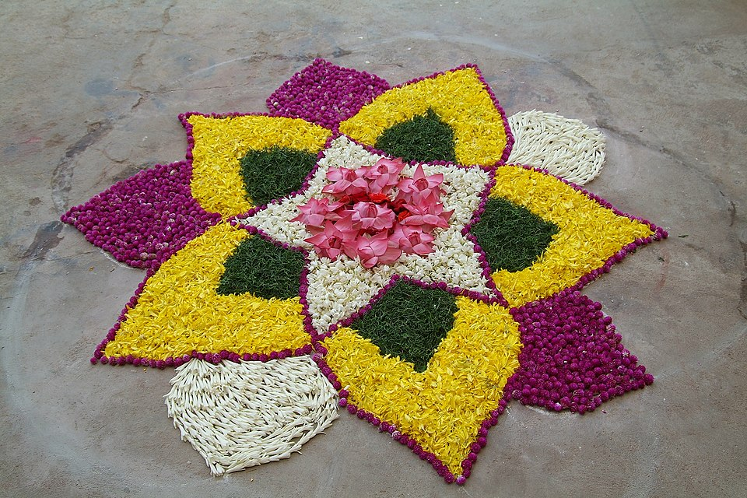
Rangoli with flowers at Chennai, India

28

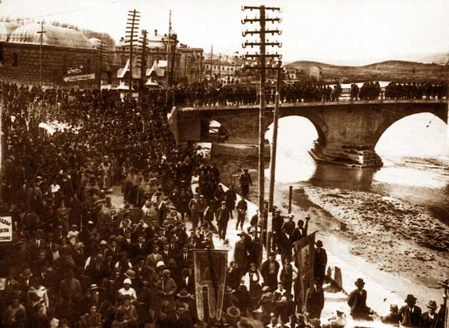
Epiphany procession in the capital of North Macedonia Skopje near Stone Bridge on the Vardar river in the early 1920s
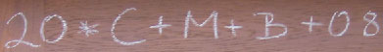

Traditional house blessing in chalk, written by Sternsinger on the door beam of the home
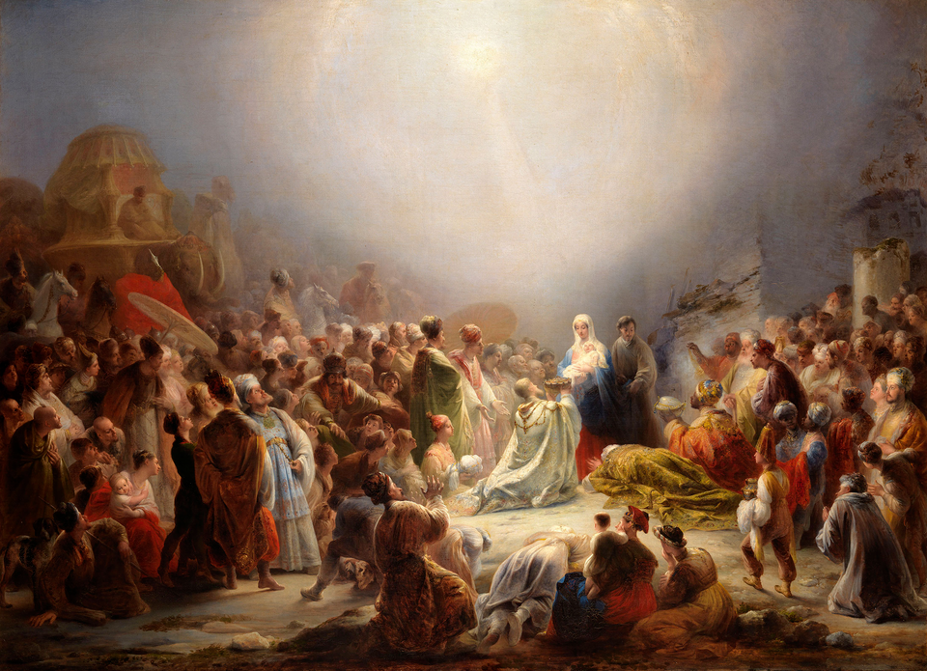

Domingos Sequeira, Adoration of the Magi, 1828
marysward.com

