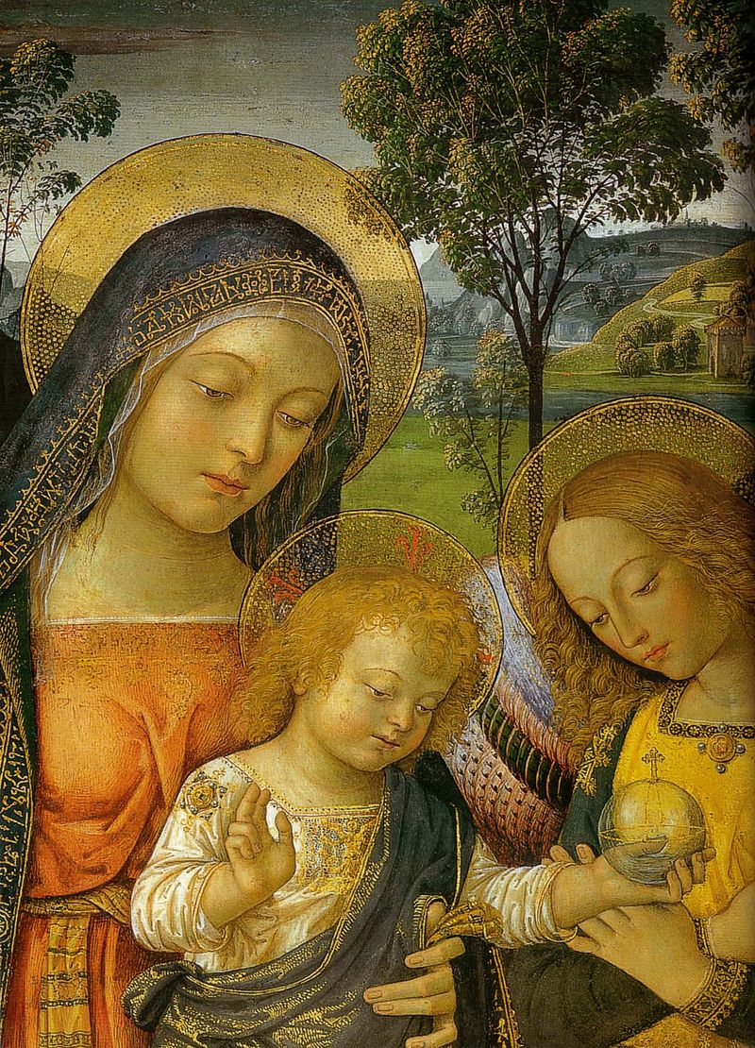
Ascend – The Monthly Publication of Mary’s Ward – July 2025 – Vol.1 No.7

From the Editor

There is a saying in Maine, that we have two seasons, Winter and Fourth of July. Short though summer may be in northern New England, it is spectacularly beautiful, hence the Maine State motto Vacationland. But this summer, with climate change, disappearing of our neighbors, US troops on US streets to “keep the peace” – targeting, rather than protecting, peaceful protesters, armored vehicles and tanks in US streets and high-five-ing bounty-hunting masked strong men supposedly representing ICE penetrating every nook and cranny of our neighborhoods, with the disrespecting and silencing of a sitting US Senator, and with irresponsible provocative military actions of this administration on the global scene, this looms as a “long hot summer”.

Peace is the overarching theme of this issue. Peace in our hearts, peace in our homes, peace on our streets, in our neighborhoods, in our government, in the world.

Not in So Many Words presents Matthew 7 in synopsis and bindu-point commentary form. GOD as Peace is the intent of the Fifth Sunday after Trinity, the occasion for the homily on peace which follows. Veda in Christianity fulfills the promise made last month to examine the events of Christ’s life as stages of Integral Yoga.

Blueprint for Marian Maternal Life examines The Mother’s words on peace and the role of Our Lady Queen of Peace. The human necessity of healthcare is addressed in this month’s Not Serving Two Masters. Movement toward attaining Mary’s Ward goals is reported in Progress.

A Teensy Tip about Goat Teeth is Chapter 7 of our kid-friendly serialized Learning to Read with Goats. Justice in Action, our kid-friendly DIY project for all ages, for this month is creating prayer gear (beads, journal, shawl, mat, mandala, etc.) so you can pray for peace! The Mary’s Ward Global Classroom update discusses teaching peace.

How You Can Help features tips on preparing to serve in times of crisis.

“Peace I leave with you; my peace I give you. I do not give to you as the world gives. Do not let your hearts be troubled and do not be afraid.” John 14:27

ॐ शान्तिः शान्तिः शान्तिः । OM śāntiḥ, śāntiḥ, śāntiḥ. Om, peace, peace, peace.

Selby Beebe-Lawson, Editor
July 1, 2025

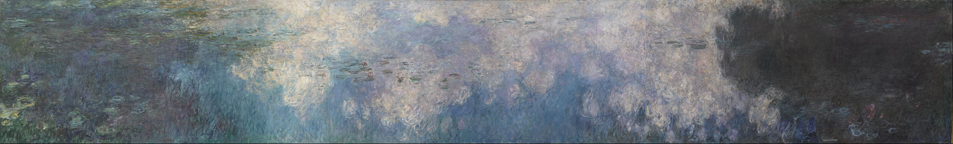
Claude Monet, The Water Lilies – The Clouds, 1920-1926

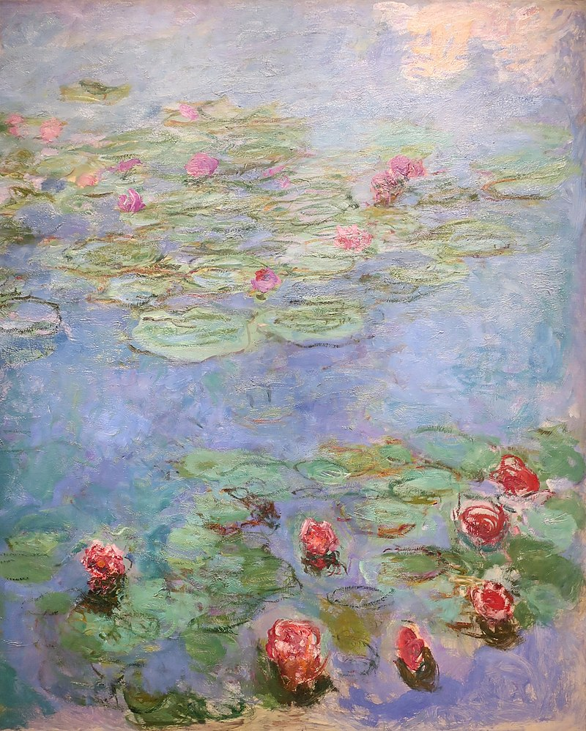
Claude Monet, Water Lilies, 1914-1917

Table of Contents

Light

Not in So Many Words 1

Homily 2

Veda in Christianity 5

Love

Blueprint for Marian Maternal Life 8

Not Serving Two Masters 10

Progress 11

Life

LTR with Goats 12

Justice in Action 16

MW Global Classroom Update 18

How You Can Help 19

Pinturicchio, Madonna of Peace, c.1490

July birth flowers are larkspur (delphinium) and water lily.

Larkspur is associated with Mary’s tears and water lily with her purity.

The Mother named larkspur Soaring and water lily Wealth.
Not in So Many Words

Matthew 7

Synopsis

Don’t judge, so that you will not be judged. Correct your own faults. Only then can you help someone else. Sacred knowledge is not to be shared with those who aren’t ready. Ask for it, and it will be given to you. Treat others as you wish to be treated. The path is difficult; most don’t find and take it. Beware of false teachers, they are wolves in sheep’s clothing. By their fruits you will know them. Not all who claim to be followers are actually part of God’s kingdom. Only those who Jesus “knew”, those who applied his teachings, will enter. Listeners distinguished between Jesus, who taught as “one having power”, and the religious authorities.

Commentary

- Don’t judge others
- Perfect yourself
- Seek spiritual knowledge
- Apply spiritual knowledge
- Jesus will know us as we know others - by our fruits
- Living the teachings = entering (building) the Kingdom of Heaven
- Using Jesus’ name and knowing the teachings is not enough
- “Ask and it shall be given to you” refers to spiritual knowledge, not material wealth
- Always, always, always treat others as you wish to be treated
- True spiritual knowledge is precious, rare, difficult to attain, but available to seekers
- Watch out for false teachers: look at their fruits
- You can discern true spiritual teachers by their power
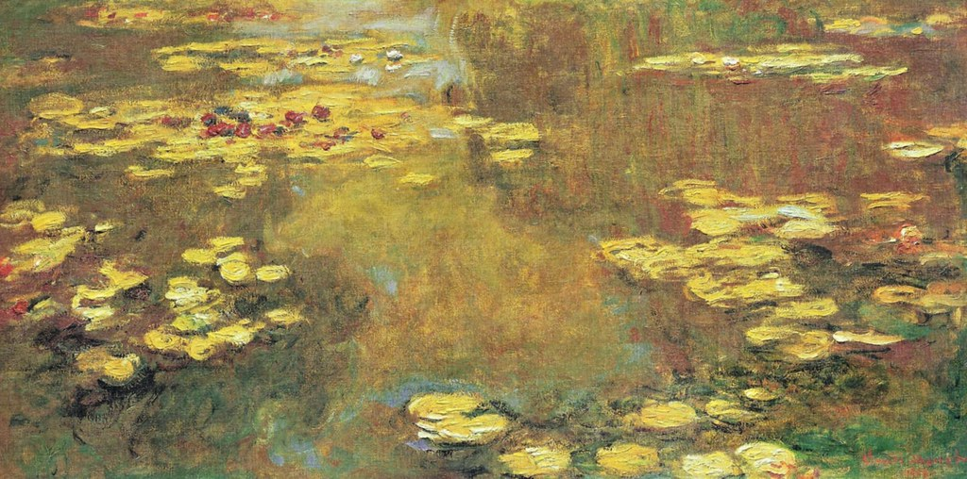
Claude Monet, from Water Lilies series
1
Homily
Fifth Sunday After Trinity
Intent: GOD as Peace

The Collect

GRANT, O Lord, that the course of this world may soon be so peaceably ordered by Thy governance that Thy Church may joyfully serve Thee in all godly quietness; through Christ our Lord, who liveth and reigneth with Thee and the Holy Ghost, ever one God throughout all ages of ages. R/. Amen.

The First Lesson

The First Lesson is taken from the fifth chapter of the Epistle of St. Paul the Apostle to the Galatians, beginning at the thirteenth verse.

BRETHREN (Siblings), ye have been called unto liberty; only, use not liberty to an occasion to the flesh, but by love serve one another. For all the law is fulfilled in one word, even in this: Thou shalt love thy neighbor as thyself. This I say then: Walk in the Spirit, and ye shall not fulfill the lust of the flesh. For the flesh lusteth against the Spirit, and the Spirit against the flesh; and these are contrary the one to the other, so that ye cannot do the things that ye would. The fruit of the spirit is love, joy, peace, long-suffering, gentleness, goodness, faith, meekness, temperance; against such there is no law. If we live in the Spirit, let us also walk in the Spirit.

Here endeth the Lesson.

The Second Lesson

The Second Lesson is taken from the fourteenth chapter of the Gospel according to St. John, beginning at the eighteenth verse.

JESUS said: I will not leave you comfortless; I will come to you. Because I live, ye shall live also. At that day ye shall know that I am in My Father, and ye in Me, and I in you. He (One) that hath My commandments and keepeth them, he (that one) it is that loveth Me; and he (one) that loveth Me shall be loved of My Father, and I will love him (them), and will manifest Myself to him (them). If a man (person) love Me, he (they) will keep My words; and My Father will love him (them), and We will come unto him (them), and make Our abode with him (them). He (One) that keepth not My sayings loveth Me not. Peace I leave with you, My peace I give unto you; not as the world giveth, give I unto you. Let not your heart be troubled, neither let it be afraid.

Here endeth the Lesson.

In the name of the Father, and of the Son, and of the Holy Spirit. Amen.

Today is the Fifth Sunday after Trinity, whose intent is GOD as Peace.

2
In my Tuesday night reading group we recently read this sentence in Sri Aurobindo’s The Ideal of Human Unity, a book which was serialized in Arya magazine between 1915 and 1918, “Human society progresses really and vitally in proportion as law becomes the child of freedom; it will reach its perfection when, man having learned to know and become spiritually one with his fellow-man, the spontaneous law of his society exists only as the outward mould of his self-governed inner liberty.” It seems that St. Paul was saying the same thing in today’s First Lesson: “ye have been called unto liberty; only, use not liberty to an occasion to the flesh, but by love serve one another. For all the law is fulfilled in one word, even in this: Thou shalt love thy neighbor as thyself.”

Today’s intent is GOD as Peace. Anyone familiar with Vedic chanting knows that every recitation ends with “OM, śāntiḥ, śāntiḥ, śāntiḥ.” OM is the primordial sound vibration, encompassing everything that is, perhaps an ancestor of our amen. Śāntiḥ, from the Sanskrit root śam, to calm, means peace. As I begin writing this homily on June 21, I am interrupted with news that Trump has authorized strikes on three nuclear plants in Iran. I am aghast. The stupidity, the disregard for the environment, the political harm of this move. GOD is peace. The bombs project a different authority.

I have been watching mass mobilization calls from many organizations protesting the Trump administration. I watched hours of footage from many No Kings demonstrations from June 14. Trump had a military parade on that day. What happens when tanks and armored vehicles are your toys? You play with them, of course. On the streets of America and in hot spots globally, Trump is playing with his toys and with our lives. At one of the No Kings demonstrations, I saw a woman handing out real flowers, “peace flowers” she called them. Who knew that flowers would become radical symbols of peace as they were in the 60’s when the slogan was “flower power”. Actually, flowers have always symbolized peace. In WW1 it was poppies; in the Vietnam era it was daffodils. I have a potted plant in my room called a peace lily.

Śāntiḥ is from the Sanskrit root śam, to calm. As a teacher of special needs children, and a member of a family with neurodivergence, knowing how to calm myself and others is essential. “Peace I leave with you, My peace I give unto you; not as the world giveth, give I unto you. Let not your heart be troubled, neither let it be afraid.” We all need to calm down. Not because there is no reason to be afraid. There are plenty of very valid reasons to fear. But because GOD’s peace has been given to us. We own it. In my study of Sanskrit grammar, I have learned that the imperative case is translated either as “this must happen” or “let this happen”; “she must give the homily today,” or “let her give the homily today.” So when the LORD says “Let not your heart be troubled, neither let it be afraid,” we are justified in saying “Our hearts must not be troubled; they must neither be afraid.” They must not, imperative, a command, just like love one another or love your neighbor as yourself. These are not suggestions. They are imperatives! Your heart must not be troubled. It must not be afraid. Serve one another. Love your neighbor as yourself. These are our weapons of mass construction. These are our shows of strength: our peace, our love, our compassion, our fruit of the Spirit, the result of the fertilization of the flowers of peace. “The fruit of the spirit is love, joy, peace, long-suffering, gentleness, goodness, faith, meekness, temperance; against such there is no law. If we live in the Spirit, let us also walk in the Spirit.” Let us – we must – walk in the Spirit, with our flowers of peace and fruit of the Spirit, along the highways and byways of our nation, protest signs in hand, until, as the Collect implores, “the course of this world may soon be so peaceably ordered by Thy governance that Thy Church may joyfully serve Thee in all godly quietness.” Until then, let us – we must – make some loud, good trouble.

In the name of the Father, and of the Son, and of the Holy Spirit. Amen.
3

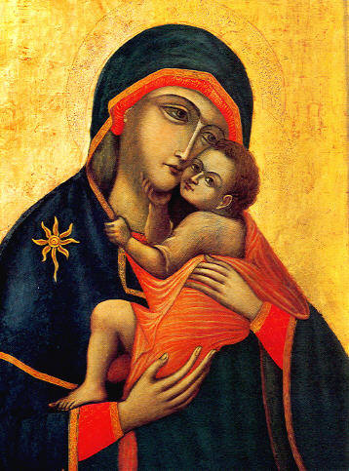
Miraculous painting of Our Lady of Mount Carmel (feast July 16), purportedly painted by St. Luke

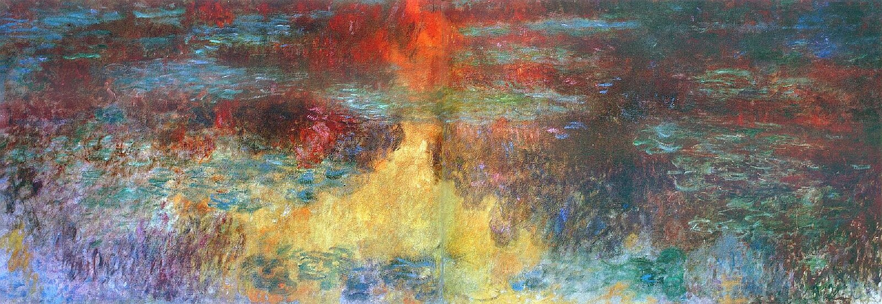
Claude Monet, Le Bassin aux nymphéas, le soir, 1926

4
Veda in Christianity

स त्वम् अग्ने सौभगत्वस्य विद्वान् अस्माकम् आयुः प्र तिरेह देव |
तन् नो मित्रो वरुणो मामहन्ताम् अदितिः सिन्धुः पृथिवी उत द्यौः || RV 01.094.16
sa tvam agne saubhagatvasya vidvān asmākam āyuḥ pra tireha deva |
tan no mitro varuṇo māmahantām aditiḥ sindhuḥ pṛthivī uta dyauḥ || RV 01.094.16
Thou art the knower of felicity and the increaser here of our life and advancer of our being! Thou art the godhead! (16HTMF 145) Sri Aurobindo’s Interpretation

“Be a power of God in humanity. … This is the transfiguration of thyself on the mountain. It is to discover God in thyself and reveal him to thyself in all things. Live in his being, shine with his light, act with his power, rejoice with his bliss. Be that Fire and that Sun and that Ocean. Be that joy and that greatness and that beauty.” Sri Aurobindo, The Hour of God, The Divine Superman, 11.

“Until we all meet into the unity of faith, and of the knowledge of the Son of God, unto a perfect man, unto the measure of the age of the fulness of Christ;” Ephesians 4:13

Let us consider the major events of Christ’s life as retold in the Bible. For each event, let us rename the action in different words and frameworks. In so doing, we may be able to see both the Veda and the Integral Yoga in the outline of Christ’s life. Except where noted, all quotes from the Ṛgveda are from Sri Aurobindo’s interpreatation as found in Hymns to the Mystic Fire.

- Annunciation – God’s messenger announces the incarnation to Mary and she assents.
The Divine instructs the Universal Mother to send Love to redeem the fallen emanations.
Agni calls the gods (powers of God), which descend to enlighten and strengthen humans.

- Visitation – Mary greets Elizabeth, unborn Jesus and John react and Holy Spirit fills all.
Recognition of the Psychic Being within begins the journey to higher levels of consciousness.
The Dawn comes, kindles Agni, brings Surya, awakens seekers.

- Nativity – No room in the inn. Shepherds are alerted by angels and attend humble birth.
The humility of God makes humility the first of The Mother’s attributes for Her work.
When Agni approaches, creatures stir; the path to “thy kingdom” becomes clear (RV 1.94.11).

- Presentation – Jesus is dedicated to God; Jewish mystics recognize him as Christ.
The Psychic Being is acknowledged in the seeker.
“ … O youngest Power, come at our word for him who aspires to thee …” (RV 2.6.6).

- Epiphany – Magi from the East follow a star; find, worship, gift Christ, return changed.
The seeker endeavors to find and follow the Psychic Being.
“In the gated house of mortals the immortal sat as King … ” (RV 3.1.18).

- Finding in the Temple – Discourse with the Doctors – Twelve-year-old Jesus’ wisdom stuns.
The seeker strives to bring the Psychic Being to the front to lead all movements.
“ … man’s Priest of the call, seated within him, the vicar set in his front; … ” (RV 3.3.2)

5
- Baptism of Our Lord – John the Baptist recognizes, baptizes, and sees Spirit descend on Jesus.
Triple transformation of Integral Yoga: psychic, spiritual, supramental.
“ … the knower of the sun-world: born, thou hast filled the world and earth and heaven,” (RV 3.3.10)

- Wedding Feast at Cana – Jesus’ first miracle at Mary’s behest; avatar and mother collaborate.
Double Avatars function as collaborators; Sri Aurobindo puts The Mother in front.
“May night and dawn differently formed… be joined close and smile upon us … ” (RV 3.4.6).

- Preaching of the Kingdom – Jesus teaches God’s kingdom within, within reach, in earthly life.
Escape from earthly existence is not the goal: ascend to Supermind, then divinize the earth.
“ … he shines out wide … and has entered earth and heaven as if they were one.” (RV 3.7.4)

- Transfiguration – on the mountaintop Elijah and Moses appear with Jesus, who shines.
Before the Supermind is attained, there are glimpses and Overmind experiences.
“ … thou standest as the sun above the peoples shining wide upon men.” (RV 3.14.4).

- Institution of the Eucharist – Jesus updates Passover symbols as spiritual sacrifice.
Remember and offer under gird the Sunlit Path.
“ … in the pilgrim-sacrifice … taste all That here, O immortal Fire.” (RV 3.14.7)

- Agony in the Garden – Jesus accepts the Father’s will, despite fear. Followers sleep.
Courage, an attribute of The Mother, is needed to walk the path and surrender.
“ … deliver us not to unconsciousness, nor to the lack of the strength of the hero,” (RV 3.16.5)

- Scourging at the Pillar – Jesus is brutally flogged almost to the point of death.
Equality of the Witness is a tool on the path. Only Divine Love can turn suffering back to Bliss.
“Burn away from us the sin, flame out on us the bliss.” (RV 1.97.1).

- Crowning with Thorns – Soldiers crown Jesus with thorns to mock his kingship.
Truth looks like falsehood until Divine Love becomes involved.
“ … the Male with hair of flaming-light whom may these peoples cherish …” (RV 1.127.2).

- Carrying of the Cross – Jesus bears his cross and meets many on his way.
Progress is both individual and collective in Their Integral Yoga.
“ … go with unerring steps towards the plenitude;” (RV 3.29.9)

- Crucifixion – Jesus is nailed to and dies upon the cross. Mary is there throughout.
Aspiration and rejection are followed by surrender, yielding to Divine Will.
“To thee … we … come, carrying by our thought the obeisance.” (RV 1.1.7)

- Resurrection – Jesus emerges from the tomb alive and stays for forty days.
Divine Love transforms death back into Life.
“ … the divine Sun is rising up with its light.” (RV 4.13.1)

- Ascension – Jesus ascends through the clouds into heaven, his origin.
First half of Integral Yoga sādhanā: ascension through levels of consciousness to Supermind.
“ … the work half done … ” (RV 1.115.4)[1].
6
- Descent of the Holy Spirit – Jesus sends the Spirit to remain with humanity and guide it.
Following aspiration, answering grace. Ascent and descent are simultaneous movements.
“The swife messenger of the illumining Sun who comes to all the seeing people;” (RV 4.7.4).

- Assumption of Mary – Mary is assumed into heaven, body and soul.
Sri Aurobindo was able to realize aspects of the yoga only after the coming of The Mother.
“ … O Master of the Word … closely thou companionest the Goddess … ” (RV 2.1.3).

- Coronation of Mary as Queen of Heaven and Earth – Mary reigns with Jesus.
The Mother is the Avatar. Sri Aurobindo is the Avatar. Perfect collaboration. Dual perfection.
“I crown the two supreme Priests of the invocation. … ” (RV 3.7.8)

The over arching theme of Christianity, Integral Yoga, and the Veda is the collaboration of the Son-Sun-Supreme-Avatar with the Mother-Dawn-Divine-Avatar to effectuate the speed up of slow evolution by the raising of humanity to higher and higher levels of consciousness until Supermind-Christ Consciousness is attained with the simultaneous drawing down of the Spirit to divinize the New Creation. As Sri Aurobindo has called it many times, Christ’s Kingdom of Heaven on earth.
This discussion will continue in greater depth next month.

Notes

1. RV 1.115.04 Interpretation: And that is indeed his Divinity and that is his Greatness: the work half done, which was widely spread out, he has taken now fully. When He has yoked his horses to work from their [unyoked] common places, then the Night spreads out her garments onto him!” Dr. Vladimir Yatsenko, Hymns to Surya-Savitri, 75

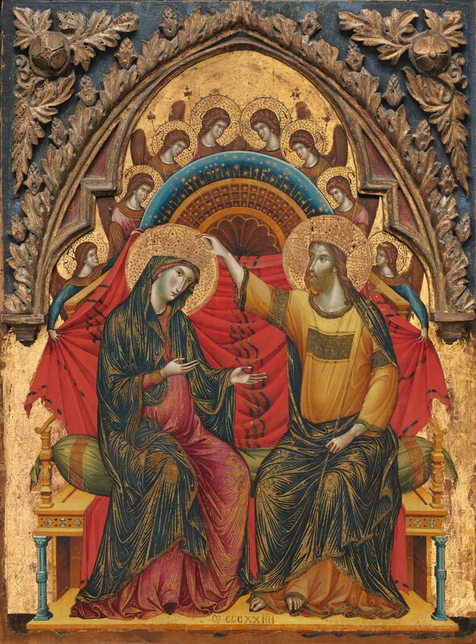
Master of the Washington Coronation,
The Coronation of the Virgin, 1324

7
Blueprint for Marian Maternal Life
“Our Lady, Queen of Peace, pray for us.” Catholic reference to Our Lady of Medjugorje.
"Peace, peace, peace, peace, peace, calm, peace!" The Mother, Questions and Answers 1954, 8 September, 1954 (Interestingly, the birth anniversary of Mary.)
In the above quote of The Mother, she is describing the process of calling peace with a quiet mind. It is a very appropriate mantra for today. Our Lady of Medjugorje, known as Queen of Peace, whose apparitions began in Bosnia-Herzegovina in 1981 have been the center of massive controversy ever since that time. The word MIR (Croatian for peace) was seen by many on August 6, 1981 in burning letters in the sky over the cross on Mt. Krizevac. How interesting that M-I-R are the first three letters also of Mirra (Mirra Alfassa is The Mother). Devotee of Sri Aurobindo and The Mother Martin Sobieroj wrote a fascinating blog in 2013 entitled “The Mother and the Virgin of Medjugorje”, in which he detailed not only the harmony of the messages from Medjugorje with the teachings of The Mother, but also enumerated Mother’s associations with reforming Christians over the years and her attitudes towards Christianity. This will be the exciting subject of next month’s Blueprint. For now, we continue looking at the subject of peace.
Jesus, known as the Prince of Peace, is yet quoted as saying, “Do not think that I have come to bring peace to the earth. I have not come to bring peace, but a sword. For I have come to set a man against his father, and a daughter against her mother, and a daughter-in-law against her mother-in-law. And a person's enemies will be those of his own household.” Matthew 10:34-36. This quixotic quote can perhaps be better understood in the light of two comments on peace by The Mother. “We have come not for Peace but for Victory, because in a world governed by the hostile forces Victory must come before Peace.” The Mother, Words of the Mother – I: India. And the following: “Two things you must never forget: Sri Aurobindo's compassion and the Mother's love, and it is with these two things that you will go on fighting steadily, patiently, until the enemies are definitively routed and the Victory is won for ever. Courage outside, peace inside and a quiet unshakable trust in the Divine's Grace.” The Mother, Words of the Mother – III: Victory.
So there is a battle because the world is governed by hostile forces. Hostile to what? To change, transformation, evolution, spiritual progress, and peace. And how do we assist in this battle? The Mother says that it is with Sri Aurobindo’s compassion (Jesus’ mercy) and The Mother’s love (Mary’s love) that we will go on fighting “steadily, patiently, until the enemies are definitively routed and the Victory is won for ever.” Nothing could be clearer, and yet she clarifies: “Courage outside, peace inside and a quiet unshakable trust in the Divine's Grace.” So our strategy is steady, patient compassion and love and our armor is courage outside, peace inside and quiet unshakable trust in Divine Grace. There’s nothing like clear instructions!
Let us all take up this battle individually and collectively. Let us exercise compassion and love exclusively, with courage, peace, and unshakable trust in Divine Grace.
Ave Maria! Hail Mary! जै मा । Jai Maa ! Victory to the Mother!
8
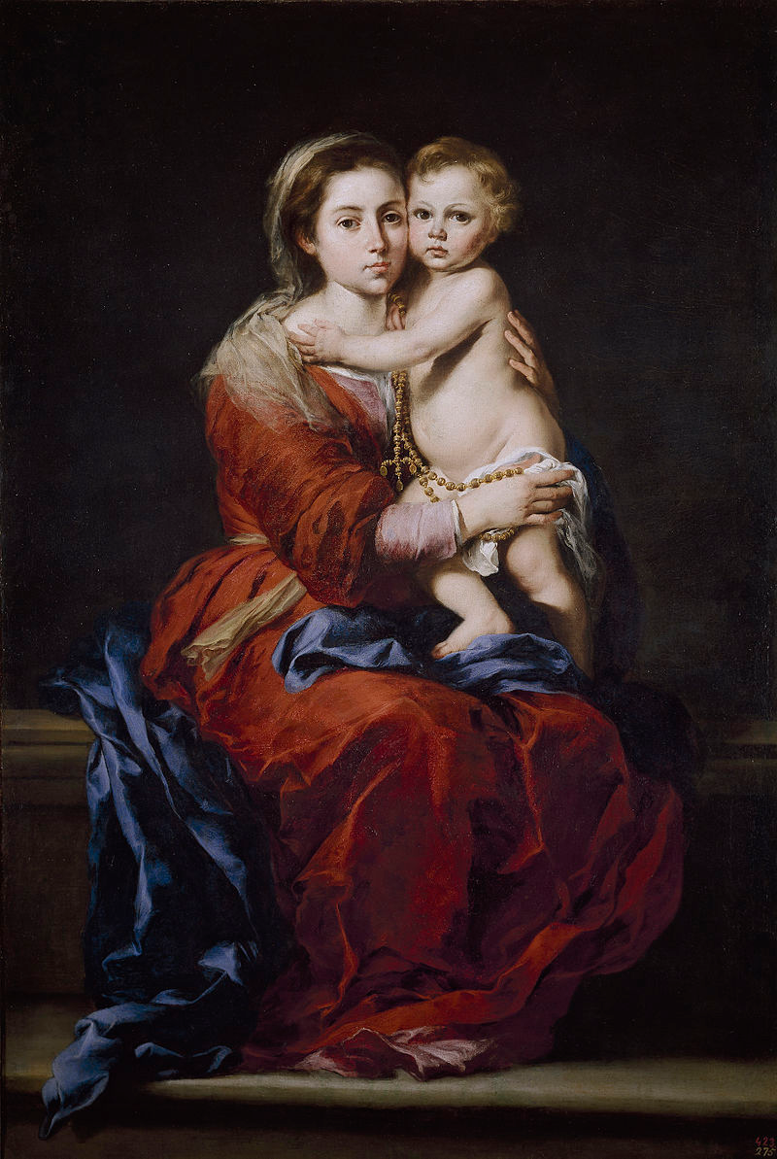
Bartolomé Esteban Murillo,
Our Lady of the Rosary, c. 1650-1655

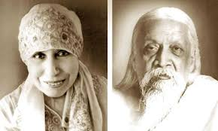
Sri Aurobindo and The Mother
9
Not Serving Two Masters
Stepping Out of the Money Paradigm by Choice

Is healthcare a luxury or a human necessity? As it appears on the list of twelve human essentials, which gave birth to this series of articles, the answer is the latter. Why do so many people lack this expression of compassion in their lives? The simple answer is greed.

So, while we advocate for systemic change that would allow basic healthcare for all as a human right, what can we do to provide self-care for ourselves and our loved ones? Three achievable actions come to mind: eliminate, as much as is in our control, factors detrimental to our health and well-being; practice those good habits which help promote health; learn to listen to our body-mind-spirit.

Eliminating smoking, drinking alcohol, overuse of caffeine, direct sunlight, processed foods, artificial colors and sweeteners, too much sugar, hydrogenated fat, negative emotions and attitude, despair.

Enbrace whole foods, fresh fruits and vegetables, plenty of water, fresh air, shade, adequate sleep, moderate exercise, positive outlook and hope. Smile!

Pay attention to what foods, situations, habits make you healthier and which do not. Every person is individual, thus no regimen or program can be a one-size-fits-all. You know yourself better than the professionals do. But do watch out for trying to justify your bad habits in the name of individuality. No, God probably isn’t asking your to eat only jelly donuts and drink energy drinks. Listen to the good advice of the professionals, but also learn to listen to your deepest truth.

Ayurveda, from the Sanskrit for knowledge or science of life, is an ancient healthcare system. There are professional is ayurveda, who can help guide you, but there is also a certain basic understanding which you can acquire on your own. Body types, foods, seasons, times of day, activities, and general qualities are divided into three types or doshas. There are questionnaires you can use to get a sense of your doshas. Most people have one dominant primary and a secondary dosha, although all are present to some extent. Some people have two primary doshas, and a few have three equally prominent. There are lists of foods recommended for each dosha, but it is also possible to choose a diet of tridoshic foods, ones which do not aggravate any type of body. Specific information is widely available online or at the library. Ayurveda also recommended certain good habits that promote health. This kind of knowledge can serve as your shield until healthcare is universally recognized as a human right.


Tiven Gonzalves, photograph of Vailankanni Basilica (Our Lady of Good Health, Vailankanni, India), 2017

10
Progress

“Pray for me for peace; peace in my heart, peace of mind and of soul, peace in my family, peace with all whom I meet, the peace of Jesus.” A portion of Mary’s Peace Prayer

“You must learn to be calm and quiet even in the midst of difficulties. This is the way to overcome all obstacles.” The Mother, Words of the Mother – II – Peace and Silence

- Seminary studies have begun for Mary’s Ward’s seminarian.
- The garden is finally planted. Soil has been made, seeds have been sprouted. Rain and sun now greatly appreciated.
- Obstacles to travel to all Mary’s Ward locations are being addressed.
- With an eye to current events, safety in all contingencies is being examined and preparatory actions, where needed, are being taken.
- Realities of life in this moment are persuasive that the Little Free Library/Pantry is not workable at this time as an outdoor kiosk. Alternative ways to address needs of the vulnerable are being considered. The Little Free Library/Pantry will be stationed indoors for now.
- LCCI Bishop of New England will visit Solace of Migrants Chapel this month!

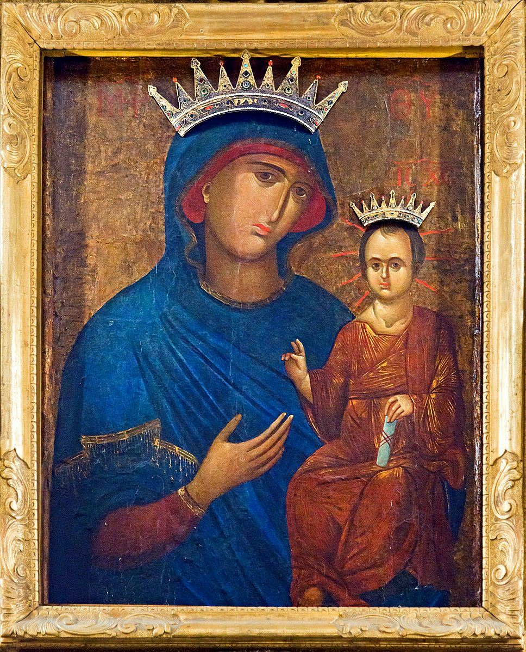
Virgin of Peace, Byzantine icon brought in Venice in 1349.

11
kid-friendly!
Learning to Read with Goats
Chapter 7 A Teensy Tip about Goat Teeth

“Time to brush your teeth, girls,” Farmer Lane intoned.

Linh and Hong arrived in the bathroom simultaneously. A tussle broke out between the sink and the tub as two girls tried to take the toothpaste tube at the same time.

“Two can brush their teeth together with no tugging or tears,” Farmer Lane told the twosome. “Take care that you treat one another tenderly. Uyen, you can tiptoe right in here, too. A trio can take care of their teeth together.”

Toothbrushes were taken and toothpaste was shared, and everyone tried to resist the temptation to make a tempest in a teapot.

“Teeth are very important,” taught Farmer Lane.

“Do goats have teeth, Grandma?” asked Linh truthfully.

“Do they brush their teeth?” wondered Hong, tagging on.

“Too much trouble,” twittered Uyen.

“Yes, girls, goats do have teeth. And although they don’t brush their teeth exactly like we do, they really don’t have to. Their fibrous diet of hay, leaves, twigs and bark scrapes and cleans their teeth very efficiently,” noted Farmer Lane.

“I guess they don’t eat much candy or drink sugary drinks like we do,” said Linh, herself tempted by even the mention of such treats.

“Sugar causes tooth decay.” Hong offered in tandem.

Linh stuck her tongue out at Hong, feeling personally targeted by Hong’s comment. Hong reciprocated by wrinkling her nose and squinting as her face trembled with tension. Trying to distract from the temper-testing turmoil, Farmer Lane returned to teaching.

“People must be careful about goat teeth, because they are made for cutting twigs and stripping bark. Never put your fingers in a goat’s mouth, or you could be hurt.”

The girls took in the message.

“Here’s another true and interesting fact about goat’s teeth,” Farmer Lane tendered.

Teeth now cleaned, the girls returned the toothbrushes and toothpaste to the tray and twirled on tiptoe to the couch to attend to more goat tales.

12
“Goats have top teeth only in the back, but bottom teeth all around,” disclosed Farmer Lane.

“Truly?” asked Linh, still battling the remnants of a testy attitude.

“How does that work?” inquired Hong earnestly.

“Sounds like trouble to me,” Uyen tumbled off the couch, twirled a few times on one leg, then leaped back on as her sisters tossed pillows at her.

“Sharp bottom teeth, with only a hard palate on top in front, enable goats to strip bark. Two sets of teeth, upper and lower, in back help them chop twigs. And please stop tossing the couch cushions at your sister.”

“They are called ‘throw pillows’, Grandma,” Linh’s testiness was definitely getting the best of her.

“Sorry,” Hong returned.

Recovering her tact, Linh proposed a new distraction.

“May we take a trip to the barn to try to see goats’ teeth, Grandma?”

“Without touching their mouths,” Hong insisted timidly. “We’ll be totally careful.”

“Goat teeth,” Uyen trembled, without her usual temerity.

“Terrific idea,” retorted Farmer Lane.

They took their time, traversing the turf, touting twigs as goat toothbrushes in testimony to their goat tooth-brushing topic. When the twig-touting troupe had traipsed into the barn, a more serious tone took hold.

“I don’t see any goat teeth, Grandma,” Linh said with uncertainty.

“Why don’t they show their teeth, Grandma?” Hong added with tension.

“No teeth!” tattled Uyen.

“Goats’ teeth are hidden by their lips most of the time. Unless their mouths are open, you rarely see their teeth. In truth, if a goat shows their front teeth or grinds their teeth when not chewing, they are telling you that they don’t feel well. So hidden goat teeth is typical and terrific.”

Farmer Lane was right; the happy, healthy goats were all hiding their teeth.

“I’ll tempt them with a treat of leaves and twigs. Then maybe you’ll see some teeth.”

Farmer Lane took a branch with leaves and the girls surrendered their twigs, hoping to tantalize the goats into opening their mouths wide enough to reveal their teeth. While they watched for telltale signs

13
of white teeth, Linh spotted a kid drinking milk from its mommy’s teat.

“Do baby goats have teeth when they’re born, Grandma?” she questioned, still struggling to avert even the tiniest tinge of a tantrum.

“Yes, they do, Linh. They have tiny teeth in tiny mouths. And where do those teeth grow?”

“All around on the bottom, and just in back on the top,” testified Hong.

“How about a teensy tip about goat teeth,” tempted Farmer Lane.

The girls forgot all about the fact that they hadn’t seen any goat teeth, and attended to the task at hand, the crafting of a rhyming tip about goat teeth.

“/t/, /t/, /t/, /t/, teeth…” Uyen trial-ballooned.

“A goat’s got ‘em,” completed Hong tentatively.

The trio of girls tried to tackle the second line of their tongue-twisting tip.

“Their lips are sealed; we’ll never spot ‘em,” taunted Linh peevishly. “Got no candy or soda to rot ‘em,” she continued, heading for trouble.

“Oh!” twinkled Hong, “on top in the back, all around on the bottom.”

“Put it together, girls,” Farmer Lane gratefully intervened.

“/t/, /t/, /t/, /t/, teeth, a goat’s got ‘em, on top in the back, all around on the bottom.”

“Terrific,” started Farmer Lane

“Tremendous,” stated Linh, trying hard to turn her mood around.

“Ta da,” Hong took her turn.

“Tee hee,” tittered Uyen.

“Well, my goat tooth truth-telling troubadours, let’s trudge back to the farm house and see what tasks we can tackle today.”

The girls took Farmer Lane’s timely advice and trekked back up the hill toward the house. They timed the tempo of their steps to the rhythm of their teensy tip.

“/t/, /t/, /t/, /t/,”

Step, step, step, step.

“teeth, a goat’s got ‘em,”
14
(Twice as fast) step-step-step----, step-step-step----.

“on top in the back, all around on the bottom.”

Freestyle stepping, posing, and movement.

And so they continued. Soon there was no trace of testiness, just triumphant troubadours testing new moves as they traveled up the hill.

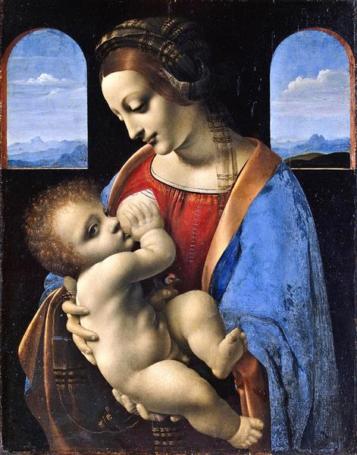
Leonardo da Vinci, Madonna Litta, c. 1490

15
(kid-friendly)
Justice in Action
DIY Free Projects for Independence at All Ages

As peace is on everyone’s mind this summer, prayer gear is our project for July. What is prayer gear, you ask? Certainly it is nothing that is required for prayer, which comes spontaneously from the heart. Prayer gear is a collection of items which, more than anything else, remind you to pray. They are aids and good-habit-builders. Hopefully, making prayer gear and seeing it in your environment will help you to pray more often.

Before we make prayer gear, how do we pray? There are as many answers to that as there are people on this earth. Prayer is communication or simply communion with God. What exactly that means is personal to you. But if you have a sense that there is Someone or Something more evolved than you, with which/whom you wish to have contact, try starting by just being quiet. What happens next is between you and that One.

Some folks like to have a special spot to pray or meditate. The Bhagavad Gita prescribes a piece of white wool cloth, whose natural fibers can retain the spiritual vibrations of your meditation. The cloth is then thought to help you meditate more readily the next time. Any natural material may work as well. But spiritual vibrations are not dependent on a cloth! The cloth is simply an aid. Any kind of mat will be a reminder of your intention to pray or meditate regularly. A mat can be woven, crocheted, or knit from strips of torn clothing, natural fibers from accessible weeds (we’ll do this step-by-step next month!) or may consist more simply is an existing mat, rug, folded blanket or cloth, anything that is available. If you are unhoused, you may have something as simple as a handkerchief to lay on whatever surface you sit on. The intention and habit themselves bring fruit. The vibrations of natural fibers are additional, when circumstances allow.

Next we have a prayer journal. This has two purposes: listing intentions for which you want to pray or meditate, and noting experiences in prayer that you don’t want to forget. These can be fancy: pages and decorated cardboard covers sewn together – the covers can be drawn, painted, collage or fabric-covered using flour and water paste. Poke holes in both covers and all papers along one side and lace through the holes with string, thread, or homemade fiber cord (next month!). Or they can be very, very simple: pages headed for recycling with at least one side blank, folded in quarters together. For those on the street, clean trash paper (empty envelopes deconstructed, paper bags opened up, one-sided mail or fliers) can serve. Salvage a pencil or pen or, in dire circumstances, a feather and watered down dirt, and write your notes. Instead of writing, you might salvage an old magazine, tear representative pictures and paste them on the pages to remind you of intentions and experiences.

Because you sit still while meditating or praying, it is nice to have a shawl to keep you covered. It also helps focus your attention and energy on what you’re doing/being, and in colder seasons, keeps you warm. It can be very thin material, supplemented by a warmer shawl in winter. In Asia they make beautiful cotton and silk shawls with sacred images and words on them. But for our purposes, anything which will be comfortable and remind you of the sacredness of the moment will suffice. It can be a scarf, a shawl, a piece of cloth, a table cloth, whatever you have or can obtain. If nothing is available to you, try obtaining a special piece of clothing at a local free clothing distributor and deconstruct it if

16
necessary. You only need one. Something of a thin material will roll up into a small roll for easy
travel, if you are unhoused. Wearing this shawl when you sit to meditate or pray is like giving yourself a hug as you search for God-access within.

Beads are used for prayer and meditation in many cultures and religions. Catholics use rosaries. Yogis use mālās. Free rosaries are often available in Roman Catholic churches during Mass times. But we can definitely make our own. The simplest kind of rosary is made from a long string or cord, tied into knots at various intervals and joined into a circle. A shorter piece of string or cord is then knotted into beads and a cross and tied on. The pattern is this: ten evenly-spaced knots, bigger space, one knot, bigger space, ten evenly-spaced knots, bigger space, one knot, bigger space – continued until you have five [or seven, depending on the style of rosary] groups of ten knots. After the last group, leave a space and then tie to the first end to make the loop. The second string has a cross made with knots (play around with it until you can get a series of knots to form a cross) then one knot, big space, three evenly-spaced knots, big space, one knot, then tie to the knot that forms the loop.

You can also just make knots with no pattern. To use for japa (repetition of God’s name or a mantra), it is customary to string 108 beads, with one bead, sometimes with a tassel, to let you know you’ve gone all the way around. Plain knots can create this kind of mālā easily. How to obtain or make beads will be the subject of a future article.

What about a focal point for prayer or meditation? These can be of two kinds: those that are temporary and created each time, and those you can easily keep and carry with you. Let’s consider the permanent kind first. If you want a traditional image, most Roman Catholic churches have free holy cards available in their entrance way, if you go when the church is open. Or you may find an image in a discarded magazine that strikes you as compelling. You may create your own image by use of any art materials available to you. Or, if you choose the fleeting image, you can draw with your finger on the ground (Jesus did it!), arrange pebbles, assemble a feather and leaves, arrange loose buttons, make a design with tiny twigs, and more. The object is to focus your attention and quiet the mind.

We have discussed five kinds of prayer gear. In a future article (after plant fiber cord and bead-making) we can make special bag for your prayer gear. For now, as you’re making the gear, and beginning to use it, remember that the most important element we’ve discussed is prayer and meditation itself. Let’s all make it a daily habit! OM! Amen.

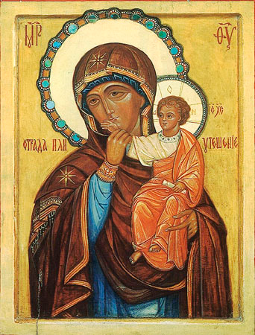
Icon in Vatopedi Monastery, Mount Athos, Greece, before 807 AD

17
Mary’s Ward Global Classroom

“Don't worry about Hitler. No asuric force can stand eternally against the divine force and the hour of his defeat is bound to come.” The Mother, Words of the Mother – III, 27 May 1940
“It is only by the growth and establishment of the consciousness of human unity, that a true and lasting peace can be achieved upon earth. All means leading towards this goal are welcome, although the external ones have a very limited effect; however, the most important, urgent and indispensable of all, is a transformation of the human consciousness itself, an enlightenment of and conversion in its working.” The Mother, Words of the Mother – III

- Growth and consciousness of human unity is the acceptance of unity in diversity.
- Sri Aurobindo and The Mother advocated an international center of education with pavilions for different cultures. One must know and love one’s own background, be exposed to those of others, and then begin to develop the taste for human unity.
- The same can be said for the individuality and universality of humans. One must know one’s own uniqueness and svabhava before one can embrace and respect that of other.
- Education must include development of each individual’s uniqueness, their culture and those of others throughout the global community. Only then can we hope for human unity.
- Consciousness-raising activities such as quiet prayer and meditation must be encouraged and modeled.

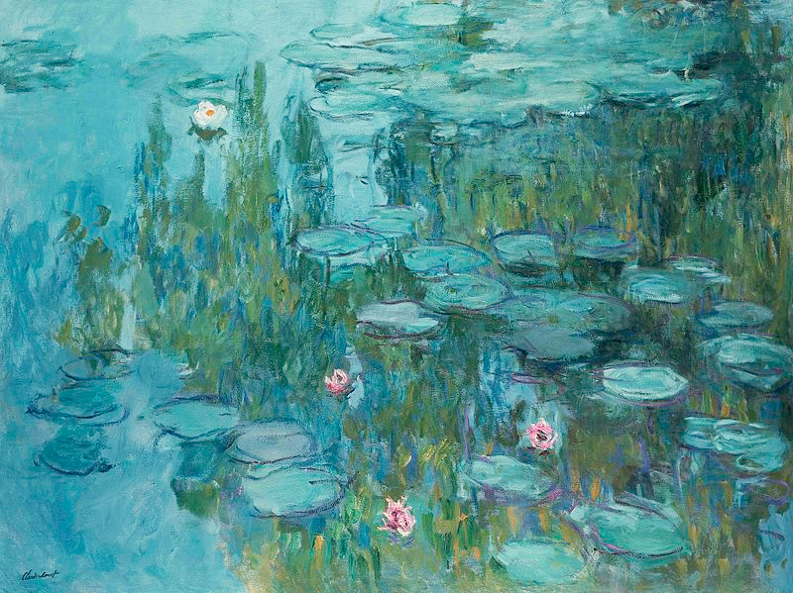
Claude Monet, Water Lilies, c. 1925

18
How You Can Help
“And why seest thou the mote that is in thy brother's eye; and seest not the beam that is in thy own eye? Or how sayest thou to thy brother: Let me cast the mote out of thy eye; and behold a beam is in thy own eye? Thou hypocrite, cast out first the beam in thy own eye, and then shalt thou see to cast out the mote out of thy brother's eye.” Matthew 7:3-5
“The best way of helping others is to transform oneself. Be perfect and you will be in a position to bring perfection to the world.
“Rise to a higher consciousness for the world to be saved.” The Mother, Words of the Mother – II, 23 August 1952

- If everyone in the world worked first on themselves, what kind of world would we have? Peaceful.
- Peace can not be imposed, it must be found within.
- As The Mother so clearly stated (see Blueprint for Marian Maternal Life), the negative forces in this world can only be defeated with compassion, love, courage, peace, and steady and unshakable trust in Divine Grace.
- In this light, let us be prepared to act with compassion and love, no matter the circumstances. Nourishment, safety, shelter from harm, solidarity, spiritual upliftment, modeling courage, peace, and trust.
- In practical terms: lighten your load, declutter, donate, make art for your soul, pursue your dreams, pray, perfect yourself, forgive others, smile and laugh, meditate, and trust in the Divine Grace.
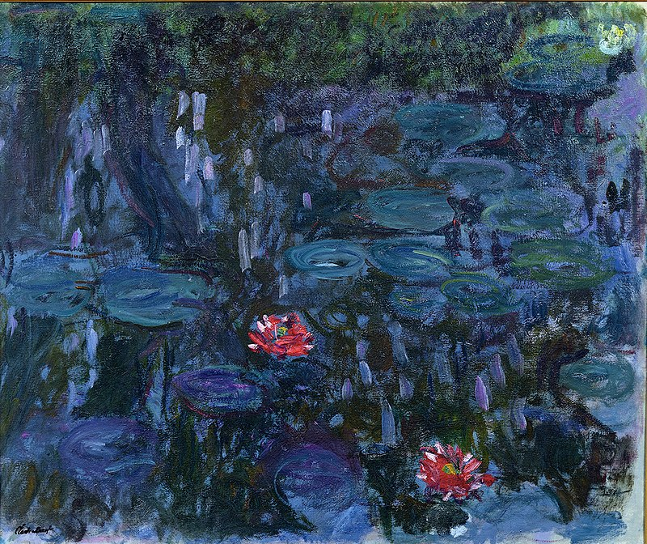
Claude Monet, Water Lilies and Reflections of a Willow, 1916-1919

19

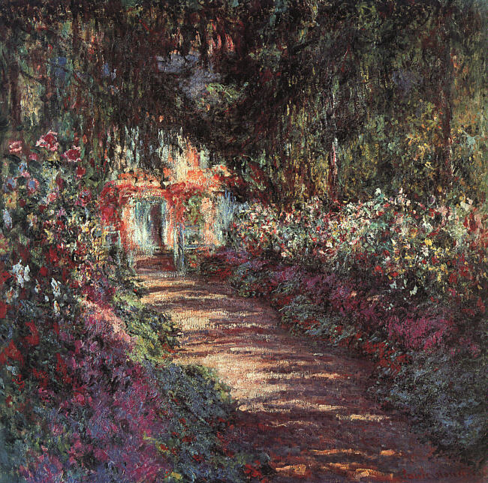
Claude Monet, The Garden in Flower, 1900

marysward.com

