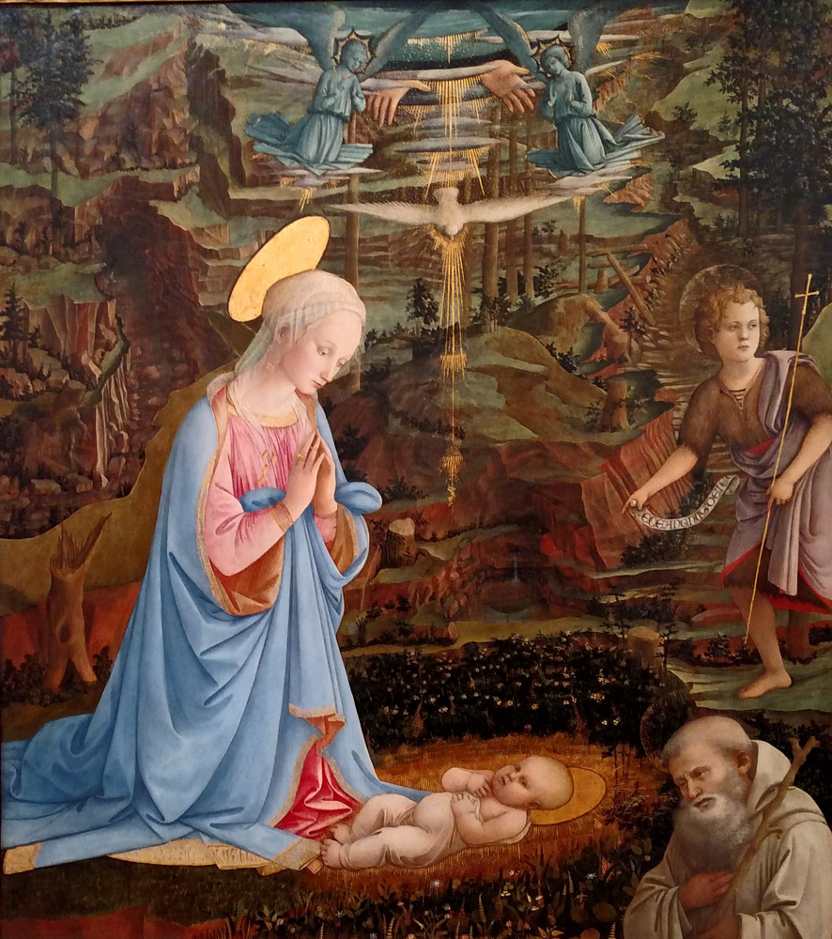
Ascend – The Monthly Publication of Mary’s Ward – November 2025 – Vol.1 No.11

From the Editor

November is a month of stark contrasts in New England in the United States. Catholicism marks All Saints and All Souls Days, local commemoration of which lack the drama and aesthetic of Polish cemeteries, which are brightly illumined with lit pumpkins and gourds covering every flat surface. The deciduous trees have lost their leaves, revealing bare branches that stand starkly against brown landscapes and gray skies. But as the inevitability of the coming winter is accepted, there is beauty in the inward turning that takes place in our hearts. The contrasts extend to the overabundance of Thanksgiving dinners and holiday sports while the divide between the rich and the poor grows visibly wider. Let us dedicate ourselves this month to a greater engagement with the difficult issues of our time. Let us endeavor to see, to recognize, to acknowledge, and to include those who are marginalized, targeted, and persecuted in our day. As we remember our dearly departed, let us celebrate our families, friends, neighbors and strangers who are living in our communities and struggling to survive.

Not in So Many Words presents Matthew 11 in synopsis and bindu-point commentary. This month’s Homily, prepared for the Twenty-first Sunday after Trinity, discusses Perseverance in the task of standing for truth. Agni and Vedic sacrifice is compared with the Catholic doctrine of Purgatory in Vedic Christianity for this month dedicated to the Holy Souls in Purgatory.

An apparition of the Blessed Virgin Mary, Our Lady of the Universe (on the Grand Concourse in the Bronx) is described in the light of Sri Aurobindo and The Mother in Blueprint for Marian Maternal Life. The human necessity of spirituality is the topic for this month’s Not Serving Two Masters. Forward, or what sometimes feels like backward, movement toward Mary’s Ward goals is expressed in Progress.

Chapter 11 “A Poem about Playful Goats” featuring the phonetic sound /p/ is our kid-friendly Learning to Read with Goats offering this month. Cozy comforters to share with those rough sleeping, made from what we have on-hand is this month’s kid-friendly Justice-in-Action DIY project for all ages. “Do we trust our souls, and those of our students (adults or children) to lead education?” is the question pondered in the Mary’s Ward Global Classroom update.

How You Can Help enumerates possible ways to join the resistance to fascism, creative actions that even the most vulnerable can feel safe to take.

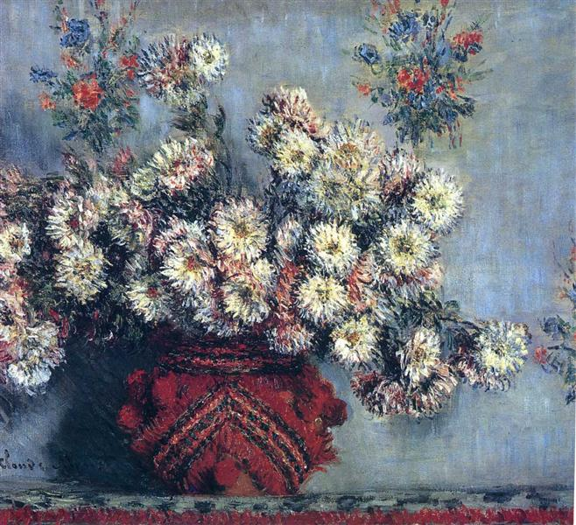
Claude Monet, Chrysanthemums, 1878

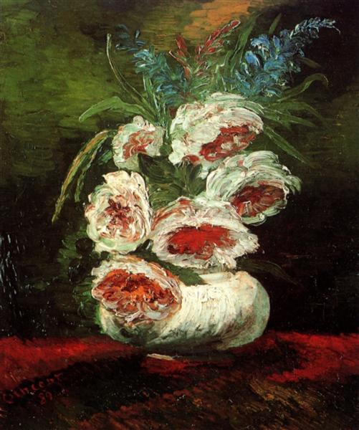

Vincent Van Gogh, Vase with Peonies, 1886

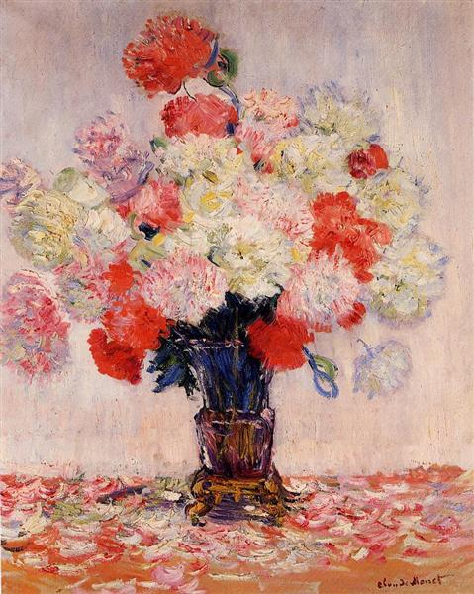

Claude Monet, Vase of Peonies, 1882

Table of Contents

Light

Not in So Many Words 1

Homily

Veda in Christianity

Love

Blueprint for Marian Maternal Life

Not Serving Two Masters

Progress

Life

LTR with Goats

Justice in Action

MW Global Classroom Update

How You Can Help

Filippo Lippi, The Adoration of the Christ Child, 1463

November birth flowers are chrysanthemum and peony.
Chrysanthemums symbolize Mary as Queen of Heaven. Peonies represent maternal grace, love, and compassion.
Mother has named peony Beauty in Art.
Not in So Many Words
Matthew 11
Synopsis
After Jesus instructed the twelve, he preached and taught in the cities. John the Baptist in prison sent two disciples to ask Jesus whether he was the expected one, or whether to await another. Jesus told them to report what they had witnessed: the blind see, the lame walk, lepers are cleansed, the deaf hear, the dead rise, the gospel is preached to the poor. And blessed is the one who is not offended by him. Jesus asks the crowd about their expectations concerning John, whom he calls more than a prophet, a messenger to prepare the way, the greatest ever born, yet the least in the kingdom of heaven is even greater. Which kingdom “suffereth violence” since John came. The violent “bear it away”. Prophets prophesied until John, who is Elijah “if you will receive it.” Hear in the Spirit. People seem unresponsive: like children who neither dance nor mourn when cued by their playmates. John was rejected for his austerity; Jesus for his abundance. “Wisdom is justified by her children.” He criticized cities where his miracles had occurred for not being changed as a result. He thanked God for hiding “these things” from the “wise and prudent”, and revealing them to “little ones”. “Come to me, all you that labour, and are burdened, and I will refresh you. Take up my yoke upon you, and learn of me, because I am meek, and humble of heart: and you shall find rest to your souls. For my yoke is sweet and my burden light.”
Commentary
- Jesus taught in all places: wilderness, villages, mountains, plains, cities, seas; inclusive
- Blessed are those who accept John and Jesus without preconceptions and judgments
- Those in the kingdom of heaven are even greater than John; “little ones”; the humble
- The violent “bear away” the kingdom of heaven, which must be non-violent and peaceful
- Soul rest is in Jesus who is humble and meek; his yoke (yoga) is sweet; his burden is light

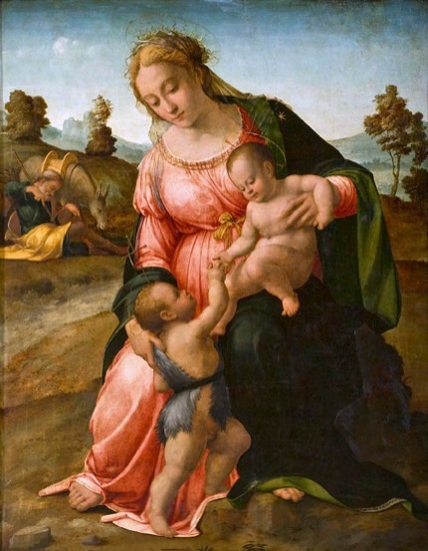
Francesco Grannaci, Madonna and Child with St. John the Baptist, c. 1505-1510

1
Homily
Twenty-first Sunday after Trinity
Intent: Perseverance

The Collect

LORD of all power and might, who art the author and giver of all good things, may our hearts be so filled with gratitude to Thee that we may continually increase in true religion, and from Thine omnipotence may we draw strength to persevere; through Christ our Lord. R/ Amen.

The First Lesson

The First Lesson is taken from the sixth chapter of the Epistle of St. Paul the Apostle to the Ephesians, beginning at the tenth verse.

MY brethern (siblings), be strong in the Lord, and in the power of His might. Put on the whole armor of God, that ye may be able to stand against the wiles of the adversary. For we wrestle not against flesh and blood, but against principalities, against powers, against the rulers of the darkness of this world, against spiritual wickedness in high places. Wherefore take unto you the whole armor of God, that ye may be able to withstand in the evil day, and having done all, to stand. Stand therefore, having your loins girt about with truth, and having on the breastplate of righteousness, and your feet shod with the preparation of the gospel of peace; above all, taking the shield of faith, wherewith ye shall be able to quench all the fiery darts of the wicked. And take the helmet of salvation, and the sword of the Spirit, which is the word of God, watching thereunto with all perseverance.

Here endeth the Lesson.

The Second Lesson

The Second Lesson is taken from the tenth chapter of the Gospel according to Matthew, beginning at the first verse.

WHEN Jesus had called unto Him His twelve disciples, He gave them power over unclean spirits, to cast them out, and to heal all manner of sickness and all manner of disease. And He said unto then: Behold, I send you forth as sheep in the midst of wolves; be ye therefore wise as serpents, and harmless as doves. The disciple is not above his (their) Master, nor the servant above his (their) lord. He (The one) that receiveth you, receiveth Me, and he (the one) that receiveth Me receiveth Him that sent Me. Whosoever shall give to drink unto one of these little ones a cup of cold water only, in the name of a disciple, Amen I say unto you, he (that one) shall by no means lose his (their) reward. He (The one) that loveth father or mother more than Me is not worthy of Me; and he (the one) that loveth son or daughter more than Me is not worthy of Me. And he (the one) that taketh not his (their) cross and followeth after Me is not worthy of Me. He (The one) that findeth his (their) life shall lose it; and he (the one) that loseth his (their) life for My sake shall find it. But he (the one) that endureth to the end shall be saved.

2
Here endeth the Lesson.

In the name of the Father, and of the Son, and of the Holy Ghost. Amen.

Today is the Twenty-first Sunday after Trinity, whose Intent is Perseverance, and if you ask me, we are being given here the playbook for 2025 America. Non-violent resistance, which is neither passive nor weak, but rather historically THE most effective strategy to defeat fascism, is exactly what is meant by being wise as serpents and harmless as doves, of being sheep in the midst of wolves, of putting on the whole armor of God, of standing against the wiles of the adversary, against principalities, against powers, against the rulers of the darkness of this world, against spiritual wickedness in high places. We are told to withstand in the evil day, to love Jesus more than mother or father, son or daughter, to pick up our own cross and follow Him, and three times we are told to stand. Those who endure to the end will be saved.

So what is this all about? It’s about spiritual warfare. It’s about opposing policies and actions because we recognize that the spirit behind them is not the Spirit of God. It’s about standing, about not backing down, about insisting that God’s love extends to everyone and that treating anyone as less than human is not acceptable. Today’s readings advocate perseverance because standing requires strength and discipline, commitment, courage, and actual training. I am aware of people across this country who are in nonviolent resistance boot camp right now. They are learning from elders in resistance movements of the past such as AIDS awareness and the Civil Rights Movement.

But what if you are not able to train in order to stand? What if, like me, you are old or perhaps very young, or in a demographic group that is marginalized and targeted? This is a spiritual battle, and it is fought on many fronts. The armor is for all of us: truth, righteousness, peace, faith, and salvation, with a lone offensive weapon, the word of God. Oh, how that lonely weapon has been misused to harm and abuse. The Bible is the word of God, but it has been twisted and deformed until those of us standing with feet shod with the preparation of the Gospel of peace, PEACE, are discouraged to the point of not wanting to be associated with it. But Jesus is the Word of God, the Great Amen, the AUM that vibrates from the Source of this Universe, the Prince of Peace, Love Incarnate, Divine Mercy, the Sacred Heart, the Lamb of God, the Good Shepherd. The disciple is not above his (their) Master, nor the servant above his (their) lord. Jesus forgave and taught us to do the same. He stood composed before those who accused and tortured him, but not silently. Pilate asked Jesus if he was the King of the Jews. Jesus responded that His Kingdom was not of this world. Pressed further, He stated (John 18:37) For this was I born, and for this came I into the world; that I should give testimony to the truth. Every one that is of the truth, heareth my voice. So, it’s been a truth battle from Day One. The armor of God is about truth. Spiritual warfare is about truth. And in 2025 America, standing nonviolently is also about truth. Loving Jesus more than mother, father, son or daughter is not about dividing families, it’s about prioritizing truth. Picking up your cross and following Jesus is about truth. We’re not battling our neighbors and families, we are insisting on God’s Truth, not twisted soundbites ripped from scripture and used as weapons to hurt people, but the One Truth that no one is excluded from God’s love. We are One human race created in the image of God. Unity in Multiplicity, in blessed diversity, in all the colors of the rainbow.

So how do we stand for truth if we are not able to attend rallies and nonviolence boot camps, and feel sad, weak, defeated, scared, and powerless. The armor of God is for all, whether the battle line for us is

3
at organized protests or in the quiet of our homes as we decide which online store to patronize. It is wherever we interface with people, no matter how minimally. We stand when we smile at the people we encounter, seeing them as people who are precious in God’s sight. We stand when we stay calm as someone with an opposing view is venting rage and we quietly state that although we don’t agree with their view, we would like to offer them one of the fruits we just purchased or picked. We stand when we bravely go about our business while others around us are freaking out at the news. When we speak the truth clearly, but have the discipline to turn the other cheek to hateful rhetoric. (Let me be very clear that I am not advocating that anyone endure speech or actions which endanger their safety. Let these stands be taken on behalf of the most vulnerable, not by them.) We can stand with very small,
anonymous acts of kindness.

If you’d like more creative ideas of how to embody nonviolent resistance, Gene Sharp, founder of the Albert Einstein Institution, an organization dedicated to the advancement of the study of nonviolent action, compiled a list of 198 Methods of Non-Violent Action in his 1973 work in three volumes, The Politics of Non-violent Action. The list is available online and really worth reading. I highlighted for myself thirty actions which I either already do, such as boycott and nonconsumption of boycotted products, want to do, such as alternative systems of transportation, communication, and economic institutions, or just think are really cool like Guerilla Theater, Religious Processions and Pilgrimages, Wearing of symbols, and preclusive purchasing (“Oh, you want to put a detention center here? I’m sorry, but our consortium of nonprofits just bought that land to put in a tiny house park to house the homeless.” Preclusive purchasing: we preclude something bad from happening.) Weirder things have happened! Never doubt God. One of my favorites on the list is Sanctuary, which is really hard to pull off these days when those who violently abduct our neighbors respect no boundaries, rights, or legal norms. But with God, all things are possible.

So let us grab that spiritual armor and take our stand for truth, whether with a simple smile, or a plan for a network of human-powered cycles. We need perseverance, because this is a very old battle and combat on our particular front could stretch on for a while. But we’ve been given armor, tools, and standing orders, you could say. Wherefore take unto you the whole armor of God, that ye may be able to withstand in the evil day, and having done all, to stand. Stand therefore, having your loins girt about with truth, and having on the breastplate of righteousness, and your feet shod with the preparation of the gospel of peace; above all, taking the shield of faith, wherewith ye shall be able to quench all the fiery darts of the wicked. And take the helmet of salvation, and the sword of the Spirit, which is the word of God, watching thereunto with all perseverance.

In the name of the Father, and of the Son, and of the Holy Ghost. Amen.

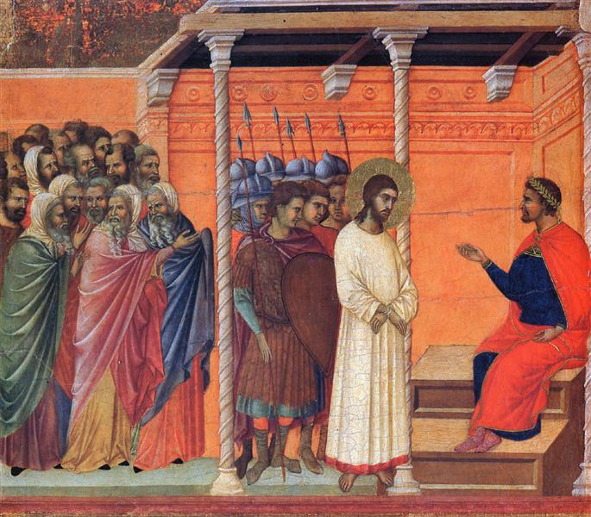
Duccio, Christ Before Pilate, 1308-1311

4
Veda in Christianity

यच्चि॒द्धि ते॑ पुरुष॒त्रा य॑वि॒ष्ठाचि॑त्तिभिश्चकृ॒मा कच्चि॒दागः॑ । कृ॒धी ष्व१॒॑स्माँ अदि॑ते॒रना॑गा॒न्व्येनां॑सि शिश्रथो॒ विष्व॑गग्ने ॥ RV 04.012.04
yácciddhí te puruṣatrā́ yaviṣṭhā́cittibhiścakṛmā́ káccidā́gaḥ ǀ
kṛdhī́ ṣvásmā́m̐ áditeránāgānvyénāṃsi śiśratho víṣvagagne ǁ RV 04.012.04
If at all in our humanity by our movements of ignorance we have done any evil against thee, O Fire, make us wholly sinless before the mother indivisible; O Fire, mayst thou loosen from us the bonds of our sins to every side. – Sri Aurobindo’s interpretation RV 04.012.04, Hymns to the Mystic Fire, (Pondicherry: Sri Aurobindo Ashram, 1996) 192

The month of November is dedicated, in Roman Catholicism, to praying for the dead, specifically for the holy souls in purgatory. What is purgatory, according to Catholic doctrine, and how, if at all, does it recall the Vedic sacrifice and hymns to Agni?

From the Catechism of the Catholic Church, Latin text copyright (c)(Citta del Vaticano, Libreria Editrice Vaticana, 1993):

“III. The Final Purification, or Purgatory
“1030 All who die in God's grace and friendship, but still imperfectly purified, are indeed assured of their eternal salvation; but after death they undergo purification, so as to achieve the holiness necessary to enter the joy of heaven.
“1031 The Church gives the name Purgatory to this final purification of the elect, which is entirely different from the punishment of the damned.604 The Church formulated her doctrine of faith on Purgatory especially at the Councils of Florence and Trent. the tradition of the Church, by reference to certain texts of Scripture, speaks of a cleansing fire:605
“As for certain lesser faults, we must believe that, before the Final Judgment, there is a purifying fire. He who is truth says that whoever utters blasphemy against the Holy Spirit will be pardoned neither in this age nor in the age to come. From this sentence we understand that certain offenses can be forgiven in this age, but certain others in the age to come.606
“1032 This teaching is also based on the practice of prayer for the dead, already mentioned in Sacred Scripture: "Therefore Judas Maccabeus] made atonement for the dead, that they might be delivered from their sin."607 From the beginning the Church has honored the memory of the dead and offered prayers in suffrage for them, above all the Eucharistic sacrifice, so that, thus purified, they may attain the beatific vision of God.608 The Church also commends almsgiving, indulgences, and works of penance undertaken on behalf of the dead:
“Let us help and commemorate them. If Job's sons were purified by their father's sacrifice, why would we doubt that our offerings for the dead bring them some consolation? Let us not hesitate to help those who have died and to offer our prayers for them.609”
5
604 Cf. Council of Florence (1439): DS 1304; Council of Trent (1563): DS 1820; (1547): 1580; see also Benedict XII, Benedictus Deus (1336): DS 1000.
605 Cf. 1 Cor 3:15; 1 Pet 1:7.
606 St. Gregory the Great, Dial. 4, 39: PL 77, 396; cf. Mt 12:31.
607 2 Macc 12:46.
608 Cf. Council of Lyons II (1274): DS 856.
609 St. John Chrysostom, Hom. in 1 Cor. 41, 5: PG 61, 361; cf. Job 1:5.
The Catechism mentions purification, flames, and the need for consolation. Images of fire, torment, and suffering have been depicted in art and have captured the popular imagination down through the centuries. In the above-quoted passage, St. John Chrysostom speaks of prayers’ efficacy as consolation for the holy souls. That the souls of the dead seek relief of some kind is implied, but not stated as doctrine. Catholics are taught that holy souls can pray for the living, but not help themselves. Therefore, praying for them has two benefits: it lessens the duration of their purgation and increases the number of those happy to pray for such benefactors.

There is also tradition which links the Blessed Virgin Mary with the holy souls in purgatory, that of the brown scapular of the Carmelites. The Order of the Blessed Virgin Mary of Mount Carmel was founded in the twelfth century after its beginnings as a group of hermits on Mount Carmel. Comprised separately of brothers, sisters, and lay people, Carmelites’ patrons are Mary and Elijah, the prophey who called down fire on an altar in a competition with worshipers of Baal (4 Kings D-RV). The Carmelite Order has produced such great Catholic saints as Teresa of Avila, John of the Cross, and Therese of Lisieux. In 1251 St. Simon Stock, a Carmelite brother, had a vision in which he received from Mary a sacramental, comprised of two small brown wool rectangles on either end of a loop of brown cord. This, Mary explained, was a miniature representation of the brown Carmelite habit. Anyone wearing this item around the neck, hanging front and back, at the time of death, would partake in the “Sabbatine privilege” of the Carmelite Order: to be released from purgatory on the Saturday following their death. A short rite of investiture was composed and this use of and devotion to the brown scapular continues today.

But let’s look at the verse from the Ṛgveda, whose authorship predates the doctrine of purgatory by millennia. “If at all in our humanity by our movements of ignorance we have done any evil against thee, O Fire, make us wholly sinless before the mother indivisible; O Fire, mayst thou loosen from us the bonds of our sins to every side.” RV 04.012.04. As Sri Aurobindo points out at length in The Secret of the Veda, the godheads such as Agni, imaged frequently as fire because his name is the Sanskrit for fire, actually signify the faculties of consciousness. The Vedic sacrifice, ritualistically carried out with the offering of materials to a fire made sacred through the chanting of Sanskrit verses of the Ṛgveda by priests, may be seen psychologically as the calling for higher faculties of consciousness to assist in the spiritual ascent of Matter towards conscious union with Spirit. The fire and the sacrifice represent the spiritual journey of human beings individually and collectively towards God, the Divine, the Supreme. Fire represents the process of transformation and ascent, the making sacred, of our lives and our world.

This understanding, still not widely accepted among Hindus any more than among Christians, sheds light on purgatory as part of the spiritual journey. Because Christians abandoned any acceptance of multiple births of one soul, the purification needed for a sinless immortality in the Christian paradigm

6
necessitates a state between life and that beatific eternal life. Hindus, while emphasizing the material and ritualistic approach to the Veda, also abandon any thought of heaven on earth, looking towards good deeds such as literal Vedic sacrifice to give them good karma for a better next life. Only the ascetics were deemed able to achieve God-realization on earth through their asceticism, discipline, and self-denial, and their focus is individual salvation, not corporate.

But what if the spiritual purification imaged as fire and sacrifice in Hindu, Jewish, and Christian traditions truly describes a psychological and spiritual transformation that is available in this life to all who feel the call to find God? Suddenly the punishments, torments, suffering, violent blood sacrifices, and intercessory requirement for a priestly hierarchy are eliminated. In their place, we find a path, the Integral Yoga, which supports the aspiring seeker in spiritual transformation and ascent with grace. The path is still arduous, but neither relegated to a distant cave, nor to a place or state after death. How interesting that Mary provides a sacramental which symbolizes devotion and consecration to her, which shortens the periuod of purification needed after death. In exactly the same way, Sri Aurobindo advocates turning to the Universal Mother, and specifically to The Mother of Integral Yoga, as the shortest, easiest, and most direct path of transformation, the “Sunlit Path.”

As all Matter contains involved Spirit, evolution is inevitable, if slow. Yoga is the process of trying to speed up that evolution. As all souls derive from the One, and spiritual work is meant to be both individual and collective, praying for deceased persons, like praying for the living, is a noble practice of collective yoga, even without reference to purgatory or karma. Anything that promotes unity and is undertaken for the common good benefits all.

ॐ शान्तिः शान्तिः शान्तिः AUM śāntiḥ śāntiḥ śāntiḥ Amen peace peace peace

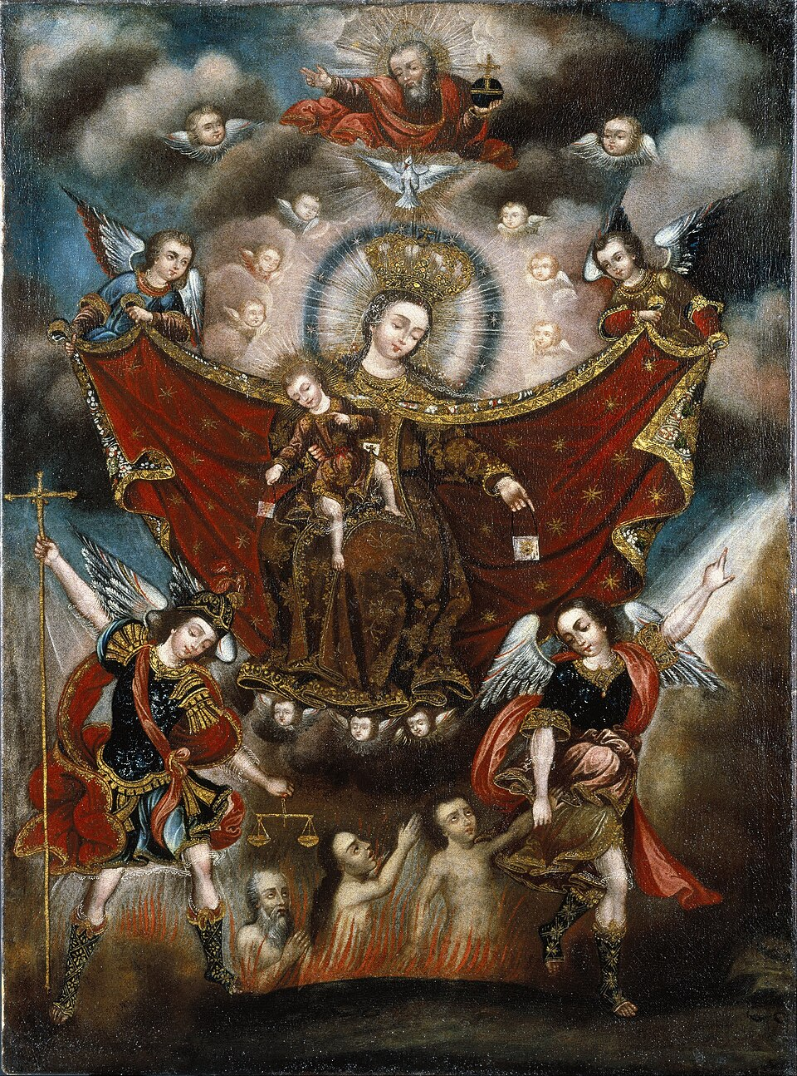
Unknown author, Virgin of Carmel Saving Souls in Purgatory, late 17th century

7
Blueprint for Marian Maternal Life
“I affirm again to you most strongly that this [the Second World War] is the Mother’s war. You should not think of it as a fight for certain nations against others or even for India; it is a struggle for an ideal that has to establish itself on earth in the life of humanity, for a Truth that has yet to realize itself fully and against a darkness and falsehood that are trying to overwhelm the earth and mankind in the immediate future..” Sri Aurobindo, 29 July 1942, On Himself, SABCL 26 p. 394
From October 29 through November 14, 1945 Our Lady appeared to a nine-year-old Italian youth named Joseph Vitolo on a boulder near his house just off the Grand Concourse in the Bronx. According to a video interview with Joseph conducted 58 years later, there were many children playing outside. As he joined them, three young girls (two Caucasian and one African-American, all age 7) were praying to Our Lady. They saw Our Lady, but he did not. One of the girls, his friend Ro Ro, told him to pray to her “like you mean it”. He did and he saw Out Lady. She spoke to him. She asked him to return at 7pm for sixteen consecutive days and pray the rosary. All twenty or so children present that first night saw Our Lady, but only Joseph heard her speak, and only Joseph saw her and spoke with her on the successive nights.
Her overall message, according to Joseph, was to pray the rosary for peace in the world. This was just after the conclusion of WWII. Word spread through the Catholic community and via the media, so that by the final night 30,000 people crowded into the northernmost area of the Grand Concourse in that Bedford Park neighborhood. Joseph reported that she appeared with a Star of David on her chest. She appeared in a variety of colored gowns. The final night she wore white and gold and as she prayed on her blue rosary beads, the rosary broke and the beads scattered. According to Joseph, she retrieved all but one bead, telling him, “One bead, Joseph, we can’t find.” She never said goodbye, and there having been one bead left behind, Joseph always hoped that she would return. He reported that many miracles and graces were received through him and the shrine, but that many of his own prayers were never answered, at least not in the way he hoped.
For many years Joseph’s friend Sal owned the adjacent property, which offered an entrance to the shrine from the Grand Concourse. Joseph passed away in 2010, but his daughter Maria maintains the family house and the shrine. Unfortunately, public access to the shrine has been eliminated through sale of adjacent properties and development. However, there was one incident while Joseph was still alive, before preservation of the shrine had been legally assured, where developers put a stick of dynamite into a hole dug into the boulder where Our Lady appeared, hoping to blast it away. The dynamite failed, and subsequently Joseph mounted a crucifix on a pole and placed it in that hole in triumph. Perhaps the lost bead has protected the shrine all these years.
Several aspects of this apparition seem very similar to The Mother of Sri Aurobindo Ashram. First of all, the fact that Our Lady appeared with a Star of David on her chest. The star was not line-drawn, but filled in, very much like the signs and patches used to identify Jews in Europe during the persecutions

8
of WWII, just recently ended at the time of these apparitions. Thus, without words, Our Lady was showing her own Jewish origin and solidarity with those who suffered such devastating suffering and scapegoating (a word, which harkens to the goat, a type of Jesus, sent away to carry the Israelites’ sins into the wilderness). Mirra Alfassa, The Mother, was herself born to an Egyptian Jewish mother and a Turkish father, her family belonging to the Sephardi Jews originally from the Iberian peninsula (Spain and Portugal). The Mother was born and raised in France. Her life’s work, however, came in India as a result of her meeting in 1914 and subsequent collaboration with Sri Aurobindo, whose symbol resembles the Star of David, adjusted so that the quadrilateral formed by the intersecting triangles forms a perfect square. Thus, the appearance of the gold six-pointed star shape on the chest of Our Lady shows significant resonance with the life of The Mother.
The Mother and Sri Aurobindo were both very concerned about and actively involved in influencing the outcome of WWII, politically, financially, and spiritually. Sri Aurobindo called it “The Mother’s War” as they both believed that if Hitler were to prevail, evolution of consciousness would be delayed, if not destroyed for the foreseeable future. While many in India wanted to cheer any opponent of Britain, Sri Aurobindo and The Mother foresaw the devastation to spiritual progress in civilization with a German victory. The appearance of Our Lady wearing a Star of David resonates with this resistance to the Nazis as well.
Another such resonance is the broken blue rosary and lost bead incident. One would think that a heavenly rosary would be incapable of breaking, and indeed, some have thought this detail an indication that Joseph is only imagining these apparitions. (The Roman Catholic Diocese has largely ignored the entire issue, choosing not to open any official investigation.) But anyone who has met Joseph can testify to his sincerity. The fact that he has helped countless others, but not personally benefited from the shrine, also suggests his veracity. Jesus and Mary’s joint mission to shake up religious establishment can not reasonably be assumed to have ended with the empty tomb. Breaking a rosary, which Our Lady specifically asked all present to pray for peace, indicates both reverence for and the will to evolve past religious practices. Leaving a bead – again, it is difficult to imagine the heavenly bead being lost – both ensures the safety of the shrine against greedy development in the future, marking the physical location as a site of God’s kingdom right there in the Bronx, and also leaves behind an image of unfinished business, a call to the future, an invitation to conscious evolution.
Sadly, there is currently no public access to the shrine, except, perhaps by invitation only, through the Vitolo home. But the bead is still there; the invitation, rather than to the shrine, to collaborate with the Mother of God to help realize Christ’s kingdom of heaven on earth remains. Our Lady of the Grand Concourse (also known as Our Lady of the Universe) and The Mother of Integral Yoga both invite us to take up this challenge: to pray for peace in the world, to break the chains of complacency, to identify with the marginalized and persecuted, to accept the adventure of conscious evolution, to have stubborn faith against the seemingly overwhelming violence threatened by the dynamite of greed, to take refuge in her as she leads us to the Divine.
Our Lady of the Grand Concourse, pray for us! Jai Maa!
9
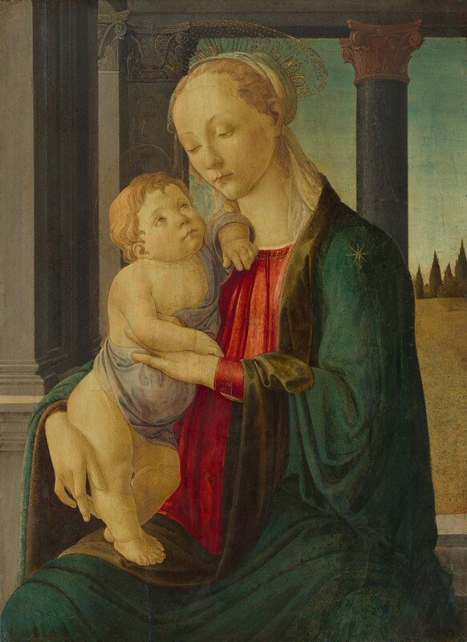
Sandro Botticelli, Madonna and Child, 1470

Note the star on Mary’s cloak, a frequent addition symbol on her clothing in art.

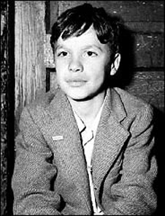

Joseph Vitolo, seer of Our Lady of the Universe in the Bronx, age 9 in 1945.

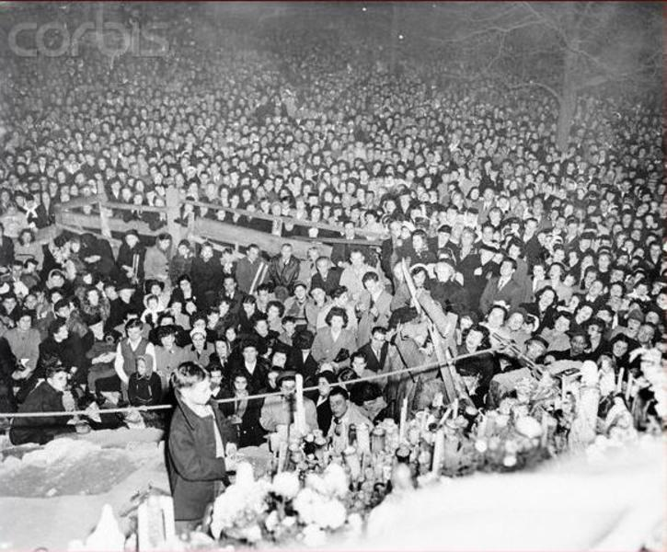
Crowds grew over the seventeen days of the apparition, culminating in 30,000 people attending on November 14, 1945

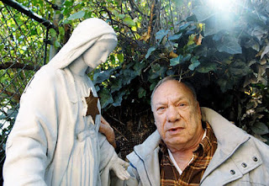
Joseph Vitolo in his later years at the Shrine of Our Lady of the Universe in the Bronx. The gold star on the chest of the statue is how he saw Our Lady in 1945.

10
Not Serving Two Masters
Stepping Out of the Money Paradigm by Choice

The Ways of the Spirit – I
Sonnet by Sri Aurobindo

What points ascending Nature to her goal?
'Tis not man's lame transcribing intellect
With its carved figures rigid and erect
But the far subtle vision of his soul.
His instruments have served his weakness well
But they must change to tread the paths of Fire
That lead through his calm self immeasurable
To the last rapture's incandescent spire.
The spirit keeps for him its ample ways,
A sense that takes the world into our being,
A close illumined touch and intimate seeing,
Wide Thought that is a god's ensphering gaze,
A tranquil heart in sympathy with all,
A will wide-winging, armed, imperial.

There is no such thing as pure matter devoid of spirit. The spirit versus matter dichotomy is false. All matter is infused with spirit, which may be more or less hidden. Human beings are the most evolved, the most consciously spiritual beings of terrestrial existence. We are by no means as far along as we may travel in the direction toward pure spirit, the Divine. But there is spirit in the rock, the plant, and the animal as well. As humans, nurturing the spirit is an absolute necessity. It is this need of spirituality that we explore this month.
To nurture the spirit, it is not necessary to be part of a religion. Many today identify as “spiritual, but not religiously affiliated.” What is necessary is to acknowledge that there is a part of every human that transcends the physical body and even the mind. There is an in-built aspiration toward certain absolutes such as Truth, Goodness, and Beauty, which absolutes are not limited to a specific moral paradigm. There is something holy which draws us forward toward excellence and leads us to strive to exceed our limits.
Humans have a need for quiet, peace, calm, and inspiration from beyond ourselves in the form of nature, art, reading, and prayer, meditation, and contemplation. Public libraries and parks offer low-barrier opportunities for such inner seeking. Of course, there are more formal ways to be spiritual

11
within various religious frameworks, but simply showing up for a meeting or service does not guarantee a spiritual experience. The writings and teachings of spiritual masters and saints can often assist in the seeker’s journey. There are resources to use in libraries and on the internet. Many religious groups also have tables where they offer literature (booklets, prayer cards, rosaries, sometimes even books, etc.) free for the taking.
However one approaches spirituality, the fact that it is a human need is undeniable. It is a need for all humans at all stages of development, in every period and circumstance of life. Let us assist one another to honor this need, attending to our own spiritual journey, while encouraging others’.
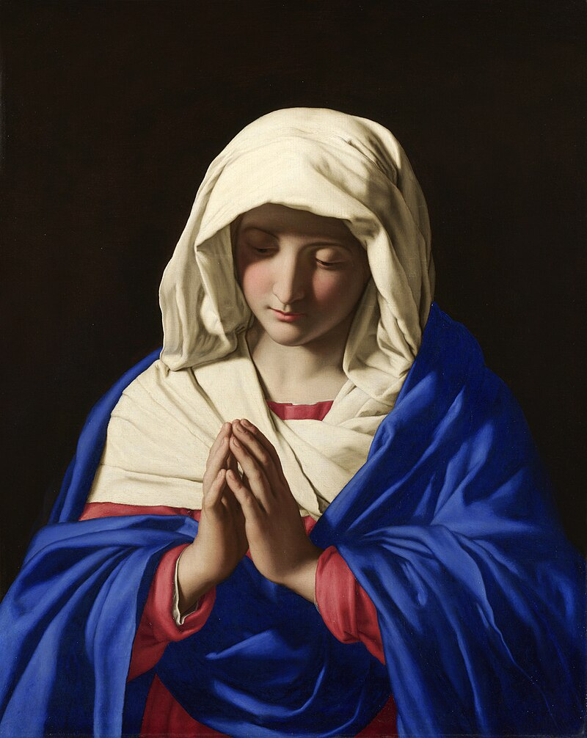

Giovanni Battista Salvi da Sassoferrato, The Virgin in Prayer, c. 1540-1650

12
Progress

Our Lady, Undoer of Knots, Mediatrix of All Graces, pray for us.
“It is our lack of faith that creates our limitations.” The Mother, Words of the Mother – II, 30 July 1954
- Monthly Episcopal visits to Solace of Migrants Mission continue
- Mary’s Ward seminarian continues her studies
- Marian Maternal House in Springfield was finally visited. Damage due to absence and weather was as expected. Damage due to sometime squatter and more recent break-in was far worse than anticipated. Much debris of broken glass, smashed ceramics, crushed plaster, and destroyed electronics was cleaned up and left along with weather damage debris in boxes for town trash collectors.
- The online store moved a step closer to completion.
- A strategic plan for SonLight Incorporated has been written.
- A budget for repairs and projects is being assembled.
- marysward.com is being reworked, refocusing on nonviolent resistance in the light of the activism of Jesus and Mary, Sri Aurobindo and The Mother, Dorothy Day and Peter Maurin and others
- Like-minded local grassroots, community and religious groups are being located for collaborative protests, direct action, and mutual aid
- Inspiration: until purchase of micro locations becomes feasible, public libraries, community buildings, public spaces, and possibly low-barrier, inclusive faith community properties may serve as the beads on a necklace of swaraj (literally “self-rule”, mutual aid nexus: Solace of Migrants Mission, legal aid, Mary’s Ward Global Classroom, Mother of Strength Sri Aurobindo Hub, human-powered transport station, community garden (seeds and mobile garden?), mutual aid/works of mercy
- MW seminarian represented Solace of Migrants Mission at a prayer vigil organized by the Maine Council of Churches outside the Cumberland County Jail where ICE detainees are among the inmates. There was praying, joyful singing, and silence held in solidarity with all(inmates and staff) inside. It will be a weekly event for as long as the jail houses detainees. MW seminarian will attend.
- The Way of the Cross for Migrants and other liturgical and devotional resources are being developed to meet the needs of this moment in history.
- A new eco-friendly, free construction technology using layered corrugated cardboard has been learned and will be tested.
13
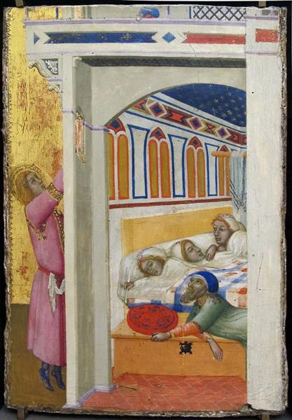
Ambrogio Lorenzetti, The Charity of St. Nicholas of Bari, 1330

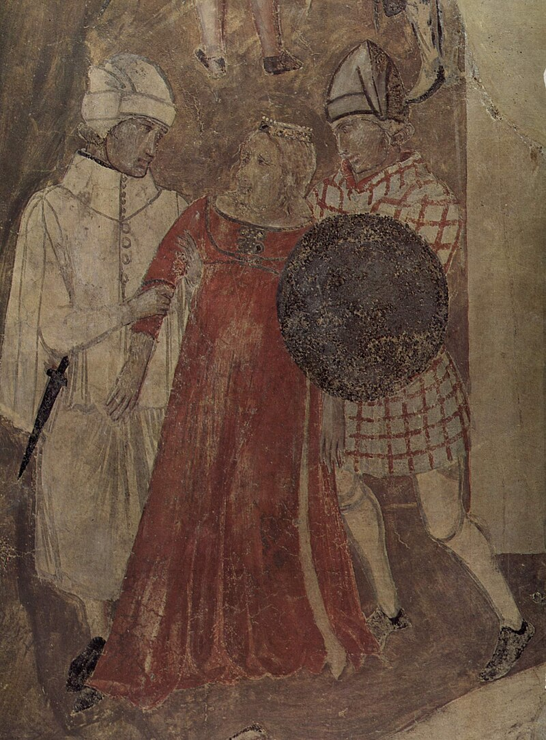
Ambrogio Lorenzetti, Allegory of Bad Government (two soldiers robbing a woman), 1338-1340

14
kid-friendly!
Learning to Read with Goats
Chapter 11 A Poem about Playful Goats

“Peaches, plums, pears, and purple grapes are prepared, porridge is piping hot, and place mats are set. Places, please, girls,” proclaimed Farmer Lane.

“Peaches, plums, pears, and purple grapes,” parroted Linh.

“Purple grapes are perfectly proportioned for popping in your mouth,” predicted Hong.

“Peaches! Peaches!”preferred Uyen.

Three girls in pajamas padded to the table to partake of the peaches, plums, and pears cut in pieces and the purple grapes piled on a pretty plate. There were also portions of steaming porridge and three pancakes left over from the previous day. The girls palmed the pancakes and plunged them into their porridge as edible spoons.

“Porridge is my dipping sauce,” reported Linh pleasantly.

“When I dip my pancake into the porridge, then the peaches, plums, pears, and purple grapes can stick to it,” piped up Hong.

“Pancake plus porridge plus peaches equals a peachy burrito,” proposed Uyen.

Once the pancakes were eaten, the girls poured the remaining pieces of fruit into their porridge and promptly polished it off.

“That was perfect, Grandma,” praised Linh.

“Purply,” pictured Hong.

“Peachy,” preached Uyen.

“Later today,” promised Farmer Lane, “I will prepare pineapple pieces and popcorn for a pleasing pick-me-up.”

“Pineapples have prickly leaves, Grandma,” pointed out Linh.

“It takes practice to pick up a pineapple without getting poked,” provided Hong.

“Painful punctures,” pouted Uyen.

“Pineapples do have prickly leaves, that can cause painful pokes and punctures, but pineapple is a pretty awesome fruit. It improves digestion, pleases the palate, and provides interesting projects for probing children and patient parents,” presented Farmer Lane.

15
“Or probing grandchildren and patient grandparent,” predicted Linh.

“Possibly,” replied Farmer Lane.

“Probably?” pushed Hong.

“Perhaps,” Farmer Lane played along.

“Please?” pleaded Uyen.

“Presumably and predictably, yes,” said Farmer Lane, having previously planned the pineapple project as a possibility for that afternoon’s pastime.

“Pineapple project! Pineapple project!” the girls chanted, prancing around Farmer Lane, who was peering through the plate glass window at goats prancing around the playground in the goat pen down the hill.

“Put on play clothes and ponchos, girls, and let’s parade down to the goat pen where playful goats are prancing on their playground this morning. We can postpone our pineapple project until later today,” proposed Farmer Lane.

The girls danced and pranced in search of play clothes and ponchos, amending their chant topic from tropical fruit to caprine pizzazz.

“Playful goats! Playful goats!”

The girls put on play clothes, produced ponchos, and provided hairbrushes and hair ties.

“Pigtails?” promoted Uyen.

As Farmer Lane parted and pulled into pigtails each girl’s hair, the others put away their pajamas, applied toothpaste, brushed their teeth, and presented themselves punctually.

“Shall we prance down the path past the pond to the goat playground?” prompted Farmer Lane.

“A parade,” promoted Linh.

“A procession,” pinpointed Hong.

“A pageant” supplied Uyen.

The goat playground was a pyramid of giant wooden spools, some on their sides, some on their flat parts, all connected by planks to form ramps and platforms, so that goats could play on various levels or proceed to the very top.

The girls found places to perch along the corral fence. Farmer Lane put a few pine boughs on the highest platform of the playground pyramid to persuade the goats to approach the tippy-top.

16
“Goats are particularly good climbers, girls. Their natural habitats include mountains and rocky places. They instinctively prefer high ground,” Farmer Lane explained, “perhaps because it gives them a good position to oppose predators.”

Goats climbed the pyramid, dispatched the pine promptly, and dispersed to the many platforms of different levels. The most playful among them ran up the planks and leaped off the platforms, sometimes following one after another, exuding pure joy.

“What animals are goat predators, Grandma?” asked Linh plainly.

“Dogs and coyotes, primarily,” responded Farmer Lane.

“But I’m pretty sure I’ve read about dogs that protect goats,” Hong pursued.

“Must protect playful goats,” Uyen prayed.

“Yes, there are working breeds that protect and others that herd goats, but I’ve also known of farms where dogs who were not trained to perform these tasks, family pets, have become predators. They are meat-eaters and therefore see goats as prey.”

“Which breeds are farm workers, Grandma?” asked Linh with purpose.

“Great Pyrenees and Border Collie,” peppered Hong.

“Yes, there are others, but those are the most popular ones,” responded Farmer Lane.

“Can we get them to protect and herd our playful pals?” petitioned Uyen.

“That is something I’ve considered for a long time,” reported Farmer Lane. “It would please me very much to incorporate canine farm workers in our caprine operation. It’s expensive and it’s a process, but we can all picture the promise of this proposal as we plod along and see what’s possible.”

“I propose a poem about our playful pals,” put forth Linh.

“Please proceed,” encouraged Farmer Lane politely.

“A perfect poem,” Hong appealed.

“A partridge in a pear tree,” pranked Uyen.

“/p/, /p/, /p/, /p/,” prefaced Linh.

“Playful goat pals,” prattled Uyen.

There was a pause for pensive consideration of the appropriate completion of the poem. Hong produced the final product.

17
“Playgrounds and Great Pyrenees in their corrals.”

“Perfect,” praised Farmer Lane. “Put it all together.”

“/p/, /p/, /p/, /p/, playful goat pals, playgrounds and Great Pyrenees in their corrals.”

“Powerful,” panted Linh.

“Poignant,” postured Hong.

“Pomegranate-peppermint-pistachio, no, really, it’s a pretty good poem,” promised Uyen.

“Time to prepare the pineapple project, Grandma. Uyen’s dreaming up ice cream flavors again,” Linh reported.

“I’m hungry,” protested Uyen.

“What about the peachy burrito you ate, Uyen?” pried Hong.

“Past tense, Hong. I’m hungry now,” Uyen pivoted to start plodding up the hill, picturing pineapple pieces on a pretty plate and popcorn in cups.

The others reluctantly peeled off after her.

“Good job getting the playground and the Great Pyrenees both into the second line of the poem, Hong,” appreciated Linh.

Farmer Lane was pleased to hear praise rather than complaints.

“/p/, /p/, /p/, /p/, playful goat pals, playgrounds and Great Pyrenees in their corrals.” The two sisters repeated their poem as they paraded together behind Uyen. They were united in their aspiration to see working dogs partnering to keep their goat pals safe.

“What are the pineapple projects you previewed this morning, Grandma? You never said,” puzzled Hong.

“We’ll investigate the prickly pockets where the seeds are protected on the pineapple, and then we’ll prepare the core to grow roots and become a prickly, but pretty, houseplant,” promoted Farmer Lane.

“And, of course, we’ll eat the pineapple pieces,” presumed Linh.

“And popcorn,” projected Uyen, as she approached the farm house door.

“Plenty to eat, plenty to learn, and plenty to aspire to in the future,” promised Farmer Lane as they entered the house.

18
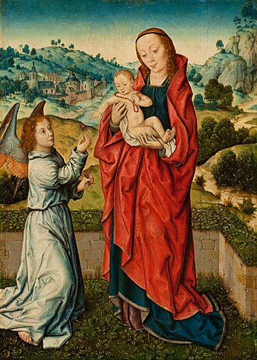
Aelbrecht Bouts, The Virgin and Child with an Angel, 1540’s

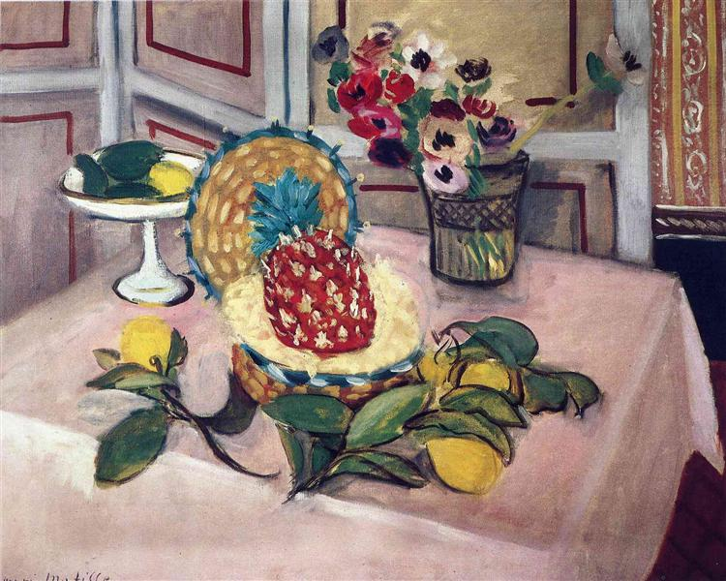
Henri Matisse, Still Life, Pineapples, Lemons, 1925

19
kid-friendly!
Justice in Action
DIY Free Projects for Independence at All Ages

Cozy comforters! Every soft and warm covering for chilly sleepers is comprised of three elements, with an optional fourth. All of this, with access to needle and thread, can be created from scraps of fabric, used clothing, or any textile that does not have a more important purpose and might otherwise be heading for the landfill. A soft, air-trapping blanket-like layer, top and bottom covering layers,periodic stitching through all three layers to hold it together, and to make it extra appealing, decorative designs appliqued on the top. As long as one has needle and thread, the rest can be created from all varieties of cloth.

Any old blanket, or towel, or piece of material with substance and air holes will work for the middle layer. But it can also be created from strips of multiple kinds of textiles (including unmatched old socks) cut into strips and woven into mats on a cardboard loom and then attached into a sizable blanket by “sewing” with more strips of fabric. This alone can be a cozy comforter, or it can serve as the middle later. The top and bottom covering layers can either be any soft piece of fabric such as stained sheets (stains can be covered with appliqued designs at the end) or can be made by sewing together pieces of scrap fabric, even unworn pieces cut from otherwise worn out clothing. The top and bottom should be slightly bigger than the middle layer. If you have pins, then you can pin the three layers together while you sew all around the perimeter (all four sides) to enclose the comforter. If you don’t have pins, skip ahead to the tying step, so that the comforter stays together while you sew the edges together. You don’t want to create a giant bag with a loose middle that can migrate and bunch. The tying step involves sewing through all three layers at regular distances (stitch through all three in one direction, then back through close by, so that you can tie the ends on the top and cut the thread to leave short tails). Doing this throughout the comforter will stabilize the middle layer. The optional decorations of designs or symbols can be appliqued to the top layer to make it more attractive, whether before the three layers are assembled, or after the comforter is finished. If you do it at the end, you can sew through all three layers as you attach it, creating more quilting, which is both attractive and functional in keeping the layers together. Use your imagination to create heart-warming designs that amplify the loving message of a cozy comforter.

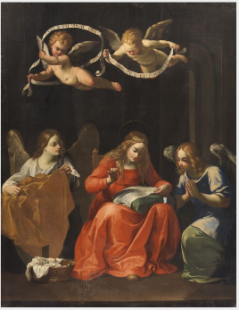
Guido Reni, The Virgin Sewing,
1575-1642

20
Mary’s Ward Global Classroom

“The soul is that which comes out of the Divine without ever leaving Him and goes back to Him without ever ceasing from manifestation. … These souls are emanated by the Lord to do His work in the world and each one comes upon earth with a special purpose, for a special action and with a special destiny, carrying in itself its own law which is imperative for itself alone and cannot be a general law.” The Mother, Words of the Mother – II. The Soul (the Psychic)

- Do we trust our own souls and those of others to lead authentic education?
- The first task of education must be to find one’s soul.
- The industrial model of education drowns out, or causes to wither by neglect, one’s own individual sense of purpose and directions
- Why should learning ever be boring? It is only so when learning is disconnected from natural curiosity and thirst for knowledge
- All the so-called core requirements will be met naturally and organically if one pursues one’s passions
- After all, what are those subjects which attract us other than the leading of the Divine, of our soul, toward the work that we are here to do?
- The idea that work is a burden, that toil and sweat are our punishment for original sin is a misinterpretation of the story of the Fall of Man in the Garden of Eden.
- The world is nothing but the delight of the Divine, whether we can perceive that or not.
- Let us guide children and those who request instruction by our own examples of svabhava (unique soul’s inclination) and svadharma (unique soul’s right path)
- The Mother said that all teachers should be yogis, doing their own spiritual work
- The thoughtful guide can assist students to turn inward and listen to their authentic selves
- Every student has inclinations and aspirations
- The work of the educational guide is to listen and help the student discern
- Learning that is soul-led will never be boring and should not and need not ever be imposed
- All souls are learners, regardless of biological age

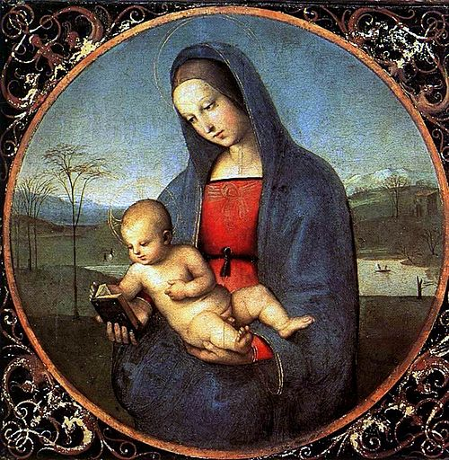
Raphael, Madonna and Child (The Conestabile Madonna), 1504

21
How You Can Help
- Learn deescalation and gray rocking skills both to help you survive the traumatic impact of current events and so that encounters with those who disagree will neither trigger you nor feed their desire to inflame you
- Read the wisdom of other nonviolent resisters
- Look for opportunities to plug into mutual aid actions locally
- Organize with neighbors to resist collectively
- Find a source of information that you trust and stay informed
- Include subtle, but recognizable, symbols of resistance in your attire or on your personal property to increase solidarity with those being targeted and fellow resisters
- Examples range from green frogs, pink cat hats, the color yellow, to non-authoritarian religious imagery, particularly those not utilized by fascists
- All images of Our Lady express compassion and motherly concern. Some famous Marian messages include: Our Lady of Guadalupe (“Am I not your Mother?”), Salus Populi Romani (Health/Salvation/Safety of the Roman People), Our Lady of Czestochowa (cut marks on her cheek from failed attempts to destroy the icon), Our Lady of Medjugorje (“Peace, peace, peace!”)
- Jesus’ message: “You did it to Me!”
- Join Mary’s Ward as a volunteer “sibling”

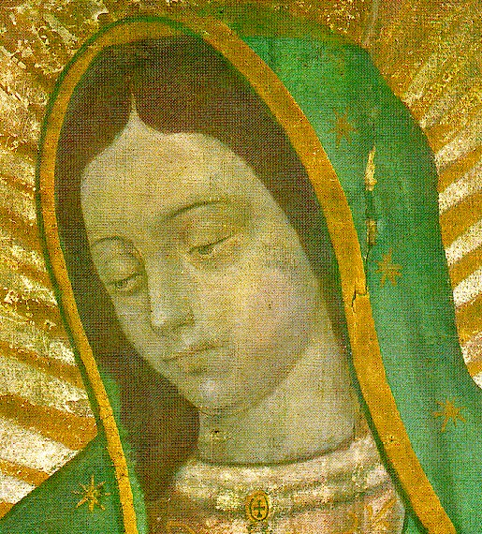
Our Lady of Guadalupe, 1531

22

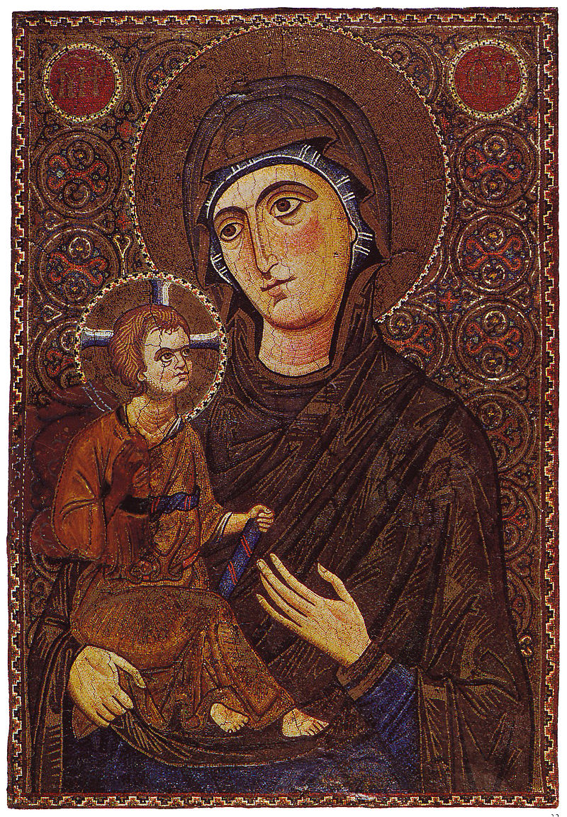
Tesselated icon in monumental style, Saint Catherine's Monastery in the Sinai, Egypt, early 13th century

marysward.com

