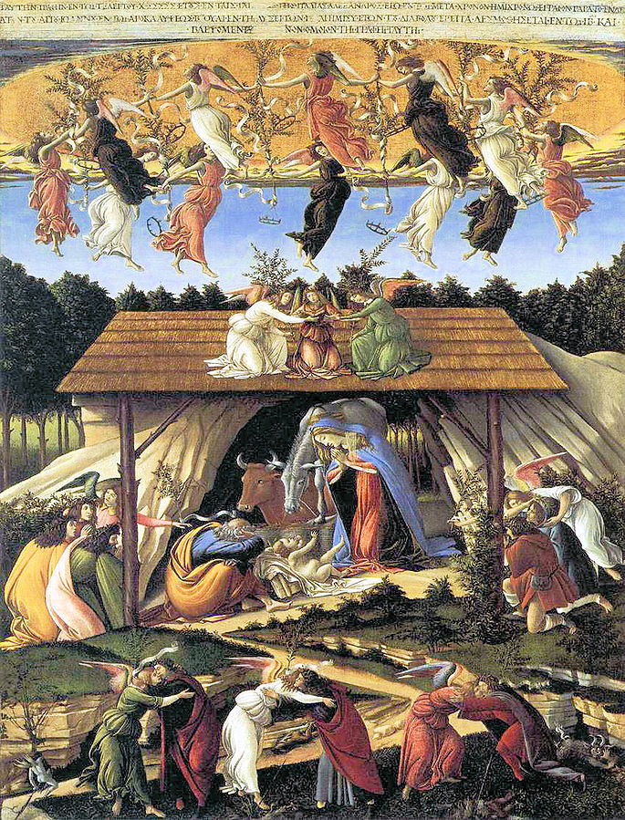
Ascend – The Monthly Publication of Mary’s Ward – December 2025 – Vol.1 No.12

From the Editor

There are many Christian feasts and commemorations this month, as well as what has become a global mega celebration, Christmas. This closely follows the Winter solstice, the day with the fewest daylight hours and longest period of darkness. But as optimists are quick to point out, this means that hours of daylight will steadily increase over the next six months. It may be the darkest time of year, but the light is returning, a very hopeful sign. December also brings feasts of Immaculate Conception, St. Nicholas, Our Lady of Guadalupe, St. Lucia in the Roman Catholic Church. Christians of most stripes count down the time until Christmas with Advent calendars, Jesse Trees, and Advent wreaths. The season is dark and cold in the Northern Hemisphere, but in most cultures, festivals of light and hospitality brighten the time.

Not in So Many Words takes up Matthew Chapter 12 in synopsis and bindu-point format. This month’s homily prepared for the Third Sunday of Advent, Gaudete (Joy) Sunday, contemplates John the Baptist and our own roles as prophetic messengers. Veda in Christianity revisits the Nativity scene and its Vedic roots.

Blueprint for Marian Maternal Life takes up the Roman Catholic dogma of the Immaculate Conception, why the Mother of God was necessarily, in the eyes of the dogmatic Church, virgin and conceived without sin and how Indian tradition went down a similar path in its developing concept of Maya as first Creatrix and later as Illusion. Not Serving Two Masters takes up the human necessity for community. Updates on Mary’s Ward activities are reported in Progress.

Chapter 12 A Headline about Goat Horns, featuring the phonic sound /h/, is the portion of kid-friendly Learning to Read with Goats serialized this month. Building with corrugated cardboard and flour/water paste is our kid-friendly DIY free project for all ages described in Justice in Action. How lifelong learning feeds our souls is the topic for Mary’s Ward Global Classroom Update this month.

Finally, How You Can Help presents more ideas for nonviolent resistance to fascism that can be practiced in daily life as 2025 yields to 2026.

Hail Mary! Jai Maa!

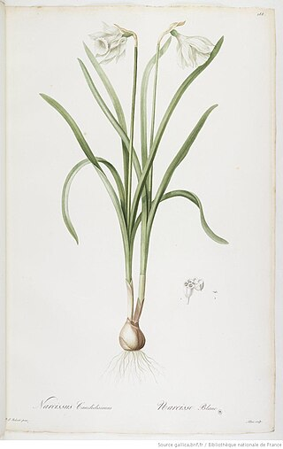
Selby Beebe-Lawson, Editor
December 1, 2025

Pierre-Joseph Redouté,
N. candidiassimus, 1808

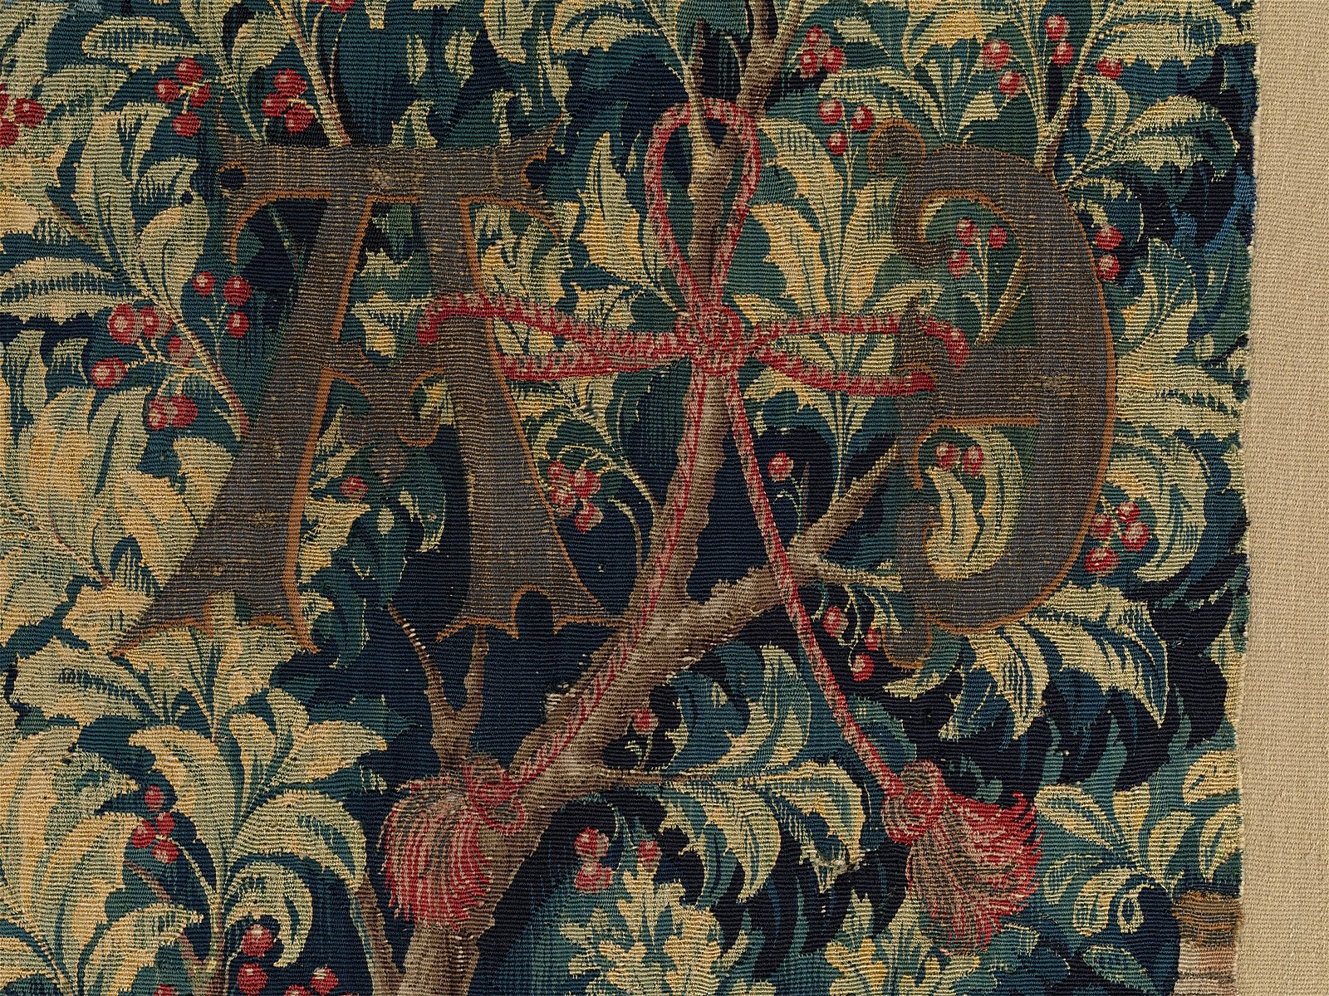
Detail from the Mystic Capture of the Unicorn from the Unicorn Tapestries, 1495-1505

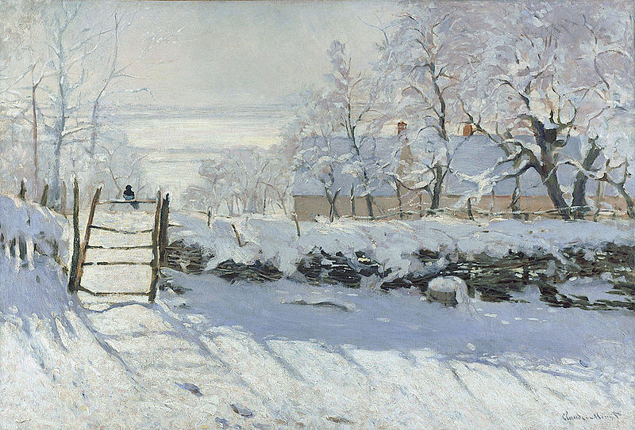

Claude Monet, The Magpie, 1868-1869

Table of Contents

Light

Not in So Many Words 1

Homily 3

Veda in Christianity 6

Love

Blueprint for Marian Maternal Life 9

Not Serving Two Masters 13

Progress 14

Life

LTR with Goats 16

Justice in Action 20

MW Global Classroom Update 22

How You Can Help 24

Sandro Botticelli, The Mystical Nativity, c. 1500-1501
December birth flowers are holly and narcissus. Holly’s green thorny leaves represent Christ’s crown of thorns and the red berries drops of blood. Narcissus symbolizes Mary’s purity and compassion.
Mother named holly Courageous Goodwill and narcissus Beauty Aspiring for the Supramental Realization
Not in So Many Words
Matthew 12
Synopsis
Pharisees criticized Jesus and his disciples for eating corn from a field on the sabbath. Jesus countered with examples of David and his company eating priestly bread and priests being sinless in temple work on the sabbath. “There is here” greater than the temple. Jesus references “I will have mercy and not sacrifice” (Hosea 6:6 “For I desired mercy, and not sacrifice: and the knowledge of God more than holocausts”.) They are innocent and He as Son of man is Lord even of the sabbath. Then in a synagogue he healed a man with a withered hand, stating that it is lawful to do good on the sabbath, infuriating the pharisees. Jesus left, many followed, and He healed all. Jesus quoted Isaiah 42:1-4 about God’s servant who pleases him, being gentle, to whom God has given God’s spirit, who will bring “judgment unto truth” to the Gentiles, offering them hope. Jesus healed a deaf mute person with a demon. Pharisees accused him of healing by the power of the prince of demons. He replied that a house divided can not stand. He asked by whom they cast out demons? If he heals by the spirit of God, then the kingdom of God has “come upon” them. Demons can not cast out demons. “He that is not with me, is against me” and whoever does not gather with me, scatters. The blasphemy against the Holy Spirit can not be forgiven in this world or the “world to come”. By the fruit a tree is known. “O generation of vipers” you can not speak good when you are evil. All will be judged by their words. Scribes and Pharisees asked for a sign. Jesus said none would be given except the sign of Jonah who was in the belly of the fish for three days and three nights. People of Nineveh and the Queen of Sheba will judge this evil generation because they believed Jonah and Solomon, and there is greater than both in the person of Jesus. An unclean spirit cast from someone wanders without rest, then returning to the healed host, brings seven more spirits and reinhabits the host. So shall it be with this wicked generation. Word came that Jesus’ mother and brothers were outside wanting to speak to him. whosoever shall do the will of my Father, that is in heaven, he is my brother, and sister, and mother. “Whosoever shall do the will of my Father, that is in heaven, he is my brother, and sister, and mother.”
Commentary
- Hosea 6:6 “For I desired mercy, and not sacrifice: and the knowledge of God more than holocausts” – acquiring knowledge of God, not giving up anything, is the goal. God wants communion with us through our knowledge of God.
- Rigid laws are not the point; love and mercy, doing good, that is sabbath
- Jesus heals all, with the Spirit of God = the kingdom of God “come upon” them
- The coming of the kingdom of God = manifestation of God’s Spirit
- Blasphemy of the Holy Spirit = denial of God’s power *; since God’s Spirit heals (forgives), rejection of that Spirit prevents healing (forgiveness).
1
- Sign of Jonah, three days and three nights, does not line up with the death and resurrection narrative, but does line up with the triplicity of the Vedic vision, within which the number three and the images of night and day are consistent references.
- Healing will not hold unless transformation and progress occurs
- Those who do the will of God are Jesus’ family. Clearly some of his biological earthly family was included as well. But fruit identifies the tree.
*Interestingly, God’s Power, His Śakti, is the Divine Feminine, the Universal Mother. Denial of this power can not be remedied, since it is by that power that all remedy is effected. Most of the Christian world, while scrupulously avoiding saying anything bad about The Holy Spirit, nonetheless, to varying degrees, deny the role of the Blessed Mother in redemption and her identity with God’s power.

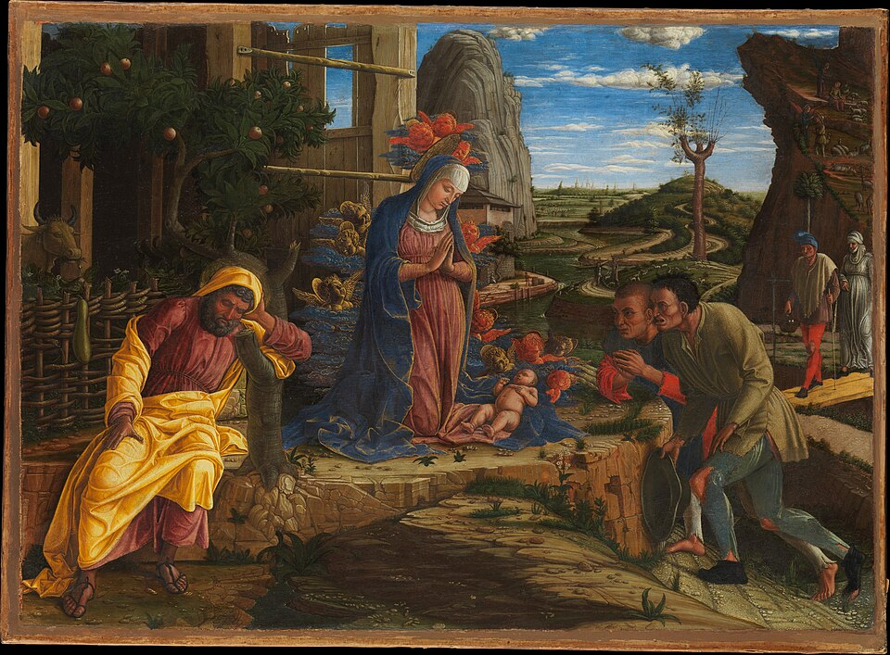
Andrea Mantegna, The Adoration of the Shepherds, 1450

2
Homily
The Third Sunday in Advent

The Collect

O CHRIST our Lord, we pray for strength to increase and multiply within our hearts Thy heavenly grace; that we, loving Thee above all things, may faithfully serve Thee in all good works; Thou who livest and reignest in the unity of the Father and of the Holy Spirit, one God, throughout all ages of ages. R/. Amen.

The First Lesson

The First Lesson is taken from the first chapter of the Book of the Prophet Malachi, beginning at the eleventh verse.

FROM the rising of the sun even unto the going down of the same My Name shall be great among the Gentiles, and in every place incense shall be offered unto My Name and a pure offering. Behold, I will send My messenger, and he shall prepare the way before Me; and the Lord whom ye seek shall suddenly come to His temple, even the messenger of the covenant whom ye delight in; behold, He shall come, saith the Lord of hosts. But who may abide the day of His coming; and who shall stand when He appeareth? For He is like a refiner’s fire, and like fuller’s soap. And He shall sit as a refiner and purifier of silver; and He shall purify the sons (children) of Levi, and purge them as gold and silver, that they may offer unto the Lord an offering in righteousness. Then shall the offering of Judah and Jerusalem be pleasant unto the Lord; and they shall be Mine, saith the Lord of Hosts, in that day when I make up My jewels.

Here endeth the Lesson.

The Second Lesson

The Second Lesson is taken from the first chapter of the Gospel according to St. Mark, beginning at the first verse.

THE beginning of the Gospel of Jesus Christ the Son of God; as it is written in the prophets: Behold, I send My messenger before Thy face, who shall prepare Thy way before Thee; the voice of one crying in the wilderness: Prepare ye the way of the Lord, make His paths straight. John did baptize in the wilderness, and preach the baptism of repentance for the remission of sins. And there went out unto him all the land of Judaea, and they of Jerusalem, and were all baptized of him in the river Jordan, confessing their sins. And John was clothed with camel’s hair, and with a girdle of a skin about his loins; and he did eat locusts and wild honey; and preached, saying: There cometh after me One mightier than I, the latchet of whose shoes I am not worthy to stoop down and unloose. I indeed have baptized you with water, but He shall baptize you with the Holy Ghost.

Here endeth the Lesson.

3
In the Name of the Father, and of the Son, and of the Holy Ghost. Amen.

Today is the Third Sunday of Advent, Gaudete Sunday, the Sunday when we express the joy of expectation as we await the Nativity of the Lord at Christmas. Our readings provide us with a prophecy of the coming of God’s messenger and reference to that same prophecy as fulfilled in John the Baptist. The story is familiar to us. A wild ascetic, clothed in animal skins and rough fiber, eating wild fruit, living and crying in the wilderness, warning all to prepare … the way of the Lord, to make His paths straight. We’re so familiar with the story – maybe thinking of that great song from Godspell, and the scene in the movie where all the disciples who hear the haunting call of John the Baptist converge on Bethesda Fountain in Central Park joyfully singing and splashing in the water https://www.youtube.com/watch?v=c1SiaCV26aQ&list=RDc1SiaCV26aQ (we know those words, they’re cool) – but no, a wild ascetic prophet living on the margins, challenging societal norms, calling out authority, do we joyfully run toward such a figure? Sometimes we recognize the prophets among us, sometimes we are those prophets, but sometimes we shun those prophets as other, as dangerous domestic terrorists, and we call out troops to suppress their voices or allow federal agents to brutalize, detain, and even deport them to some foreign wilderness. Where are we individually in this array of possible responses to the prophetic call to God’s peace and justice in our world?

What do prepare ye the way of the Lord and make His paths straight mean? If we consider the birth of Christ in several of it’s possible significances, then preparing the way or the path will make sense. The coming of Christ can refer to His birth in a rude shelter in Bethlehem two millennia ago or to His return at the end of the age, both of which stories have both literal and symbolic interpretations. Or it can also refer to the journey of the individual soul towards the Divine and the coming of God’s kingdom of heaven on earth. All of these meanings converge in the prophecies of Isaiah, Malachi, John the Baptist and others. For example, at Christmas time we sometimes see holiday cards with the images of the lion lying down with the lamb, prophetic imagery of God’s peaceable kingdom. So, focusing on the here and now of our souls’ journeys to God and our collaboration to hasten Christ’s kingdom of heaven on earth, how do we prepare the way and make straight the paths? John the Baptist was very clear that he was the forerunner, the messenger, not the Messiah. Likewise in our prophetic roles, while the Spirit of God dwells in our souls, we are not the accomplishers, but only the proposers of transformation in others and in society as a whole. We prepare the way and make straight His paths by facilitating, by catalyzing, by embracing, by embodying the transformation we promote. And we do all that by living the kingdom of God every minute of every day, by being God’s children and insisting that all others, with no exceptions, are as well. We prepare the way and make straight the paths by following the compass of Christ, clearing the obstructions of selfishness and division, marking the trails with the orange blaze of the Spirit’s gifts, offering the refreshment of spiritual fruits, and tending to the needs of travelers through the works of mercy. We prepare the way and make straight the paths by seeing and pointing out the kingdom of heaven where it manifests in our midst even now, even in such a difficult time. In short, we prepare the way and make straight the paths with love. Very simple. And very difficult, unless we really accept the simplicity of love. But if we do accept and practice love in its simplicity, then there is nothing but joy. Joy, joy, joy! Love prepares the way. Love makes straight the paths. And then the way and the paths are nothing but pure joy, because they lead to God, who is Love and Power and Truth and Light, according to our Act of Faith, Existence-Consciousness/Force-Bliss according to India’s traditions.

But the First Lesson, the prophecy from Malachi, gives us more than the prefigurement of John the Baptist. FROM the rising of the sun even unto the going down of the same My Name shall be

4
great among the Gentiles, and in every place incense shall be offered unto My Name and a pure offering. From the East to the West, in other words everywhere, everybody, the Gentiles, shall worship the Name of God. That is a beautiful prophecy in itself. My Name, capital M capital N, not the name of my (lower case m) God, or your (lower case y) God, or our (lower case o) God or their (lower case t) God, but simply God’s Name.

Behold, I will send My messenger, and he shall prepare the way before Me; and the Lord whom ye seek shall suddenly come to His temple, even the messenger of the covenant whom ye delight in; behold, He shall come, saith the Lord of hosts. Now this is getting very interesting, because all of a sudden this messenger sounds more like a Spirit than the human through which the Spirit speaks. What if the messenger is the Holy Ghost, the Holy Spirit, the Psychic Being according to Integral Yoga. Are we not told that the human is the temple of the Holy Spirit? … and the Lord whom ye seek shall suddenly come to His temple, even the messenger of the covenant whom ye delight in; behold, He shall come, saith the Lord of hosts. First we seek that Spirit, we aspire, we pray for the Spirit’s coming. Then that messenger comes and yes, we delight in the Spirit. We delight, and as Malachi goes on to explain, shudder a bit in awe and perhaps even fear. Sometimes a full blast of the Spirit literally blows us away. But who may abide the day of His coming; and who shall stand when He appeareth? We must be refined and purified in order to stand when He appeareth. Both Christianity and Integral Yoga confirm this idea that one must prepare for each higher level of consciousness in one’s ascent toward union with the Divine. We humans can’t take it all at once. Hence the steps of preparation before Sacraments and Ordinations. In Yoga the discipline is called tapasya, a word which implies application of concentrated pressure. In both East and West we are purified and refined as by fire or caustic soap, but the activity is spiritual, not physical. This, too is preparing the way, making straight the paths, and the result of this pressure and concentrated effort is our ability to absorb and transmit the higher light, not unlike the way jewels, which Malachi mentions at the end of this passage, are able to absorb and transmit light around them: and they shall be Mine, saith the Lord of Hosts, in that day when I make up My jewels.

So we prepare the way and make straight the paths both individually and collectively. Let us love with great joy until we become God’s jewels in Christ’s kingdom of heaven on earth.

In the name of the Father, and of the Son, and of the Holy Spirit. Amen.

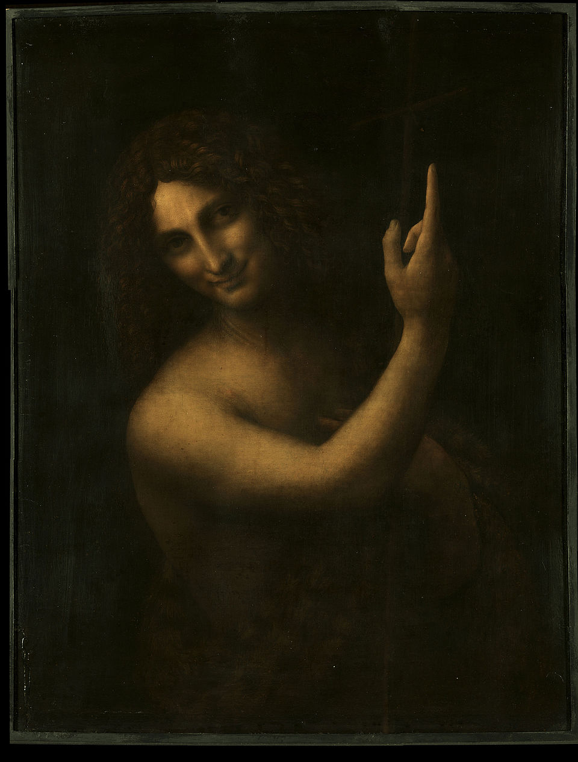
Leonardo da Vinci,
John the Baptist, 1513-1514

5
Veda in Christianity

शुक्रः शुशुक्वां उषो न जारः पप्रा समीची दिवो न ज्योतिः || RV 01.069.01
śukraḥ śuśukvāṃ uṣo na jāraḥ paprā samīcī divo na jyotiḥ || RV 01.069.01
Blazing out brilliant as the lover of the Dawn, filling the two equal worlds¹ like the Light of Heaven, thou art born by our will and comest into being all around us; thou hast become the father of the Gods, thou who art the Son. – Sri Aurobindo’s interpretation of RV 01.069.01

1. Or, the two companions

RV 01.069.01 is a very mysterious verse, even with Sri Aurobindo’s interpretation. “Blazing out brilliant”, effulgent, radiant, are images we find also apply to Christ.

“In him was life, and the life was the light of men. And the light shineth in darkness, and the darkness did not comprehend it.” John 1:4-5

“Again therefore, Jesus spoke to them, saying: I am the light of the world: he that followeth me, walketh not in darkness, but shall have the light of life.” John 8:12

“As long as I am in the world, I am the light of the world.” John 9:5

Agni, in RV 01.069.01, is shining “as the lover of the Dawn.” The Vedic image of the Dawn represent the Divine Mother who brings the light of the Supreme. Dawn, not personified, but as a time of day, is symbolic also within the Christian context. As both the time of day Jesus’ tomb was found empty and as a symbol of resurrection, dawn and the East, as direction of the sunrise, can be called primary symbols. Church altars traditionally face the eastern direction (before the years where liturgy was turned to face the congregation.)

Agni is “filling the two equal worlds¹ like the Light of Heaven”. The two equal worlds or two companions are heaven and earth. This reflects the Vedic conception of the golden egg, two hemispheres, each containing three elements, with a region in-between, also comprised of three elements. The middle region is where vijñana, Truth-consciousness, Supermind (in Sri Aurobindo and The Mother’s Integral Yoga) resides, where sacrifice and transformation take place. In the nativity narrative, Jesus is born at night, in the darkness, but his birth is announced to local shepherds by an angel, followed by all the heavenly hosts, undoubtedly a radiantly shining image. In Catholic Christmass (Christ’s Mass) is celebrated at midnight, and also known as the Shepherd’s Mass.

The arrival of Agni is described as a birth: “thou art born by our will and comest into being all around us”. Among us, might be what is meant by “all around us”. Matthew heralds the coming of Christ in 1:23 by quoting Isaiah 7:14: “Therefore the Lord himself shall give you a sign. Behold a virgin shall conceive, and bear a son, and his name shall be called Emmanuel.” Matthew interprets Emmanuel as God with us.

Agni is then described as bringing forth the Overmind world: “thou hast become the father of the Gods, thou who art the Son.” In a Christian context, this statement seems to have no relevance, except for the

6
reference to “the Son”. However, let us examine what Sri Aurobindo understands about the Gods and let us also consider who we are as Christians.

“Thus in these four verses of the opening hymn of the Veda we get the first indications of the principal ideas of the Vedic Rishis,—the conception of a Truth-consciousness supramental and divine, the invocation of the gods as powers of the Truth to raise man out of the falsehoods of the mortal mind, the attainment in and by this Truth of an immortal state of perfect good and felicity and the inner sacrifice and offering of what one has and is by the mortal to the Immortal as the means of the divine consummation. All the rest of Vedic thought in its spiritual aspects is grouped around these central conceptions.” Sri Aurobindo, The Secret of the Veda, 69 (emphasis mine).
Agni, the will, the psychic being, aspiration, Christ, has become the father of “powers of the Truth to raise man out of the falsehoods of the mortal mind.” Sri Aurobindo sees the gods as powers, faculties, aids to achieving higher consciousness beyond what is normal to humans. The will and aspiration “father”, produce, generate these powers. In that sense Agni is father, while remaining the Son of the Supreme. In a very similar way Christ leads us to higher realms of consciousness, shows us the Father, while remaining Himself the Son. And who are we as Christians? We are children of God, and as Romans 8:17 states: “And if sons, heirs also; heirs indeed of God, and joint heirs with Christ: yet so, if we suffer with him, that we may be also glorified with him.” Does that only refer to some distant glorification in heaven? The Church has taught so, but it needn’t be interpreted thus.
Let’s revisit RV 01.069.01 in light of the nativity scene portrayed in Christian households during this Advent season leading to Christmas.
“Blazing out brilliant as the lover of the Dawn, filling the two equal worlds¹ like the Light of Heaven, thou art born by our will and comest into being all around us; thou hast become the father of the Gods, thou who art the Son.” Shining from his humble bed of straw, the Infant Savior lies in the night, surrounded by the inanimate rock of the cave, the elements, the stars; the plant-produced wood and straw of the manger; the warmth of the animals – donkey, ox, and sheep at the very least; the people – his mother Mary, foster father Joseph, the shepherds; and many, many angels – heavenly beings without bodies, pure spirit, messengers, helpers, the gods of the Veda? And He Himself is Son of the Most High, God with us. The nativity scene, the crèche, is a symbolic representation of the same truth of which Vedic mantra RV01.069.01 is also a symbolic representation. The meaning of both is that God answers our aspiration with grace in the form of the vehicles we need to achieve reunion with God. God is not far away. God is as close as our will to unite with God. God is “with us”, “all around us”, in a form which both fathers spiritual help and is Son of the Supreme.

Merry Christmas! OM tat sat!

7
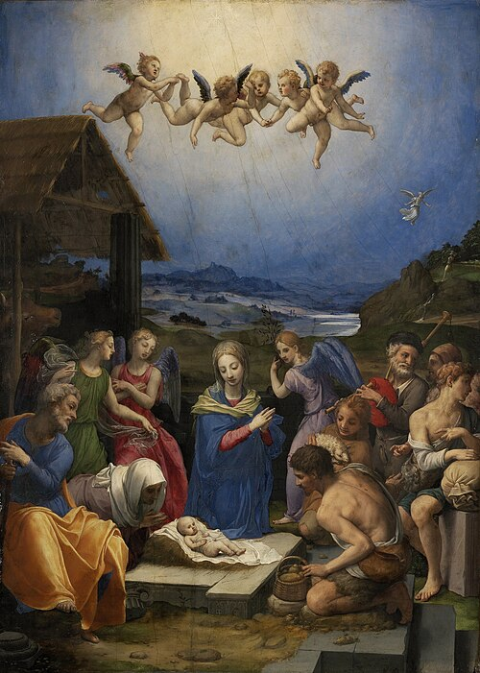
Bronzino, The Adoration of the Shepherds, 1539-1540

Elements of interest: rock, broken Roman pillar beside crude shed with capital next to manger, straw roof and in manger and basket of produce including cucumber – symbol of immortality/resurrection, ox and ass and sheep, family and shepherds, angels, star, hills in the distance, angel appearing to shepherds, water descending from a crevice in the rock of the hill, angel holding plant – possibly olive branch.

8
Blueprint for Marian Maternal Life
“We declare, pronounce, and define that the doctrine which holds that the most Blessed Virgin Mary, in the first instance of her conception, by a singular grace and privilege granted by Almighty God, in view of the merits of Jesus Christ, the Savior of the human race, was preserved free from all stain of original sin, is a doctrine revealed by God and therefore to be believed firmly and constantly by all the faithful.” Definition of the Dogma of the Immaculate Conception, Pope Pius IX. Ineffabilis Deus, 1854
“The Vedic Rishis thirsted for Immortality, Buddha wanted Permanence, Jesus preached Compassion, Sri Aurobindo promised Perfection and to attain it, the first requisite, what men need today, is Security.” The Mother, Agenda, March 27, 1963

In the above two quotes we see a collision of worldviews, especially as regards Christ’s purpose in incarnating. The Church sees Jesus as “the Savior of the human race”, come to live and die and rise again to save humankind from original sin. In The Mother’s view, we see Christ as someone preaching love of neighbor as self. The dogma of the Immaculate Conception (Mary’s, as distinct from the concept of the virgin birth of Jesus) was an inevitable result of the acceptance of the doctrine of original sin, the idea that when Adam and Eve disobeyed God in the Garden of Eden and were expelled, that tendency toward sinfulness, concupiscence, was genetically wired into humanity as a result, requiring a Savior to expunge it from our record. The Church regards baptism as a sacrament which removes original sin. The dogma of Mary’s Immaculate Conception was necessary, since a flawed human being could not be a safe guardian of the Divine in the form of a helpless infant. Therefore, the dogma is conceived as preserving Mary from original sin by the merits of Christ’s future redemption.
However, there are alternative interpretations of the Fall of Man in the Garden of Eden, and thereby alternative views of Mary as the new Eve. Having engaged with the serpent and convinced her husband also to partake of the forbidden fruit, Eve is seen as the most fallen character of the Eden drama. She must be replaced by a sinless, immaculate, woman who will give her total assent, her fiat, to God’s plan to undo the disobedience of Eve. Makes perfect sense unless the original understanding of the meaning of the Garden of Eden narrative is wrong.
The Mother say about snakes, “The Christians say it's the spirit of evil, but this is due to a lack of understanding.
“Théon always told me that the true interpretation of the Biblical story of the serpent in the Garden of Eden is that humanity wanted to pass from a state of animal-like divinity to the state of conscious divinity by means of mental development, symbolized by eating the fruit of the Tree of Knowledge. And this serpent, which Théon always said was iridescent, reflecting all the colors of the prism, was not at all the spirit of evil, but the power of evolution – the force, the power of evolution. And it was natural that this power of evolution would make them taste the fruit of knowledge.
9
“Now, according to Théon, Jehovah was the chief of the Asuras*, the supreme Asura, the egoistic God who wanted to dominate everything and keep everything under his control. And of course this act made him furious, for it enabled mankind to become gods through the power of an evolution of consciousness. And that's why he banished them from Paradise.
Although told in a childish manner, there's a great deal of truth in this story, a great deal.” The Mother, Agenda, February 4, 1961
If the serpent represents not disobedience and evil, but the path to evolution from animal-like human to mental human on the way toward divinity, then the woman’s role is an essential, rather than a regrettable, one. Mary need not be preserved from sin in order to bear the Christ, but rather represents the evolutionary progress since Eve. She is the Divine Mother who bears the recognizable soul, the psychic being, to humanity, the light that dispels the darkness of human ignorance, God with us.
Interestingly, the role of the Divine Mother in the Veda underwent a similar distortion through the ages. And why not, as she is the entrance point of the Divine within humanity. Powers that do not want evolution are militating for distortion. Originally, in the Ṛgveda, Maya is the creatrix, the power of the Supreme, the Dawn, the Śakti, the dynamic truth, ṛtam. But later, as the West went toward materialism and the East toward pure spirit, Maya was seen as illusion. When the goal of a traditional yoga became uniting with the Divine and escape from life, then it became simultaneously reasonable to see all aspects of the life to be escaped as illusory. But Maya is the Divine Mother, and in the Integral Yoga of Sri Aurobindo and the Mother, union with the Divine is the work of yoga only half done. The fulfillment of the yoga lies in the divinization of all of creation, not individual escape.
The definition of the dogma of the Immaculate Conception and the distortion of the role of Maya both resulted from the Spirit/Matter divide that occurred after the post-Vedic period. The West concentrated on solely on matter, while the East abandoned matter for spirit alone. Jesus and Sri Aurobindo both sought synthesis of the two, Jesus through reforming Judaism, Sri Aurobindo through integrating all known yogas into the Integral Yoga. Through their lenses we can see the Divine Mother more accurately as the consciousness-force of the Supreme. She is not fallen, not illusory, but the Spreme’s own power to execute the Supreme’s will. She is sinless because she is in perfect harmony with Divine will, not because of grace at the moment of conception to remove sin. She is creative, dynamic Truth because the Supreme inhabits every aspect of creation.
In 1858, four years after the proclamation of the dogma of the Immacualte Conception of Mary, a fourteen-year-old girl in Lourdes, France saw an apparition of a beautiful lady in a grotto in a boulder. The lady prayed the rosary with her And asked her to ask the religious authorities to build a church there. When the young seer, Bernadette Soubirous, repeatedly asked the lady for her name, the lady finally said, in the local dialect spoken by Bernadette, “I am the Immaculate Conception.” When this was related to the local priest, he believed her, as it was impossible for such a poorly educated child to have heard such a complicated phrase made public just four years prior in Rome. But let’s consider the
* Asura: demon of the mental plane embodying the forces of division and darkness.

10
implications of the lady’s words. “I am the Immaculate Conception”, not I had an immaculate conception. In both Vedic, Jewish, and Christian traditions, when someone with spiritual authority says, “I am”, it no doubt has significance. The Taittiriya Upanishad, the burning bush, and the Gospels all come to mind. “I am the Immaculate Conception” must mean something like ‘I am the sinless creation’, ‘I am the pure idea’, which is another term for Truth-consciousness, vijñana, Supermind, the Maya of the Vedas! Around we go and back we come!
Hail Mary! Jai Maa!
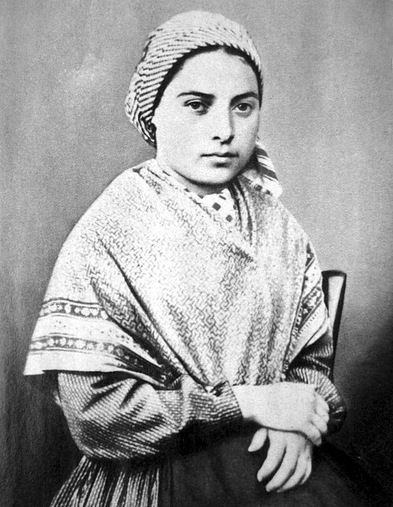
Bernadette Soubirous, c. January 1, 1958 (age 14)

More about the details of this apparition will be discussed in the February 2026 issue of Ascend.
11
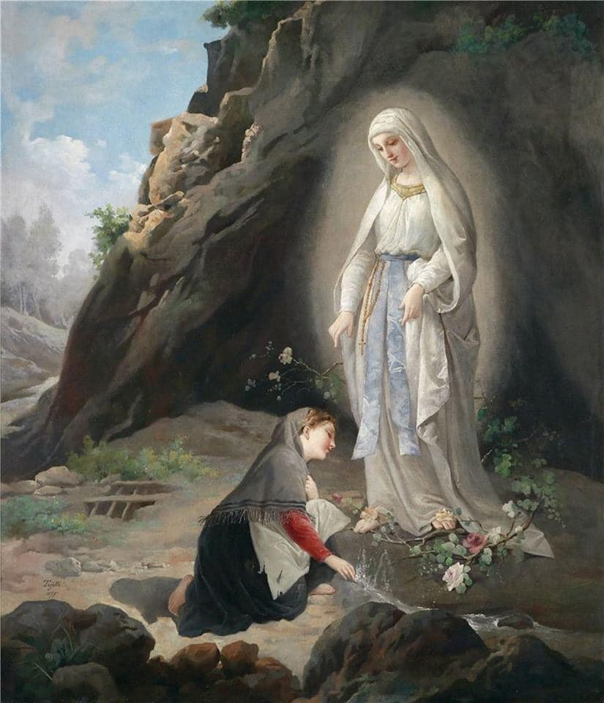
Virgilio Tojetti, Our Lady of Lourdes and Bernadette Soubirous, 1877

12
Not Serving Two Masters
Stepping Out of the Money Paradigm by Choice

Community is the twelfth and final human necessity that we will consider this year. (We will begin our list anew in 2026 and see in what new ways we can step outside the money paradigm to fulfill them after a year’s time!) People are not wired to be hermits, at least not the majority of folks. Having sufficient alone time can seem like a crucial need when one is housed in constantly crowded conditions. But given adequate privacy, humans are communal. Being overly isolated can have truly deleterious effects on mental, physical, and spiritual health.

The problem for many is that without adequate resources to secure safe, individual housing, which permits privacy and meeting of basic needs, communal shelters or encampments are often the only alternative, which reverse the preferred balance of when to be alone and when to be in community. This is also because being in community is not just about being with random people. Community expresses shared values or interests more comfortably than just shared needs. So to meet this need to be in community with like-minded people, various kinds of associations are helpful. Many are free, but may have to be sought on the internet or in person. Groups naturally form around shared religious or political beliefs, interests such as hobbies and activities, artistic pursuits, or even volunteering opportunities. There are book clubs and author presentations available through public libraries, community theater productions in local theaters, volunteer jobs through local nonprofits, and local organizing meetings in neighborhoods. With access to the internet, groups can be located anywhere globally, but even without the web, opportunities exist everywhere locally.

Shared interest, enthusiasm, purpose, and results all nurture a sense of accomplishment and belonging. Community is necessary, but happily does not need to cost money. And should one wish for a group that does not yet exist, consider it an invitation to start a new group! It may be just the gathering that others are looking for as well!

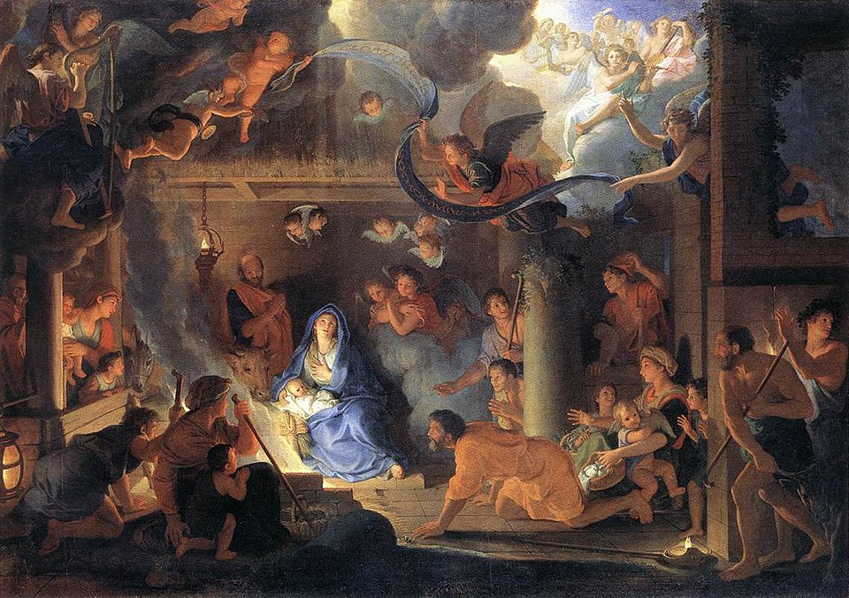
Charles Le Brun, The Adoration
of the Shepherds, 1689

Mineral, vegetable, animal, human, and spiritual community.

13
Progress
- marysward.com has been updated and the MW blog restarted!
- A very professional and comprehensive estimate for roof replacement on the Springfield House was received. The extremely poor condition of the house came into clear focus. Counsel from people knowledgeable about structure rehabilitation and from those with knowledge of the history of the project resulted in unanimous advice that SonLight sell the property.
- In the spring personal property will be removed and an advantageous sale (perhaps straight to a builder) will be sought.
- Focus will also shift to development of Mary’s Wood and Mary’s Hill properties to meet Mary’s Ward needs.
- Interest in the intersection of Veda and Christianity through the lens of Sri Aurobindo and The Mother’s Integral Yoga is increasing! A collaborator in India has signed on to the research! A few bindu-points and a short video are requested for a Veda conference this month and a ten-minute presentation is requested for a conference in February 2026, both in India. Participation will be with notes and video for the former and via zoom for the latter.
- A method of wood replacement by layered corrugated cardboard is being tested. If successful, walls and shelves will be created for Solace of Migrants Mission/studio.
- The above method could certainly be used to build a dome hermitage prototype. A method of waterproofing with biodegradable materials will be tested. Otherwise, a combination of methods: reinforced cardboard, waterproof fabric, and earth will be tried.
- Anti-progress may have been the result of theft at Mary’s Wood. Notification was received that the framed meeting/chapel/meditation barn is now reduced to a few 2x4’s. The site is well-hidden from the road, insuring privacy for future use, but also for theft. The site will be inspected at the earliest possible opportunity.
- As construction begins in Mary’s Wood and on Mary’s Hill, frequent visits will be needed to insure the safety of the project. Eventually, residence by MW members would be best.
- The MW library has recently been increased by a 5/6 complete set of the Collected Works of Sri Aurobindo (every volume is precious!) and eight new books on topics related to tyranny and resistance.
- Our MW seminarian continues through the seminary curriculum.
- The little free library/pantry has been painted with sunflowers and stands ready to serve once the outdoor location is determined.
- A concept of mobile micro locations (“beads on a necklace”) is under consideration: Auromobiles!
14
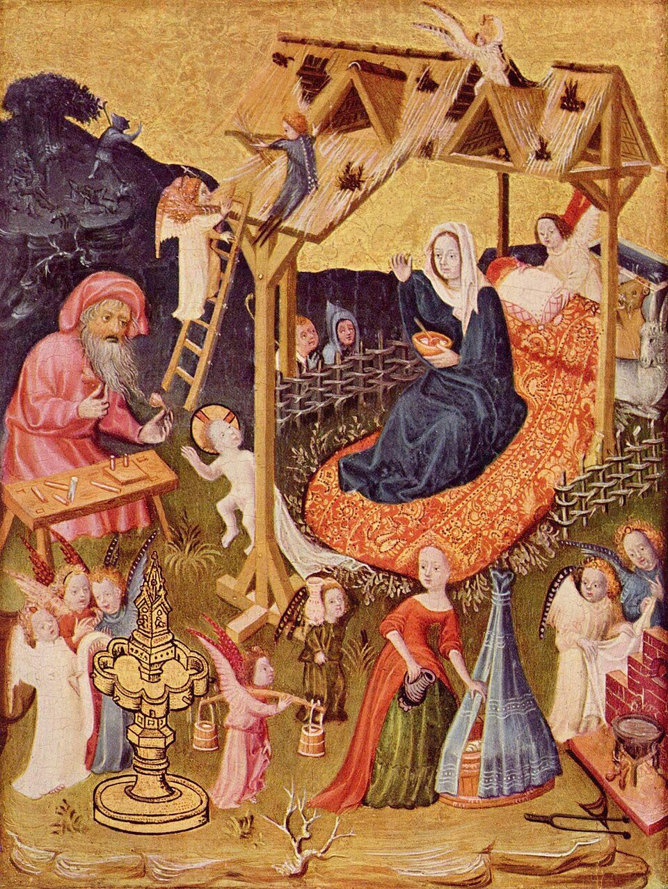
Mittelrheinischer Meister, Holy Family and Angels, 1420
Of particular interest is the wholly inadequate roof!

15
kid-friendly!
Learning to Read with Goats
Chapter 12 A Headline about Goat Horns

“Heigh ho, hillbilly girls! I’m happy to help you with your hair. Have your hairbrushes and hair ties; I will help you with any hairdos you have in mind,” hailed Farmer Lane.

“Here I am,” hollered Linh, with hairbrush and hair ribbons in hand.

“Hello,” Hong hopped into the room with her hair hardware as well.

“Hee hee,” hinted Uyen from behind the heavy door.

“How about,” Linh held everyone’s attention as she hunted for hoped-for inspiration. It came, in humorous form, as she thought about the happy goat herd. “How about goat horn hairdos?”

“Hmmmmm,” hazarded Farmer Lane. “Hair held high on your head, each half braided and crossed to the other side, where it is hitched so that the hair hanging from your braids sticks out like horns. Is that it?”

“Hooray!” the girls happily embraced this goat-themed invention.

Horn hairdo hoopla ensued.

“Our hair doesn’t hurt to handle,” began Hong.

“Unless you pull it,” interrupted Linh in a mildly mean way.

“Or unless it gets tangled,” Uyen hastened to add.

“But goat horns are hard, and look like they could hurt you,” finished Hong, ignoring the unhelpful interruptions.

“Goat horns are very hard,” agreed Farmer Lane. “And while horns have hurt humans, when we understand how goats use their horns and how to remain safe, then horns are not harmful to us. They are beautiful and very helpful to goats. Each pair is unique in its combination of color, size, shape, and texture.”

“Grandma, may we help you with goat housekeeping this morning, and hear more about goat horns?” asked Linh hopefully.

“Happy to have you help with the herd,” she replied. “Have some homemade applesauce and walnut halves, then we’ll head to the barn in hoodies and heavy boots.”

“Hoo! Hoo! Hoo! Hoo!” hooted the girls as they marched heroically, their horn hairdos bouncing rhythmically.

16
The hungry girls hovered at the table, heartily eating their homemade applesauce and walnut halves breakfast. Afterwards they hurried to find hoodies and heavy boots for their hike to the goat barn and headed out.

“Hip, hip, hooray!” hollered Hong as they hit the mini highway path down the hill. Farmer Lane held the barn door open and the girls hustled inside.

“Horns and horns and horns and horns,” remarked Uyen.

“Are goat horns hollow inside, Grandma?” Linh asked, hastily grabbing Farmer Lane’s hand.

“No,” Farmer Lane replied, “look here at Hilary’s horn. Half its height got broken off and you can see that there is no empty space inside.”

“Is that dried blood, Grandma?” Hong hoped Hilary was not hurting.

“Yes, healthy horns have flesh inside, with blood. The horns act like radiators to let off heat and cool the goats in hot weather. Excess heat from their bodies passes from their blood to the air through their horns.”

“Don’t goats sweat, Grandma?” wondered Linh hurriedly.

“No, they do not perspire, so their only way to cool off is heat radiation through their horns. Perhaps it is that way because perspiration might leave more of their scent for predators to track.”

“Do goats fight with their horns, Grandma?” Uyen was remembering loud noises from goat horns hitting one another.

“That’s a really interesting question, Uyen, because the answer is yes and no. When goats are challenging one another, like when two bucks want to know who is king, and thus who will get to breed first with the does, they do butt each other with their heads down. Their horns hit and make a very loud sound, amplified even louder by the hollow barn. Then, with horns together, they push each other to see who is stronger. The does do the same thing to determine the queen. But none use their horns to poke or hurt as you might imagine.”

“Some of the bucks have really big horns, and the ends look pointy and sharp,” Linh hastened to point out.

“They look pointy on the ends because they start to emerge when the goat is only two weeks old, and the kid’s head is very small. They continue to grow for the goat’s entire life. The pointy ends are hard, but not sharp.”

“Why do I sometimes see pictures of goats with no horns, Grandma?” observed Hong.

“Many goat farmers take actions to prevent their goats’ horns from growing. This is called disbudding. Occasionally a goat is born with no horns naturally, we call that a polled goat, but that is somewhat rare. Horns are a necessary body part for goats in the wild.”

17
“Are they more than radiators?” Linh was still unsure about how harmless to humans they were.

“Besides reducing heat and settling disputes, horns help goats relocate objects or small animals that are bothering them. They lift and toss with their horns the same way we toss hay with a pitchfork. They do not stick the object with the ends of their horns as we stick a fork in food, they scoop and toss. I’ve seen a doe do it to a kid who mistakenly thinks she is his mom. She relocated the kid without harming it.”

“So are horns safe for us to be around?” Hong wondered.

“The only danger from horns comes from not giving the goat enough room to maneuver without bumping you with them. And, remember, as I told you, never scratch a goat between the horns, although this is the place they most love to be scratched, unless you really know what you’re doing. Any sudden movement of the goat’s head, in reaction to a strange noise, for example, could endanger your hand. No human hands between goat horns, is a good safety rule.”

“So they need space, Grandma, just like you say we do when we get upset.” Uyen was obviously paying close attention.

“One more hilarious use of horns is as a handy back scratcher!” Farmer Lane added.

“The horns really start growing when the kids are two weeks old?” Linh remembered newborn kids without horns.

“They’re so huggable when they’re first born.” Uyen held and rocked an invisible kid.

“But after two weeks, you have to be more careful,” Linh reminded her.

“How about this headline about goat horns,” Hong proposed happily. “/h/, /h/, /h/, /h/, horns always growing, two weeks after birth goat horns will be showing.”

“Heavenly hullabaloo,” noted Farmer Lane whimsically.

“Heroic,” Linh said, hoisting Hong’s hand in the air.

“Ha ha ha, more hoopla,” giggled Uyen.

“Please help me by carrying flakes of hay to the hay rack, after I heave the bales into the corral and cut the baling twine,” Farmer Lane invited, recalling Linh’s request to help with goat housekeeping. “I will do some hoof-trimming, then I have a hodgepodge of other little helps, if you like, before we head back to the house.”

The girls hurried to grab and transport the light flakes, into which the heavy bales naturally broke. They distributed the hay in the racks throughout the barn, giving the hungry goats plenty of space for eating, as Farmer Lane checked their hooves. After all the hay was transported, the girls hobbled on their heels around in a circle, repeating their headline and making their goat horn hairdos bounce to the beat.

18
“/h/, /h/, /h/, /h/, horns always growing, two weeks after birth goat horns will be showing.”

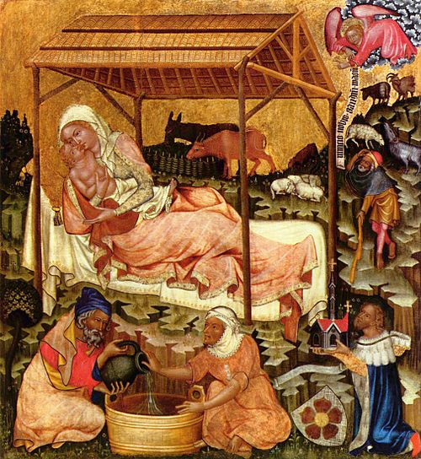

Master of Vyšší Brod, Nativity, 1350

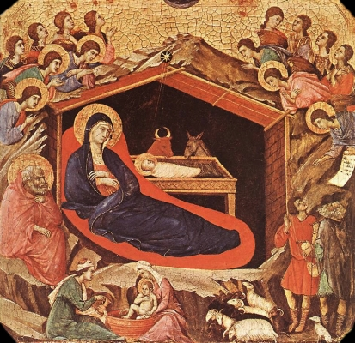

Duccio, Maestá, 13th century

19
kid-friendly!
Justice in Action
DIY Free Projects for Independence at All Ages

Reference was made in this month’s Progress article to a technique of reinforcing corrugated cardboard to make it a wood substitute. This procedure was gleaned from a video by a creator called NightHawkInLight https://www.youtube.com/watch?v=45JhacvmXV8. This video also presents a bio-friendly waterproofing mixture. This Justice in Action project will focus only on the cardboard reinforcing aspect, although I link the video for those who want to know about both. The making of the paste for this reinforcing project requires a short amount of cooking, so while this is a project for all ages, very young participants need to either get help with cooking or resort to uncooked flour and water paste.

The essence of the concept here is layering corrugated cardboard in perpendicular directions so that the corrugation lines (the texture of stripes somewhat visible) are layered horizontal-vertical-horizontal-vertical-horizontal – or vice versa – in five layers. The video creator suggests not worrying about trimming the cardboard until they are pasted together and dry. In any case, before or after pasting, trimming involves using a sharp cutting tool – saw or box cutter – so again, adult supervision is necessary. However, if you are a young child and want to try this, I suggest simply ripping the cardboard along already creased lines (like detaching box flaps), making simple paste with flour and water, and trying it by yourself!

The paste is based on a simple flour and water mixture, made more spreadable by blending and cooking. But the power of gluten to hold cardboard together is there in the simple mixture. For those with access to a blender and a cook surface, add flour and water (1-to-5 in proportions) to a blender and blend until smooth. Heat in a saucepan until just starting to boil. Remove from heat, cool, and store in jars with lids. In the refrigerator it keeps for weeks.

Brush paste on top of bottom layer of cardboard, then place next layer (with corrugation at 90 degree), add paste on top, add another layer in the same direction as the first. Continue until five layers are assembled. Place weights on top (stacks of books, for example) over the entire surface and allow to dry. The rigid piece can be trimmed once it is dry. Different pieces of assembled layers can be attached using more cardboard and paste. Regular paper mâché can create a smoother top surface, cover rough edges and further reinforce finished products. Allegedly this technique can create sheets as strong as drywall, or furniture, including bookshelves. Paint and waterproofing mixture can also be applied for potential outdoor use.

Layering structured (corrugated) cardboard with paste (water and plant protein) does make sense as a way to reconstruct the strength of wood. But unlike finished lumber, cardboard is free and readily available and flour is (thus far) relatively inexpensive.

Cardboard scraps and paste can be made into cardboard clay. Read the Progress article in future issues of Ascend to see how testing of these proposals pans out! Meanwhile, happy cardboard constructing!

20
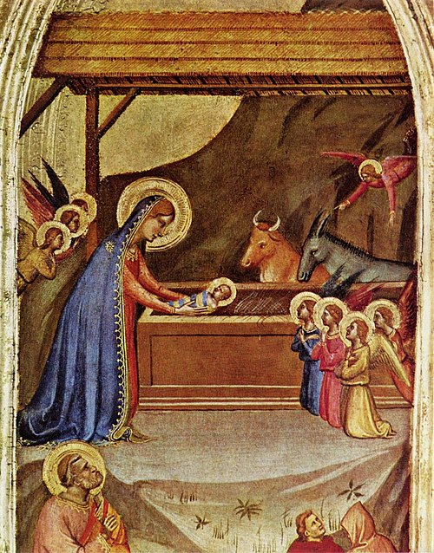
Bernardo Daddi, Birth of Christ, c.1325-1350

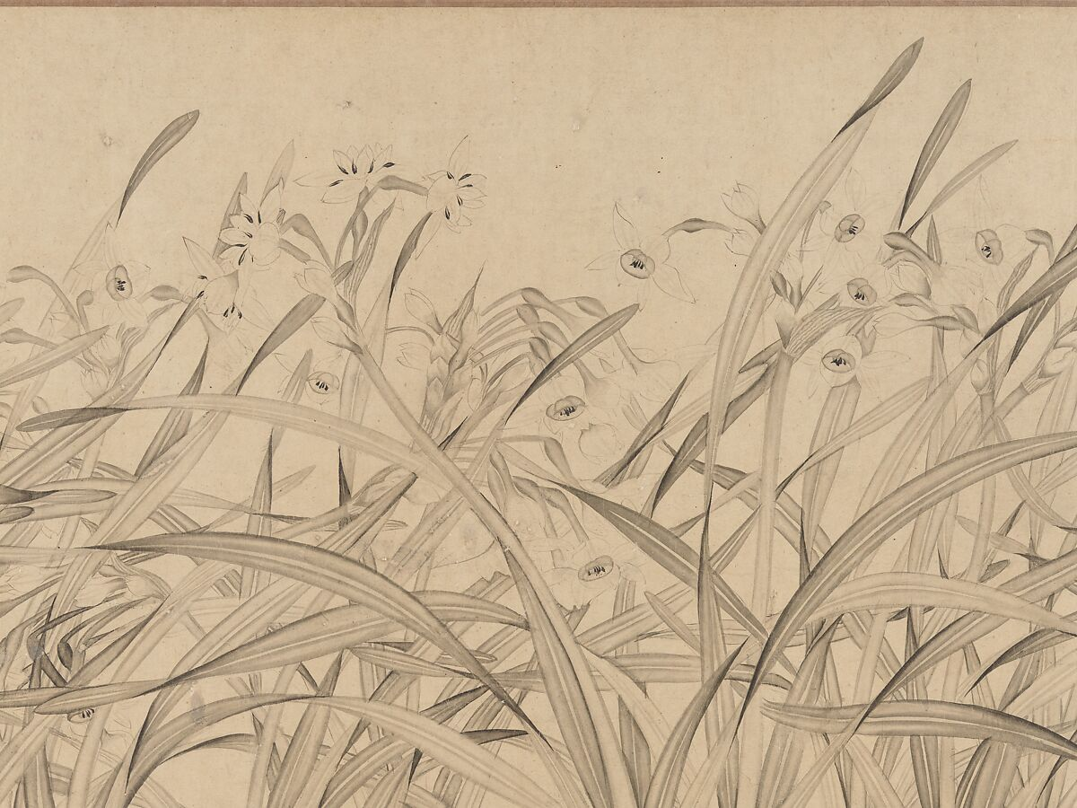
Zhao Mengjian, Narcissus, mid-13th century

21
Mary’s Ward Global Classroom

“The mothertongue is the proper medium of education and therefore the first energies of the child should be directed to the thorough mastering of the medium. Almost every child has an imagination, an instinct for words, a dramatic faculty, a wealth of idea and fancy. These should be interested in the literature and history of the nation. Instead of stupid and dry spelling and reading books, looked on as a dreary and ungrateful task, he should be introduced by rapidly progressive stages to the most interesting parts of his own literature and the life around him and behind him, and they should be put before him in such a way as to attract and appeal to the qualities of which I have spoken. All other study at this period should be devoted to the perfection of the mental functions and the moral character. A foundation should be laid at this time for the study of history, science, philosophy, art, but not in an obtrusive and formal manner. Every child is a lover of interesting narrative, a hero-worshipper and a patriot. Appeal to these qualities in him and through them let him master without knowing it the living and human parts of his nation's history. Every child is an enquirer, an investigator, analyser, a merciless anatomist. Appeal to those qualities in him and let him acquire without knowing it the right temper and the necessary fundamental knowledge of the scientist. Every child has an insatiable intellectual curiosity and turn for metaphysical enquiry. Use it to draw him on slowly to an understanding of the world and himself. Every child has the gift of imitation and a touch of imaginative power. Use it to give him the groundwork of the faculty of the artist. It is by allowing Nature to work that we get the benefit of the gifts she has bestowed on us. Humanity in its education of children has chosen to thwart and hamper her processes and, by so doing, has done much to thwart and hamper the rapidity of its onward march. Happily, saner ideas are now beginning to prevail. But the way has not yet been found. The past hangs about our necks with all its prejudices and errors and will not leave us: it enters into our most radical attempts. to return to the guidance of the all-wise Mother, we must have the courage to take up clearer knowledge and apply it fearlessly in the interests of posterity. Teaching by snippets must be relegated to the lumber-room of dead sorrows. The first work is to interest the child in life, work and knowledge, to develop his instruments of knowledge with the utmost thoroughness, to give him mastery of the medium he must use. Afterwards, the rapidity with which he will learn will make up for any delay in taking up regular studies, and it will be found that, where now he learns a few things badly, then he will learn many things thoroughly well.” Sri Aurobindo, On Education, 34-35

- Lifelong learning should be approached in the same way
- “Almost every child [person] has an imagination, an instinct for words, a dramatic faculty, a wealth of idea and fancy”
- “Every child [person] is a lover of interesting narrative, a hero-worshipper and a patriot”
- “Every child [person] is an enquirer, an investigator, analyser, a merciless anatomist”
- “Every child [person] has an insatiable intellectual curiosity and turn for metaphysical enquiry”
- “Every child [person] has the gift of imitation and a touch of imaginative power
- Let us rekindle the imagination, instinct, dramatic faculty, wealth of idea and fancy, love of narrative, hero worship, patriotism, spirit of enquiry and investigation and analysis and anatomy, insatiable intellectual curiosity, turn for metaphysics, gift of imitation and touch of imaginative power within us.
- Let us learn, study, question, explore, discover, experiment and create with courage and humility and perseverance.

22
“When, on the contrary, you are convinced that what you know is nothing compared to all which remains to be known, when you feel that what you have done is just the starting-point of what remains to be done, when you see the future like an attractive sun shining with the innumerable possibilities yet to be achieved, then you are young, however many are the years you have passed upon earth, young and rich with all the realisations of tomorrow.” The Mother, On Education, 21 February, 1968

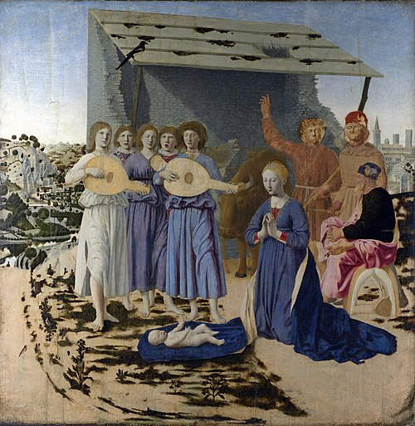
Piero della Francesca, The Nativity (unfinished), 1460-1475

The unfinished nature of this work speaks to the lifelong aspect of education and personal growth. Evolution is never finished. One species overpasses another as the world of involved Spirit expresses itself in increasingly higher forms on its way to complete manifestation of the Divine. We do our small part when we aspire for higher consciousness and work to perfect our instruments through joyful, lifelong learning.

23
How You Can Help
- Hold firm in not patronizing businesses that support billionaires and fascists
- Find and support local merchants, especially those owned or operated by targeted groups
- Locate and join local co-ops
- Wear something yellow every day – it’s a small ask, not widely recognized yet, but signals those who know that you are fighting tyranny. It can be as simple as a button, a kerchief, a scarf, a hat, a bracelet, beads, a ribbon, a patch
- Research, find, and learn protest songs from around the world – music at gatherings, vigils, protests really does raise spirits
- Lean into tactical frivolity with all necessary purchases. Do you need to buy a gift or something for your home? Make it a frog, a sunflower, a chicken, loud and cheerful and recognizable as defiantly nonviolent
- Fascists predict that resistance dresses in black, covers with masks, and looks sullen or threatening. Be colorful, peaceful, ebullient, helpful, loving and both quietly and loudly so.
- Incorporate cultural symbols, rainbows, images of diverse peoples into your attire. We are fighting erasure of peoples and cultures and our blessed diversity as Americans.
- Be creative in counteracting the terrible symbols and reality of white supremacy in our nation. If you are a follower of Jesus, search for new symbols that separate you from the Christian Nationalists who cower behind the cross and Bible. No, they don’t own them, but we want everyone to know that we have nothing to do with their hate.
- Smile, be kind, be patient, be strong. Rest when you need to. Lean when you need to. Cry when you need to. But gather strength from the collective energy of the movement to resist.
ॐ शान्तिः शान्तिः शान्तिः OM śāntiḥ śāntiḥ śāntiḥ Amen peace peace peace

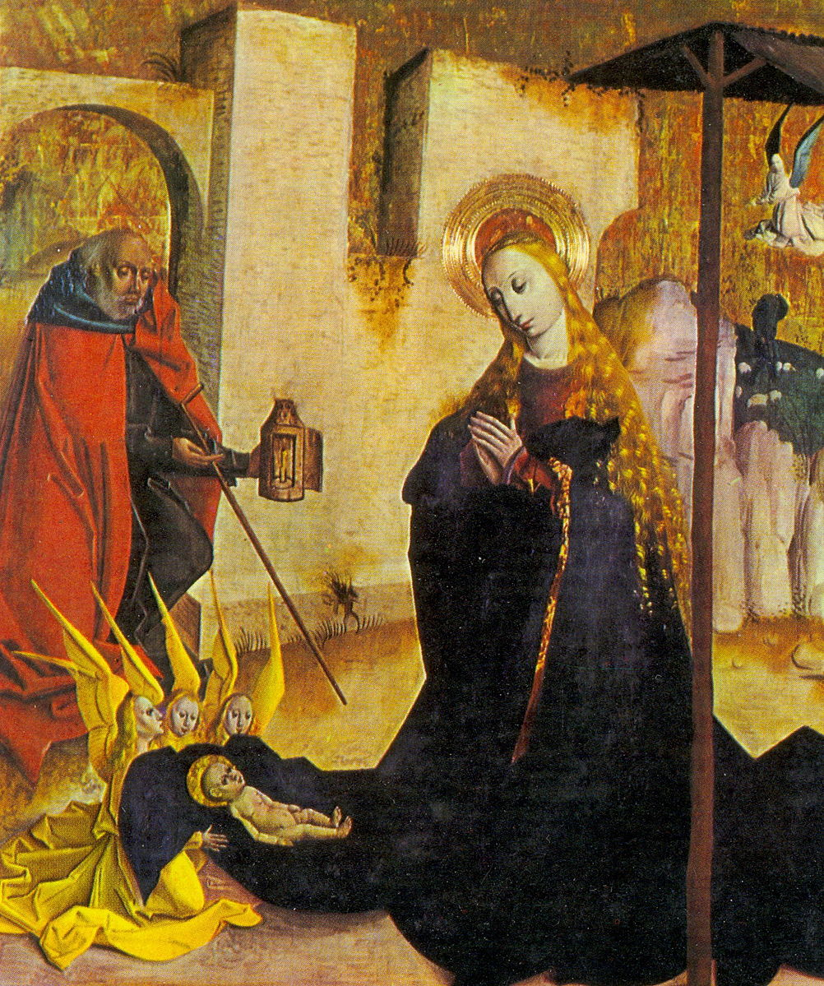
Unknown master, Nativity, 1490

24

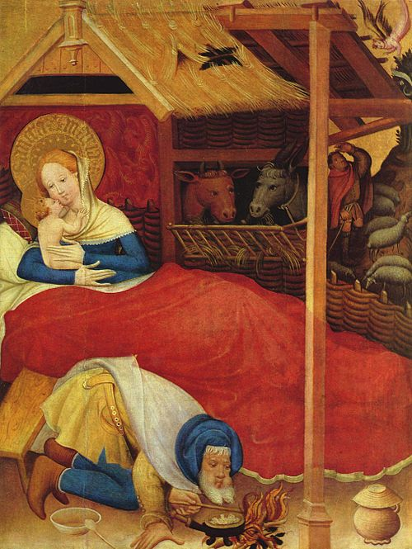
Conrad von Soest, Nativity, 1404

marysward.com

